
This eBook shows you how to TEST COMPONENTS.
To do this you need "TEST GEAR." The best item of Test Gear is a
MULTIMETER. It can test almost 90% of all components. And that's what we will do in this eBook:
CONTENTS
Analogue Multimeter  Audio Stages  Batteries - testing  Burnt Resistor  Buying A Multimeter  Capacitors  Capacitors - decoupling caps  Capacitors in Parallel  Capacitor Substitution Box  Cells - batteries  Circuit Symbols  Co-Ax Cables  Colour Code (Resistor)  Coils  Continuity  Creating any value of R  Current - measuring  Current Sensing Resistors  Current Transformer  Damper Diodes  Darlington Transistors  Digital Chips  Digital Multimeter  Digital Transistors  Diodes replacing a diode  Discharge a Capacitor  Earth Leakage Detectors  Electrolytics  FETs  Fingers - to feel temperature  Focus pots  Fuses and 100mA fuses  Germanium Diodes  Heatsinks  Impedance - of a stage  IC's - also called Digital Chips  IC's - Analogue Chips  "In-Circuit" testing  Inductors  Inductors - measuring  Integrated Circuits  Isolation Transformer  Latching Reed Switch  LEDs  Logic Probe MkIIB  Logic Probe - Simple  Logic Probe - using CD4001  Logic Probe - using CD4011  Making your own components  Measuring Resistance  Measuring Voltage  Mica Washers and Insulators  Motor - testing  MOSFETs | Multimeters  Non-polar Capacitor (electrolytic)  Open Circuit  "Open" Resistor - damaged  Opto-couplers  Parallel - resistors  Parallel and Series Capacitors  Piezo Diaphragms  Piezo Buzzers  Potentiometers  Pots - testing  Power Diodes  Power Supply -see Basic Electronics 1A  Reed Switch  Relays  Remote Controls  Resistor Colour Code  Resistor Networks  Resistors - series  Resistor Substitution Box  Ripple Factor  Schottky Diodes  SCRs  Short Circuit  Signal Injector  Silicon diodes  Soldering  Spark Gaps  Speaker  Substitution Box  Super Probe MkII  Surface Mount - Packs  Surface-Mount Resistors  Surface-Mount Resistor Markings  Switches  Symbols  Test Equipment  Testing A Circuit  Testing A Resistor  Testing Components "In-Circuit"  Transformers - current transformer  Transformer Ratings 28v-0-28v  Transistor Outlines  Transistors  Transistors Digital  Triacs  Unknown resistors - testing  Using A Multimeter  Voltage Divider  Voltage Regulators  Voltages on a circuit  Wire Wound Resistor  Yokes  Zener Diodes  4-Band Resistors  5-Band Resistors  10-Turn Pots

Use your "brain, knowledge and your fingers."
Before we start, fixing anything is a combination of skill, luck and good diagnosis.
Sometimes you can fix something by letting it run until it finally fails.
Some things start to work as soon as you touch them.
Some things can never be fixed.
But some things can be fixed by feeling the temperature rise and deciding if it is getting too hot.
Sometimes you can smell something getting too hot.
Sometimes you can see SMOKE.
All these things make you a very clever technician and about 50% of faults will be fixed by looking for dry joints, burnt parts, overheating and carefully inspecting an item before you disturb it.
By simply touching different items you can quite often feel a hot item and home-in on the fault - at a saving of hours of work.
Servicing is not "A bull at a gate" approach.
You may be able to service something by turning it on and leaving it for hours - and start thinking.
It may take you a day to come up with the answer.
Believe me. That's how it worked for me - while fixing over 35,000 TV's.
TEST EQUIPMENT
Everyone thinks TEST EQUIPMENT will "solve the problem."
This is a big big MISTAKE.
Test equipment can help solve a problem and it can "lead to frustration," "give an incorrect answer," "mess you up," and make things worse.
You have to be very careful with test equipment and especially EXPENSIVE equipment because it is very sensitive and can detect pulses and glitches and voltages that are not affecting the operation of the circuit.
You will learn a lot of tricks when reading through this article, but let me say two things.
There are lots of faults and components that you cannot test with "test equipment" because they are either intermittent or the equipment does not load the device to the same extent as the circuit.
And secondly you need both an ANALOGUE multimeter and a DIGITAL meter to cover all the situations.
And if you are working on a car, you only need a $5.00 analogue meter because it will be dropped or fall into a crack, and you will only lose $5.00
You will learn that a digital meter will pick up spikes and signals on a line and show an incorrect reading.
That's why you need to back-up your readings with an analogue meter.
When you charge a battery it gets a "floating voltage" and this will be higher than the actual voltage, when the battery is fitted to a project. An analogue meter will draw a slight current and remove the "floating voltage."
Component testers can also give you a false reading, either because the component is out of range of the tester or intermittent and you need to be aware of this.
Oscilloscopes can also display waveforms that are parts of glitches or noise from other chips and these do not affect the operation of the part of the circuit you are investigating.
Sometimes you cannot pickup a pulse because it is not regular and the trigger on the oscilloscope does not show it on the screen. You may think it is missing.
It all depends on the "speed of the oscilloscope" - it's maximum frequency of operation.
Lastly- Power Supplies. You cannot test globes and motors on a power supply because the starting current can be 5 times more than the operating current. The power supply may not be able to deliver this high current and thus you will think the motor or globe is faulty.
MULTIMETERS
There are two types:
DIGITAL and ANALOGUE
A Digital Multimeter has a set of digits on the display and an Analogue Multimeter has a scale with a pointer (or needle).
You really need both types to cover the number of tests needed for designing and repair-work. We will discuss how they work, how to use them and some of the differences between them.
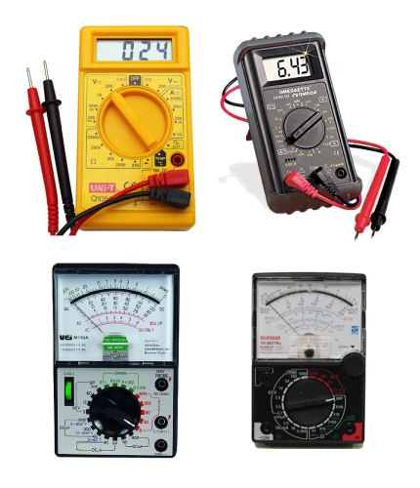
DIGITAL AND ANALOGUE MULTIMETERS
BUYING A MULTIMETER
There are many different types on the market.
The cost is determined by the number of ranges and also the extra features such as diode tester, buzzer (continuity), transistor tester, high DC current and others.
Since most multimeters are reliable and accurate, buy one with the greatest number of ranges at the lowest cost.
This article explains the difference between a cheap analogue meter, an expensive analogue meter and a digital meter. You will then be able to work out which two meters you should buy.
Multimeters are sometimes called a "meter", a "VOM" (Volts-Ohms-Milliamps or Volt Ohm Meter) or "multi-tester" or even "a tester" - they are all the same.
USING A MULTIMETER
Analogue and digital multimeters have either a rotary selector switch or push buttons to select the appropriate function and range. Some Digital Multimeters (DMMs) are auto ranging; they automatically select the correct range of voltage, resistance, or current when doing a test. However you need to select the function.
Before making any measurement you need to know what you are checking. If you are measuring voltage, select the AC range (10v, 50v, 250v, or 1000v) or DC range (0.5v, 2.5v, 10v, 50v, 250v, or 1000v). If you are measuring resistance, select the Ohms range (x1, x10, x100, x1k, x10k). If you are measuring current, select the appropriate current range DCmA 0.5mA, 50mA, 500mA. Every multimeter is different however the photo below shows a low cost meter with the basic ranges.
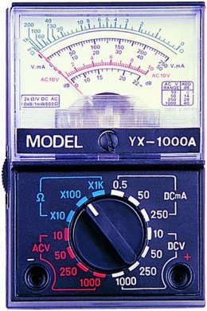
The most important point to remember is this:
You must select a voltage or current range that is bigger or HIGHER than the maximum expected value, so the needle does not swing across the scale and hit the "end stop."
If you are using a DMM (Digital Multi Meter), the meter will indicate if the voltage or current is higher than the selected scale, by showing "OL" - this means "Overload." If you are measuring resistance such as 1M on the x10 range the "OL" means "Open Loop" and you will need to change the range. Some meters show "1' on the display when the measurement is higher than the display will indicate and some flash a set of digits to show over-voltage or over-current. A "-1" indicates the leads should be reversed for a "positive reading."
If it is an AUTO RANGING meter, it will automatically produce a reading, otherwise the selector switch must be changed to another range.
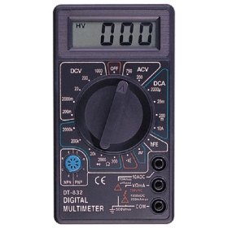
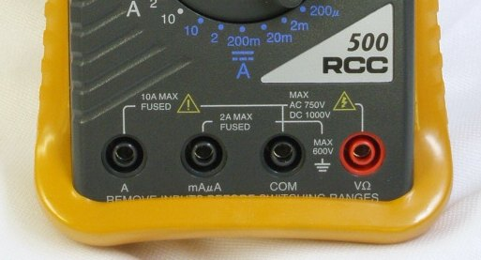
The Common (negative) lead ALWAYS fits into
the "COM" socket. The red lead fits into the
red socket for Voltage and Resistance.
Place the red lead (red banana plug)
into "A" (for HIGH CURRENT "Amps")
or mA,uA for LOW CURRENT.
The black "test lead" plugs into the socket marked "-" "Common", or "Com," and the red "test lead" plugs into meter socket marked "+" or "V-W-mA." The third banana socket measures HIGH CURRENT and the positive (red lead) plugs into this. You DO NOT move the negative "-" lead at any time.
The following two photos show the test leads fitted to a digital meter. The probes and plugs have "guards" surrounding the probe tips and also the plugs so you can measure high voltages without getting near the voltage-source.
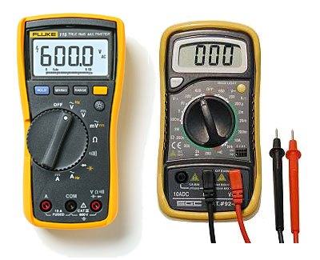
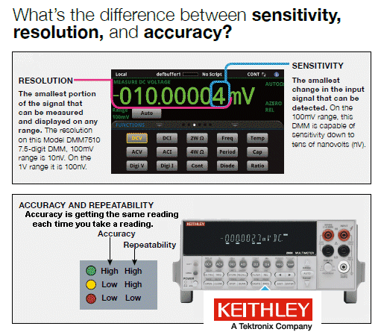
The question above applies to both (every) type of multimeter and the type of meter you use depends on the accuracy you need. Sometimes you are looking for 1mV change on a 20v rail. Only a DMM will (or a CRO) will produce a result.
Analogue meters have an "Ohms Adjustment" to allow for the change in voltage of the battery inside the meter (as it gets old).
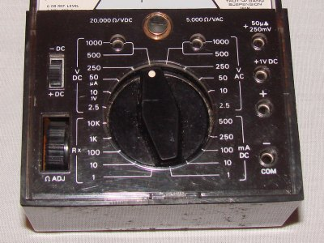
"Ohms Adjust" is also called "ZERO SET"
The sensitivity of this meter is 20,000ohms/volt
on the DC ranges and 5k/v on the AC ranges
Before taking a resistance reading (each time on any of the Ohms scales) you need to "ZERO SET" the scale, by touching the two probes together and adjust the pot until the needle reads "0" (swings FULL SCALE). If the pointer does not reach full scale, the batteries need replacing. Digital multimeters do not need "zero adjustment."
FIXING A MULTIMETER
A multimeter can get "broken" "damaged" and go "faulty."
I don't know why, but eventually they stop working.
It can be something simple like a flat battery, corroded battery contacts, broken switch or something complex, like the circuitry failing.
Multimeters are so cheap, you can buy a new one for less than $10.00
These meters can have a 10 amp range, transistor tester and measure up to 2 meg ohms.
That's why I suggest buying a $10.00 meter. They are just as good as a $60.00 meter and the cheapest meters last the longest.
Dropping an analogue meter can cause the hair spring to loop over one of the supports and the needle will not zero correctly. You will need to open the cover on the movement and lift the spring off the support with a needle.
A faulty meter can be used in a battery-charger circuit to measure the current or voltage if that scale is still reading-correctly.
Otherwise keep the leads and throw the meter out. It is too dangerous keeping a meter that shows an incorrect reading.
MEASURING FREQUENCY
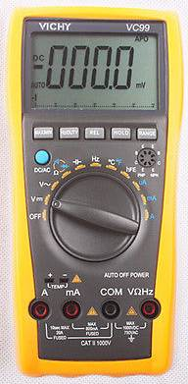
Before we cover the normal uses for a multimeter, it is interesting to note that some Digital Multimeters (DMM) have features such as Capacitance, Frequency and measuring the gain of a transistor as well as a number of other features using probes such as a temperature probe. The VICHY VC99 meter above is an example and costs about $40.00.
Basic function | Range
DCV | 600mV/6V/60V/600V/1000V
ACV | 6V/60/600/1000V
DCA | 600uA/6000uA/60mA/600mA/6A/20A
ACA | 600uA/6000uA/60mA/600mA/6A/20A
Resistance | 600Ω/6kΩ/60kΩ/600kΩ/6MΩ/60MΩ
Capacitance | 40nF/ 400nF/4uF/40uF/400uF/2000uF
Frequency | 100Hz/1kHz/10kHz/100kHz/1MHz/60MHz
Temperature | -40°C~1000°C
Temperature | 0°F~1832°F

MEASURING VOLTAGE
Most of the readings you will take with a multimeter will be VOLTAGE readings.
Before taking a reading, you should select the highest range and if the needle does not move up scale (to the right), you can select another range.
Always switch to the highest range before probing a circuit and keep your fingers away from the component being tested.
If the meter is Digital, select the highest range or use the auto-ranging feature, by selecting "V." The meter will automatically produce a result, even if the voltage is AC or DC.
If the meter is not auto-ranging, you will have to select if the voltage is from a DC source or if the voltage is from an AC source. DC means Direct Current and the voltage is coming from a battery or supply where the voltage is steady and not changing and AC means Alternating Current where the voltage is coming from a voltage that is rising and falling.
You can measure the voltage at different points in a circuit by connecting the black probe to chassis. This is the 0v reference and is commonly called "Chassis" or "Earth" or "Ground" or "0v."
The red lead is called the "measuring lead" or "measuring probe" and it can measure voltages at any point in a circuit. Sometimes there are "test points" on a circuit and these are wires or loops designed to hold the tip of the red probe (or a red probe fitted with a mini clip or mini alligator clip).
You can also measure voltages ACROSS A COMPONENT. In other words, the reading is taken in PARALLEL with the component. It may be the voltage across a transistor, resistor, capacitor, diode or coil. In most cases this voltage will be less than the supply voltage.
If you are measuring the voltage in a circuit that has a HIGH IMPEDANCE, the reading will be inaccurate, up to 90% !!!, if you use a cheap analogue meter.
Here's a simple case.
The circuit below consists of two 1M resistors in series. The voltage at the mid point will be 5v when nothing is connected to the mid point. But if we use a cheap analogue multimeter set to 10v, the resistance of the meter will be about 100k, if the meter has a sensitivity of 10k/v and the reading will be incorrect.
Here how it works:
Every meter has a sensitivity. The sensitivity of the meter is the sensitivity of the movement and is the amount of current required to deflect the needle FULL SCALE.
This current is very small, normally 1/10th of a milliamp and corresponds to a sensitivity of 10k/volt (or 1/30th mA, for a sensitivity of 30k/v).
If an analogue meter is set to 10v, the internal resistance of the meter will be 100k for a 10k/v movement.
If this multimeter is used to test the following circuit, the reading will be inaccurate.
The reading should be 5v as show in diagram A.
But the analogue multimeter has an internal resistance of 100k and it creates a circuit shown in C.
The top 1M and 100k from the meter create a combined PARALLEL resistance of 90k. This forms a series circuit with the lower 1M and the meter will read less than 1v
If we measure the voltage across the lower 1M, the 100k meter will form a value of resistance with the lower 1M and it will read less than 1v
If the multimeter is 30k/v, the readings will be 2v. See how easy it is to get a totally inaccurate reading.
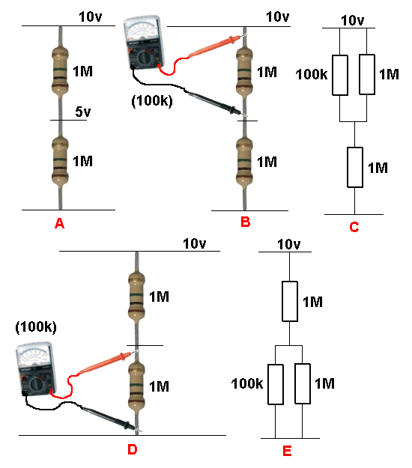
This introduces two new terms:
HIGH IMPEDANCE CIRCUIT and "RESISTORS in SERIES and PARALLEL."
If the reading is taken with a Digital Meter, it will be more accurate as a DMM does not take any current from the circuit (to activate the meter). In other words it has a very HIGH input impedance. Most Digital Multimeters have a fixed input resistance (impedance) of 10M - no matter what scale is selected. That's the reason for choosing a DMM for high impedance circuits. It also gives a reading that is accurate to about 1%.
MEASURING VOLTAGES IN A CIRCUIT
You can take many voltage-measurements in a circuit. You can measure "across" a component, or between any point in a circuit and either the positive rail or earth rail (0v rail). In the following circuit, the 5 most important voltage-measurements are shown. Voltage "A" is across the electret microphone. It should be between 20mV and 500mV. Voltage "B" should be about 0.6v. Voltage "C" should be about half-rail voltage. This allows the transistor to amplify both the positive and negative parts of the waveform. Voltage "D" should be about 1-3v. Voltage "E" should be the battery voltage of 12v.
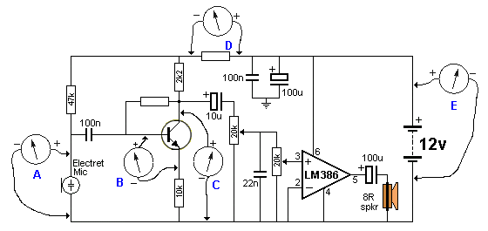
MEASURING VOLTAGES IN A CIRCUIT
MEASURING CURRENT
You will rarely need to take current measurements, however most multimeters have DC current ranges such as 0.5mA, 50mA, 500mA and 10Amp (via the extra banana socket) and some meters have AC current ranges. Measuring the current of a circuit will tell you a lot of things. If you know the normal current, a high or low current can let you know if the circuit is overloaded or not fully operational.
Current is always measured when the circuit is working (i.e: with power applied).
It is measured IN SERIES with the circuit or component under test.
The easiest way to measure current is to remove the fuse and take a reading across the fuse-holder. Or remove one lead of the battery or turn the project off, and measure across the switch.
If this is not possible, you will need to remove one end of a component and measure with the two probes in the "opening."
Resistors are the easiest things to desolder, but you may have to cut a track in some circuits. You have to get an "opening" so that a current reading can be taken.
The following diagrams show how to connect the probes to take a CURRENT reading.
Do not measure the current ACROSS a component as this will create a "short-circuit."
The component is designed to drop a certain voltage and when you place the probes across this component, you are effectively adding a "link" or "jumper" and the voltage at the left-side of the component will appear on the right-side. This voltage may be too high for the circuit being supplied and the result will be damage.
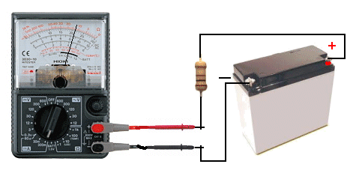
Measuring current through a resistor
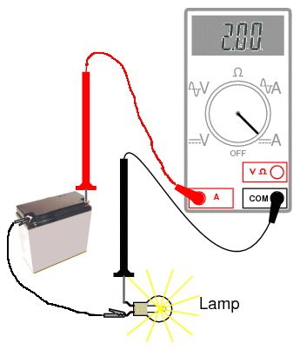
Measuring the current of a globe
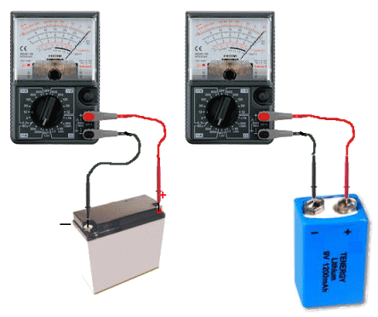
Do NOT measure the CURRENT of a battery
(by placing the meter directly across the terminals)
A battery will deliver a very HIGH current
and damage the meter
Do not measure the "current a battery will deliver" by placing the probes across the terminals. It will deliver a very high current and damage the meter instantly. There are special battery testing instruments for this purpose.
When measuring across an "opening" or "cut," place the red probe on the wire that supplies the voltage (and current) and the black probe on the other wire. This will produce a "POSITIVE" reading.
A positive reading is an UPSCALE READING and the pointer will move across the scale - to the right. A "NEGATIVE READING" will make the pointer hit the "STOP" at the left of the scale and you will not get a reading. If you are using a Digital Meter, a negative sign "-" will appear on the screen to indicate the probes are around the wrong way. No damage will be caused. It just indicates the probes are connected incorrectly.
If you want an accurate CURRENT MEASUREMENT, use a digital meter.
MEASURING RESISTANCE
Turn a circuit off before measuring resistance.
If any voltage is present, the value of resistance will be incorrect.
In most cases you cannot measure a component while it is in-circuit. This is because the meter is actually measuring a voltage across a component and calling it a "resistance." The voltage comes from the battery inside the meter. If any other voltage is present, the meter will produce a false reading.
If you are measuring the resistance of a component while still "in circuit," (with the power off) the reading will be lower than the true reading. 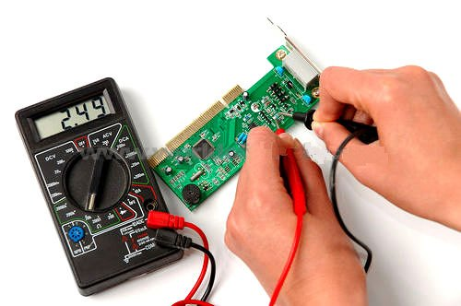
Measuring resistance
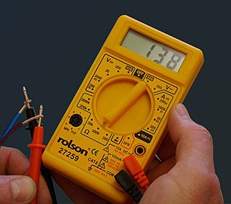
Measuring resistance of a heater
(via the leads)
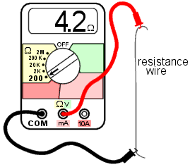
Measuring the resistance of a piece of resistance-wire
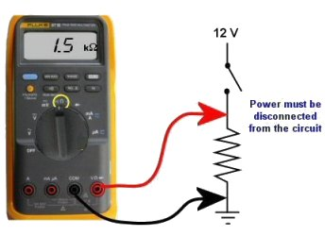
Measuring the resistance of a resistor
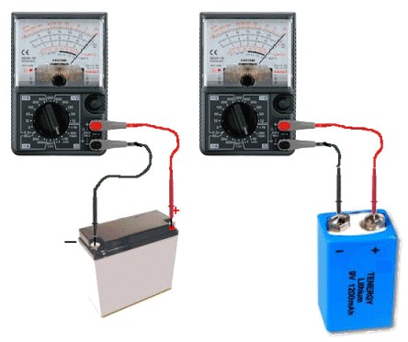
Do not measure the "Resistance of a Battery"
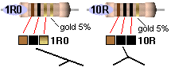
1. Do not measure the "resistance of a battery." The resistance of a battery (called the Internal impedance) is not measured as shown in the diagrams above. It is measured by creating a current-flow and measuring the voltage across the battery. Placing a multimeter set to resistance (across a battery) will destroy the meter.
2. Do not try to measure the resistance of any voltage or any "supply."
Resistance is measured in OHMs.
The resistance of a 1cm x 1cm bar, one metre long is 1 ohm.
If the bar is thinner, the resistance is higher. If the bar is longer, the resistance is higher.
If the material of the bar is changed, the resistance is higher.
When carbon is mixed with other elements, its resistance increases and this knowledge is used to make RESISTORS.
Resistors have RESISTANCE and the main purpose of a resistor is to reduce the CURRENT FLOW.
It's a bit like standing on a hose. The flow reduces.
When current flow is reduced, the output voltage is also reduced and that why the water does not spray up so high. Resistors are simple devices but they produce many different effects in a circuit.
A resistor of nearly pure carbon may be 1 ohm, but when non-conducting "impurities" are added, the same-size resistor may be 100 ohms, 1,000 ohms or 1 million ohms.
Circuits use values of less than 1 ohm to more than 22 million ohms.
Resistors are identified on a circuit with numbers and letters to show the exact value of resistance - such as 1k 2k2 4M7
The letter  (omega - a Greek symbol) is used to identify the word "Ohm."
but this symbol is not available on some word-processors, so the letter "R" is used. The letter "E" is also sometimes used and both mean "Ohms."
A one-ohm resistor is written "1R" or "1E." It can also be written "1R0" or "1E0."
A resistor of one-tenth of an ohm is written "0R1" or "0E1." The letter takes the place of the decimal point.
10 ohms = 10R
100 ohms = 100R
1,000 ohms = 1k (k= kilo = one thousand)
10,000 ohms = 10k
100,000 ohms = 100k
1,000,000 ohms = 1M (M = MEG = one million)
The size of a resistor has nothing to do with its resistance. The size determines the wattage of the resistor - how much heat it can dissipate without getting too hot.
Every resistor is identified by colour bands on the body, but when the resistor is a surface-mount device, numbers are used and sometimes letters.
You MUST learn the colour code for resistors and the following table shows all the colours for the most common resistors from 1/10th of an ohm to 22 Meg ohms for resistors with 5% and 10% tolerance.
If 3rd band is gold, Divide by 10
If 3rd band is silver, Divide by 100
(to get 0.22ohms etc)
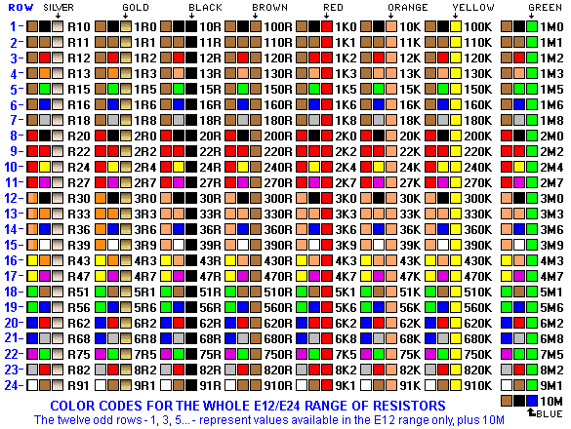
Reading 4-band resistors
The most "common" type of resistor has 4 bands and is called the 10% resistor. It now has a tolerance of 5% but is still called the "10% type" as the colours increase by 20% so that a resistor can be 10% higher or 10% lower than a particular value and all the resistors produced in a batch can be used.
The first 3 bands produce the resistance and the fourth band is the "tolerance" band. Gold = 5%
(Silver =10% but no modern resistors are 10%!! - they are 5% 2% or 1%)
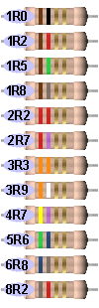 | 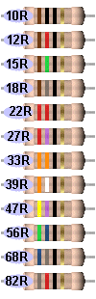 | 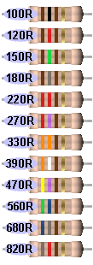 | 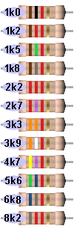

 |  | 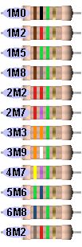 | 
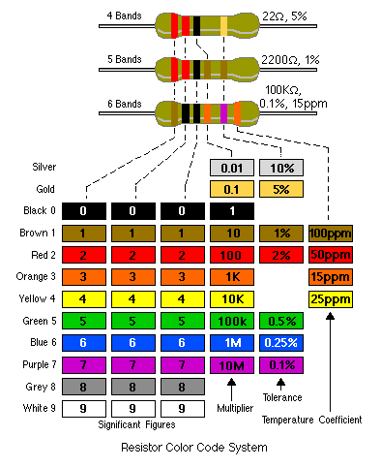
Here is another well-designed resistor colour code chart: 
Download the program and save it on your desk-top for future reference:
ColourCode.exe (520KB)
ColourCode.zip (230KB)
ColourCode.rar (180KB)
RESISTORS LESS THAN 10 OHMS
When the third band is gold, it indicates the value of the "colors" must be divided by 10.
Gold = "divide by 10" to get values 1R0 to 8R2
When the third band is silver, it indicates the value of the "colors" must be divided by 100. (Remember: more letters in the word "silver" thus the divisor is "a larger division.")
Silver = "divide by 100" to get values R1 to R82
e.g: 0R1 = 0.1 ohm 0R22 = point 22 ohms
See 4th Column above for examples.
The letters "R, k and M" take the place of a decimal point.
e.g: 1R0 = 1 ohm 2R2 = 2 point 2 ohms 22R = 22 ohms
2k2 = 2,200 ohms 100k = 100,000 ohms
2M2 = 2,200,000 ohms
HOW TO REMEMBER THE COLOUR CODE:
Each colour has a "number" (or divisor) corresponding to it.
Most of the colours are in the same order as in the spectrum. You can see the spectrum in a rainbow. It is: ROY G BIV and the colours for resistors are in the same sequence.
black
brown - colour of increasing temperature
red
orange
yellow
green
blue
(indigo - that part of the spectrum between blue and violet)
violet
gray
white
colour | value | No of zero's
silver | -2 | divide by 100
gold | -1 | divide by 10
black | 0 | No zeros
brown | 1 | 0
red | 2 | 00
orange | 3 | ,000 or k
yellow | 4 | 0,000
green | 5 | 00,000
blue | 6 | M
violet | 7
gray | 8
white | 9
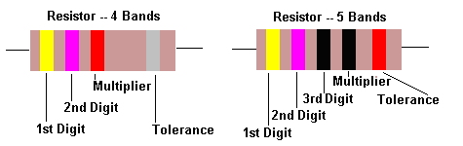
Here are some common ways to remember the colour code:
Bad Beer Rots Our Young Guts, But Vodka Goes Well
Bright Boys Rave Over Young Girls But Violet Gets Wed
Bad Boys Rave Over Young Girls But Violet Gets Wed with Gold and Silver.
Reading 5-band resistors:
5-band resistors are easy to read if you remember two simple points. The first three bands provide the digits in the answer and the 4th band supplies the number of zero's.
Reading "STANDARD VALUES" (on 5-band resistors)
5-band resistors are also made in "Standard Values" but will have different colours to 4-band "common" resistors - and will be confusing if you are just starting out. For instance, a 47k 5% resistor with 4-bands will be: yellow-purple-orange-gold. For a 47k 1% resistor the colours will be yellow-purple-black-red-brown. The brown colour-band represents 1%.
The first two colour-bands for a STANDARD VALUE or "common value" in 1% or 5% will be the SAME. These two bands provide the digits in the answer.
It's the 3rd band for a 5% resistor that is expanded into two bands in a 1% resistor. But it's easy to follow.
For a standard value, the 3rd band in a 1% resistor is BLACK. This represents a ZERO in the answer. (For 5-band resistors BLACK represents a ZERO when in the third band. This is different to 4-band resistors where black represents the word OHMS! If the third band is BROWN, the answer will be 1).
So the 4th band has to represent one-less ZERO and is one colour UP THE COLOUR CHART! In other words the 3rd and 4th bands (combined) on a 1% resistor produces the same number of zero's as the 3rd band on a 5% resistor!
Resistors come in a range of values and the two most common are the E12 and E24 series. The E12 series comes in twelve values for each decade. The E24 series comes in twenty-four values per decade.
E12 series - 10, 12, 15, 18, 22, 27, 33, 39, 47, 56, 68, 82
E24 series - 10, 11, 12, 13, 15, 16, 18, 20, 22, 24, 27, 30, 33, 36, 39, 43, 47, 51, 56, 62, 68, 75, 82, 91
Here is the complete list of 1% 1/4watt resistors from:
CIRCUIT SPECIALISTS. The following list covers 10 ohms (10R) to 1M.
To buy 1% resistors from Circuit Specialists, click: HERE.
10R  12R1  15R  18R2  22R1  27R4  30R1  33R2  36R5  39R2  47R5  49R9  51R1  56R2  68R1  75R  82R5  90R9  100R | 121R  150R  182R  200R  221R  240R  249R  274R  301R  332R  348R  392R  402R  475R  499R  565R  604R  681R  750R | 806R  825R  909R  1k0  1k21  1k5  1k82  2k  2k21  2k2  2k43  2k49  2k67  2k74  3k01  3k32  3k48  3k57  3k74 | 3k83  3k92  4k02  4k22  4k64  4k75  4k7  4k87  4k99  5k11  5k23  5k36  5k49  5k62  5k76  5k9  6k04  6k19  6k81 | 7k15  7k5  7k87  71k5  8k06  8k25  8k45  8k66  8k87  9k09  9k31  9k53  9k76  10k  11k  12k  12k1  12k4  13k | 14k7  15k  15k8  16k9  17k4  17k8  18k2  20k  22k1  22k6  23k7  24k9  27k4  29k4  30k1  33k2  34k8  36k5  38k3 | 39k2  40k2  44k2  46k4  47k  47k5  49k9  51k1  53k6  56k2  61k9  68k1  69k8  75k0  82k5  90k  90k9  95k3  100k | 121k  147k  150k  182k  200k  212k  221k  226k  249k  274k  301k  332k  357k  392k  475k  487k  499k  562k  604k  1M
Here is the list of 1% resistors from suppliers (such as Farnell):
1R0  1R2  1R5  2R2  2R7  3R3  3R9  4R7  5R6  6R2  6R8  7R5  8R2  9R1  10R  11R  12R | 13R  15R  16R  18R  20R  22R  24R  27R  30R  33R  36R  39R  43R  47R  51R  56R  62R | 68R  75R  82R  91R  100R  110R  120R  130R  150R  160R  180R  200R  220R  240R  270R  300R  330R | 360R  390R  430R  470R  510R  560R  620R  680R  750R  820R  910R  1k  1k1  1k2  1k3  1k5  1k6 | 1k8  2k0  2k2  2k4  2k7  3k  3k3  3k6  3k9  4k3  4k7  5k1  5k6  6k2  6k8  7k5  8k2 | 9k1  10k  11k  12k  13k  15k  16k  18k  20k  22k  24k  27k  30k  33k  36k  39k  43k | 47k  51k  56k  62k  68k  75k  82k  91k  100k  110k  120k  130k  150k  160k  180k  200k  220k | 240k  270k  300k  330k  360k  390k  430k  470k  510k  560k  620k  680k  750k  820k  910k  1M
Surface Mount Resistors
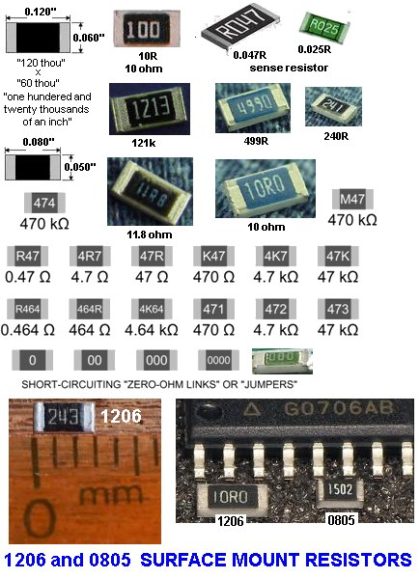
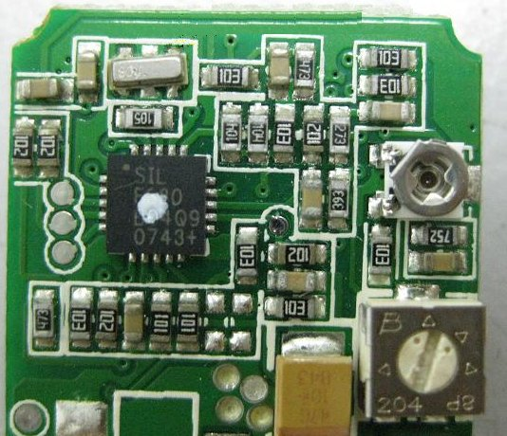
3-digit Surface Mount resistors on a PC board
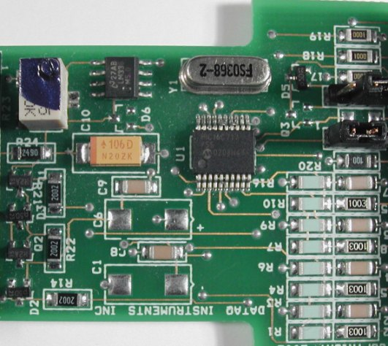
4-digit Surface Mount resistors on a PC board
The photo above shows surface mount resistors on a circuit board. The components that are not marked are capacitors (capacitors are NEVER marked).
All the SM resistors in the above photos conform to a 3-digit or 4-digit code. But there are a number of codes, and the 4-digit code caters for high tolerance resistors, so it's getting very complicated.
Here is a basic 3-digit SM resistor:
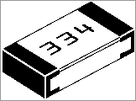
A 330k SM resistor
The first two digits represent the two digits in the answer. The third digit represents the number of zero's you must place after the two digits. The answer will be OHMS. For example: 334 is written 33 0 000. This is written 330,000 ohms. The comma can be replaced by the letter "k". The final answer is: 330k.
222 = 22 00 = 2,200 = 2k2
473 = 47 000 = 47,000 = 47k
474 = 47 0000 = 470,000 = 470k
105 = 10 00000 = 1,000,000 = 1M = one million ohms
There is one trick you have to remember. Resistances less than 100 ohms are written: 100, 220, 470. These are 10 and NO zero's = 10 ohms = 10R
or 22 and no zero's = 22R or 47 and no zero's = 47R. Sometimes the resistor is marked: 10, 22 and 47 to prevent a mistake.
Remember:
R = ohms
k = kilo ohms = 1,000 ohms
M = Meg = 1,000,000 ohms
The 3 letters (R, k and M) are put in place of the decimal point. This way you cannot make a mistake when reading a value of resistance.
Surface Mount CURRENT SENSING Resistors
Many new types of CURRENT SENSING surface-mount resistors are appearing on the market and these are creating lots of new problems.
Fortunately all resistors are marked with the value of resistance and these resistors are identified in MILLIOHMS. A miili ohm is one thousandth or an ohm and is written 0.001 when writing a normal mathematical number.
When written on a surface mount resistor, the letter R indicates the decimal point and it also signifies the word "OHM" or "OHMS" and one milli-ohm is written R001
Five miiliohms is R005 and one hundred milliohms is R100
Some surface mount resistors have the letter "M" after the value to indicate the resistor has a rating of 1 watt. e.g: R100M These surface-mount resistors are specially-made to withstand a high temperature and a surface-mount resistor of the same size is normally 250mW or less.
These current-sensing resistors can get extremely hot and the PC board can become burnt or damaged.
When designing a PC board, make the lands very large to dissipate the heat.
Normally a current sensing resistor is below one ohm (1R0) and it is easy to identify them as R100 etc.
You cannot measure the value of a current sensing resistor as the leads of a multimeter have a higher resistance than the resistor and few multimeters can read values below one ohm.
If the value is not visible, you will have to refer to the circuit.
Before replacing it, work out why it failed.
Generally it gets too hot. Use a larger size and add tiny heatsinks on each end.
Here are some surface=mount current-sense resistors:
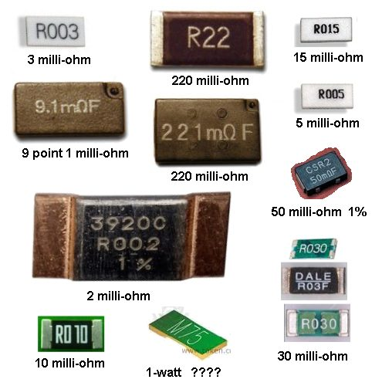
THE COMPLETE RANGE OF SM RESISTOR
MARKINGS
Click to see the complete range of SM resistor markings for 3-digit code:

Click to see the complete range of SM resistor markings for 4-digit code:

0000 is a value on a surface-mount resistor. It is a zero-ohm LINK!
Resistances less than 10 ohms have 'R' to indicate the position of the decimal point.
Here are some examples:
Three Digit Examples | Four Digit Examples
330 is 33 ohms - not 330 ohms | 1000 is 100 ohms - not 1000 ohms
221 is 220 ohms | 4992 is 49 900 ohms, or 49k9
683 is 68 000 ohms, or 68k | 1623 is 162 000 ohms, or 162k
105 is 1 000 000 ohms, or 1M | 0R56 or R56 is  0.56 ohms
8R2 is 8.2 ohms
A new coding system has appeared on 1% types. This is known as the EIA-96 marking method. It consists of a three-character code. The first two digits signify the 3 significant digits of the resistor value, using the lookup table below. The third character - a letter - signifies the multiplier.
code | value |  | code | value |  | code | value |  | code | value |  | code | value |  | code | value
01 | 100 |  | 17 | 147 |  | 33 | 215 |  | 49 | 316 |  | 65 | 464 |  | 81 | 681
02 | 102 |  | 18 | 150 |  | 34 | 221 |  | 50 | 324 |  | 66 | 475 |  | 82 | 698
03 | 105 |  | 19 | 154 |  | 35 | 226 |  | 51 | 332 |  | 67 | 487 |  | 83 | 715
04 | 107 |  | 20 | 158 |  | 36 | 232 |  | 52 | 340 |  | 68 | 499 |  | 84 | 732
05 | 110 |  | 21 | 162 |  | 37 | 237 |  | 53 | 348 |  | 69 | 511 |  | 85 | 750
06 | 113 |  | 22 | 165 |  | 38 | 243 |  | 54 | 357 |  | 70 | 523 |  | 86 | 768
07 | 115 |  | 23 | 169 |  | 39 | 249 |  | 55 | 365 |  | 71 | 536 |  | 87 | 787
08 | 118 |  | 24 | 174 |  | 40 | 255 |  | 56 | 374 |  | 72 | 549 |  | 88 | 806
09 | 121 |  | 25 | 178 |  | 41 | 261 |  | 57 | 383 |  | 73 | 562 |  | 89 | 825
10 | 124 |  | 26 | 182 |  | 42 | 267 |  | 58 | 392 |  | 74 | 576 |  | 90 | 845
11 | 127 |  | 27 | 187 |  | 43 | 274 |  | 59 | 402 |  | 75 | 590 |  | 91 | 866
12 | 130 |  | 28 | 191 |  | 44 | 280 |  | 60 | 412 |  | 76 | 604 |  | 92 | 887
13 | 133 |  | 29 | 196 |  | 45 | 287 |  | 61 | 422 |  | 77 | 619 |  | 93 | 909
14 | 137 |  | 30 | 200 |  | 46 | 294 |  | 62 | 432 |  | 78 | 634 |  | 94 | 931
15 | 140 |  | 31 | 205 |  | 47 | 301 |  | 63 | 442 |  | 79 | 649 |  | 95 | 953
16 | 143 |  | 32 | 210 |  | 48 | 309 |  | 64 | 453 |  | 80 | 665 |  | 96 | 976
The multiplier letters are as follows:
letter | mult |  | letter | mult
F | 100000 |  | B | 10
E | 10000 |  | A | 1
D | 1000 |  | X or S | 0.1
C | 100 |  | Y or R | 0.01
22A is a 165 ohm resistor, 68C is a 49900 ohm (49k9) and 43E a 2740000 (2M74). This marking scheme applies to 1% resistors only.
A similar arrangement can be used for 2% and 5% tolerance types. The multiplier letters are identical to 1% ones, but occur before the number code and the following code is used:
2% |  |  |  |  |  | 5%
code | value |  | code | value |  | code | value |  | code | value
01 | 100 |  | 13 | 330 |  | 25 | 100 |  | 37 | 330
02 | 110 |  | 14 | 360 |  | 26 | 110 |  | 38 | 360
03 | 120 |  | 15 | 390 |  | 27 | 120 |  | 39 | 390
04 | 130 |  | 16 | 430 |  | 28 | 130 |  | 40 | 430
05 | 150 |  | 17 | 470 |  | 29 | 150 |  | 41 | 470
06 | 160 |  | 18 | 510 |  | 30 | 160 |  | 42 | 510
07 | 180 |  | 19 | 560 |  | 31 | 180 |  | 43 | 560
08 | 200 |  | 20 | 620 |  | 32 | 200 |  | 44 | 620
09 | 220 |  | 21 | 680 |  | 33 | 220 |  | 45 | 680
10 | 240 |  | 22 | 750 |  | 34 | 240 |  | 46 | 750
11 | 270 |  | 23 | 820 |  | 35 | 270 |  | 47 | 820
12 | 300 |  | 24 | 910 |  | 36 | 300 |  | 48 | 910
With this arrangement, C31 is 5%, 18000 ohm (18k), and D18 is 510000 ohms (510k) 2% tolerance.
Always check with an ohm-meter (a multimeter) to make sure.
Chip resistors come in the following styles and ratings:
Style: 0402, 0603, 0805, 1206, 1210, 2010, 2512, 3616, 4022
Power Rating: 0402(1/16W), 0603(1/10W), 0805(1/8W), 1206(1/4W), 1210(1/3W), 2010(3/4W), 2512(1W), 3616(2W), 4022(3W)
Tolerance: 0.1%, 0.5%, 1%, 5%
Temperature Coefficient: 25ppm 50ppm 100ppm
EIA marking code for surface mount (SMD) resistors
01S = 1R  02S = 1R02  03S = 1R05  04S = 1R07  05S = 1R1  06S = 1R13  07S = 1R15  08S = 1R18  09S = 1R21  10S = 1R24  11S = 1R27  12S = 1R3  13S = 1R33  14S = 1R37  15S = 1R4  16S = 1R43  17S = 1R47  18S = 1R5  19S = 1R54  20S = 1R58  21S = 1R62  22S = 1R65  23S = 1R69  24S = 1R74  25S = 1R78  26S = 1R82  27S = 1R87  28S = 1R91  29S = 1R96  30S = 2R0  31S = 2R05  32S = 2R10  33S = 2R15  34S = 2R21  35S = 2R26  36S = 2R32  37S = 2R37  38S = 2R43  39S = 2R49  40S = 2R55  41S = 2R61  42S = 2R67  43S = 2R74  44S = 2R80  45S = 2R87  46S = 2R94  47S = 3R01  48S = 3R09  49S = 3R16  50S = 3R24  51S = 3R32  52S = 3R4  53S = 3R48  54S = 3R57  55S = 3R65  56S = 3R74  57S = 3R83  58S = 3R92  59S = 4R02  60S = 4R12  61S = 4R22  62S = 4R32  63S = 4R42  64S = 4R53  65S = 4R64  66S = 4R75  67S = 4R87  68S = 4R99  69S = 5R11  70S = 5R23  71S = 5R36  72S = 5R49  73S = 5R62  74S = 5R76  75S = 5R9  76S = 6R04  77S = 6R19  78S = 6R34  79S = 6R49  80S = 6R65  81S = 6R81  82S = 6R98  83S = 7R15  84S = 7R32  85S = 7R5  86S = 7R68  87S = 7R87  88S = 8R06  89S = 8R25  90S = 8R45  91S = 8R66  92S = 8R87  93S = 9R09  94S = 9R31  95S = 9R53  96S = 9R76 | 01R = 10R  02R = 10R2  03R = 10R5  04R = 10R7  05R = 11R  06R = 11R3  07R = 11R5  08R = 11R8  09R = 12R1  10R = 12R4  11R = 12R7  12R = 13R  13R = 13R3  14R = 13R7  15R = 14R  16R = 14R3  17R = 14R7  18R = 15R  19R = 15R4  20R = 15R8  21R = 16R2  22R = 16R5  23R = 16R9  24R = 17R4  25R = 17R8  26R = 18R2  27R = 18R7  28R = 19R1  29R = 19R6  30R = 20R0  31R = 20R5  32R = 21R0  33R = 21R5  34R = 22R1  35R = 22R6  36R = 23R2  37R = 23R7  38R = 24R3  39R = 24R9  40R = 25R5  41R = 26R1  42R = 26R7  43R = 27R4  44R = 28R0  45R = 28R7  46R = 29R4  47R = 30R1  48R = 30R9  49R = 31R6  50R = 32R4  51R = 33R2  52R = 34R0  53R = 34R8  54R = 35R7  55R = 36R5  56R = 37R4  57R = 38R3  58R = 39R2  59R = 40R2  60R = 41R2  61R = 42R2  62R = 43R2  63R = 44R2  64R = 45R3  65R = 46R4  66R = 47R5  67R = 48R7  68R = 49R9  69R = 51R1  70R = 52R3  71R = 53R6  72R = 54R9  73R = 56R2  74R = 57R6  75R = 59R0  76R = 60R4  77R = 61R9  78R = 63R4  79R = 64R9  80R = 66R5  81R = 68R1  82R = 69R8  83R = 71R5  84R = 73R2  85R = 75R0  86R = 76R8  87R = 78R7  88R = 80R6  89R = 82R5  90R = 84R5  91R = 86R6  92R = 88R7  93R = 90R9  94R = 93R1  95R = 95R3  96R = 97R6 | 01A = 100R  02A = 102R  03A = 105R  04A = 107R  05A = 110R  06A = 113R  07A = 115R  08A = 118R  09A = 121R  10A = 124R  11A = 127R  12A = 130R  13A = 133R  14A = 137R  15A = 140R  16A = 143R  17A = 147R  18A = 150R  19A = 154R  20A = 158R  21A = 162R  22A = 165R  23A = 169R  24A = 174R  25A = 178R  26A = 182R  27A = 187R  28A = 191R  29A = 196R  30A = 200R  31A = 205R  32A = 210R  33A = 215R  34A = 221R  35A = 226R  36A = 232R  37A = 237R  38A = 243R  39A = 249R  40A = 255R  41A = 261R  42A = 267R  43A = 274R  44A = 280R  45A = 287R  46A = 294R  47A = 301R  48A = 309R  49A = 316R  50A = 324R  51A = 332R  52A = 340R  53A = 348R  54A = 357R  55A = 365R  56A = 374R  57A = 383R  58A = 392R  59A = 402R  60A = 412R  61A = 422R  62A = 432R  63A = 442R  64A = 453R  65A = 464R  66A = 475R  67A = 487R  68A = 499R  69A = 511R  70A = 523R  71A = 536R  72A = 549R  73A = 562R  74A = 576R  75A = 590R  76A = 604R  77A = 619R  78A = 634R  79A = 649R  80A = 665R  81A = 681R  82A = 698R  83A = 715R  84A = 732R  85A = 750R  86A = 768R  87A = 787R  88A = 806R  89A = 825R  90A = 845R  91A = 866R  92A = 887R  93A = 909R  94A = 931R  95A = 953R  96A = 976R | 01B = 1k  02B = 1k02  03B = 1k05  04B = 1k07  05B = 1k1  06B = 1k13  07B = 1k15  08B = 1k18  09B = 1k21  10B = 1k24  11B = 1k27  12B = 1k3  13B = 1k33  14B = 1k37  15B = 1k4  16B = 1k43  17B = 1k47  18B = 1k5  19B = 1k54  20B = 1k58  21B = 1k62  22B = 1k65  23B = 1k69  24B = 1k74  25B = 1k78  26B = 1k82  27B = 1k87  28B = 1k91  29B = 1k96  30B = 2k0  31B = 2k05  32B = 2k10  33B = 2k15  34B = 2k21  35B = 2k26  36B = 2k32  37B = 2k37  38B = 2k43  39B = 2k49  40B = 2k55  41B = 2k61  42B = 2k67  43B = 2k74  44B = 2k80  45B = 2k87  46B = 2k94  47B = 3k01  48B = 3k09  49B = 3k16  50B = 3k24  51B = 3k32  52B = 3k4  53B = 3k48  54B = 3k57  55B = 3k65  56B = 3k74  57B = 3k83  58B = 3k92  59B = 4k02  60B = 4k12  61B = 4k22  62B = 4k32  63B = 4k42  64B = 4k53  65B = 4k64  66B = 4k75  67B = 4k87  68B = 4k99  69B = 5k11  70B = 5k23  71B = 5k36  72B = 5k49  73B = 5k62  74B = 5k76  75B = 5k9  76B = 6k04  77B = 6k19  78B = 6k34  79B = 6k49  80B = 6k65  81B = 6k81  82B = 6k98  83B = 7k15  84B = 7k32  85B = 7k5  86B = 7k68  87B = 7k87  88B = 8k06  89B = 8k25  90B = 8k45  91B = 8k66  92B = 8k87  93B = 9k09  94B = 9k31  95B = 9k53  96B = 9k76 | 01C = 10k  02C = 10k2  03C = 10k5  04C = 10k7  05C = 11k  06C = 11k3  07C = 11k5  08C = 11k8  09C = 12k1  10C = 12k4  11C = 12k7  12C = 13k  13C = 13k3  14C = 13k7  15C = 14k  16C = 14k3  17C = 14k7  18C = 15k  19C = 15k4  20C = 15k8  21C = 16k2  22C = 16k5  23C = 16k9  24C = 17k4  25C = 17k8  26C = 18k2  27C = 18k7  28C = 19k1  29C = 19k6  30C = 20k0  31C = 20k5  32C = 21k0  33C = 21k5  34C = 22k1  35C = 22k6  36C = 23k2  37C = 23k7  38C = 24k3  39C = 24k9  40C = 25k5  41C = 26k1  42C = 26k7  43C = 27k4  44C = 28k0  45C = 28k7  46C = 29k4  47C = 30k1  48C = 30k9  49C = 31k6  50C = 32k4  51C = 33k2  52C = 34k0  53C = 34k8  54C = 35k7  55C = 36k5  56C = 37k4  57C = 38k3  58C = 39k2  59C = 40k2  60C = 41k2  61C = 42k2  62C = 43k2  63C = 44k2  64C = 45k3  65C = 46k4  66C = 47k5  67C = 48k7  68C = 49k9  69C = 51k1  70C = 52k3  71C = 53k6  72C = 54k9  73C = 56k2  74C = 57k6  75C = 59k0  76C = 60k4  77C = 61k9  78C = 63k4  79C = 64k9  80C = 66k5  81C = 68k1  82C = 69k8  83C = 71k5  84C = 73k2  85C = 75k0  86C = 76k8  87C = 78k7  88C = 80k6  89C = 82k5  90C = 84k5  91C = 86k6  92C = 88k7  93C = 90k9  94C = 93k1  95C = 95k3  96C = 97k6 | 01D = 100k  02D = 102k  03D = 105k  04D = 107k  05D = 110k  06D = 113k  07D = 115k  08D = 118k  09D = 121k  10D = 124k  11D = 127k  12D = 130k  13D = 133k  14D = 137k  15D = 140k  16D = 143k  17D = 147k  18D = 15k  19D = 154k  20D = 158k  21D = 162k  22D = 165k  23D = 169k  24D = 174k  25D = 178k  26D = 182k  27D = 187k  28D = 191k  29D = 196k  30D = 200k  31D = 205k  32D = 210k  33D = 215k  34D = 221k  35D = 226k  36D = 232k  37D = 237k  38D = 243k  39D = 249k  40D = 255k  41D = 261k  42D = 267k  43D = 274k  44D = 280k  45D = 287k  46D = 294k  47D = 301k  48D = 309k  49D = 316k  50D = 324k  51D = 332k  52D = 340k  53D = 348k  54D = 357k  55D = 365k  56D = 374k  57D = 383k  58D = 392k  59D = 402k  60D = 412k  61D = 422k  62D = 432k  63D = 442k  64D = 453k  65D = 464k  66D = 475k  67D = 487k  68D = 499k  69D = 511k  70D = 523k  71D = 536k  72D = 549k  73D = 562k  74D = 576k  75D = 590k  76D = 604k  77D = 619k  78D = 634k  79D = 649k  80D = 665k  81D = 681k  82D = 698k  83D = 715k  84D = 732k  85D = 750k  86D = 768k  87D = 787k  88D = 806k  89D = 825k  90D = 845k  91D = 866k  92D = 887k  93D = 909k  94D = 931k  95D = 953k  96D = 976k | 01E = 1M  02E = 1M02  03E = 1M05  04E = 1M07  05E = 1M1  06E = 1M13  07E = 1M15  08E = 1M18  09E = 1M21  10E = 1M24  11E = 1M27  12E = 1M3  13E = 1M33  14E = 1M37  15E = 1M4  16E = 1M43  17E = 1M47  18E = 1M5  19E = 1M54  20E = 1M58  21E = 1M62  22E = 1M65  23E = 1M69  24E = 1M74  25E = 1M78  26E = 1M82  27E = 1M87  28E = 1M91  29E = 1M96  30E = 2M0  31E = 2M05  32E = 2M10  33E = 2M15  34E = 2M21  35E = 2M26  36E = 2M32  37E = 2M37  38E = 2M43  39E = 2M49  40E = 2M55  41E = 2M61  42E = 2M67  43E = 2M74  44E = 2M80  45E = 2M87  46E = 2M94  47E = 3M01  48E = 3M09  49E = 3M16  50E = 3M24  51E = 3M32  52E = 3M4  53E = 3M48  54E = 3M57  55E = 3M65  56E = 3M74  57E = 3M83  58E = 3M92  59E = 4M02  60E = 4M12  61E = 4M22  62E = 4M32  63E = 4M42  64E = 4M53  65E = 4M64  66E = 4M75  67E = 4M87  68E = 4M99  69E = 5M11  70E = 5M23  71E = 5M36  72E = 5M49  73E = 5M62  74E = 5M76  75E = 5M9  76E = 6M04  77E = 6M19  78E = 6M34  79E = 6M49  80E = 6M65  81E = 6M81  82E = 6M98  83E = 7M15  84E = 7M32  85E = 7M5  86E = 7M68  87E = 7M87  88E = 8M06  89E = 8M25  90E = 8M45  91E = 8M66  92E = 8M87  93E = 9M09  94E = 9M31  95E = 9M53  96E = 9M76 | 01F = 10M  18F = 15M  30F = 20M
If you want an accurate RESISTANCE measurement, remove the resistor from the circuit and use a Digital meter.
SURFACE MOUNT COMPONENTS - PACKS
Talking Electronics has packs of components for the repairman. The following packs are available:
SURFACE MOUNT RESISTOR PACK consists of 1 off each standard value
10 ohms to 1M & 2M2 (60 resistors)
$14.20 including pack and post
SURFACE MOUNT CAPACITOR PACK consists of:
2 - 10p 5 - 47p 5 - 100p 5 - 470p 5 - 1n 5 - 10n 5 - 22n 5 - 100n
5 - 1u 16v electrolytic 5 - 10u 16v electrolytic
(40 components)
$23.80 including pack and post
SURFACE MOUNT DIODE PACK consists of:
5 - 1N 4148 (marked as "A6")
$10.00 including pack and post
SURFACE MOUNT TRANSISTOR PACK consists of:
5 - BC 848 (marked as "1K") NPN
5 - BC858 PNP
$10.00 including pack and post
email Colin Mitchell for details on how to pay by credit card or PayPal.
CREATING ANY VALUE OF RESISTANCE
Any value of resistance can be created by connecting two resistors in PARALLEL or SERIES.
You can also create a higher wattage resistor by connecting them in SERIES OR PARALLEL.
We are only going to cover two EQUAL VALUE resistors in SERIES or in PARALLEL.
If you want to create a "Special Value," simply connect two resistors and read the value with a Digital Meter. Keep changing the values until you get the required value. We are not going into series or Parallel formulae. You can easily find a value with a multimeter.
TWO EQUAL-VALUE RESISTORS IN SERIES
Two equal-value resistors IN SERIES creates a value of DOUBLE. You simply ADD the values.
This can be done with any to two values as shown. Three equal-value resistors in series is three times the value.
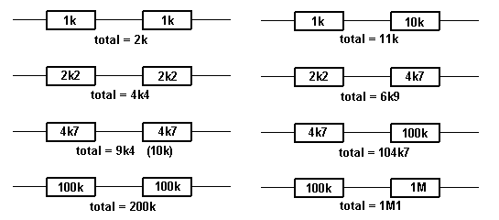
TWO EQUAL-VALUE RESISTORS IN PARALLEL
Two equal-value resistors IN PARALLEL creates a value of HALF. Three equal-value resistors in parallel is equal to one-third the value.
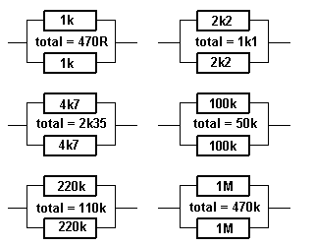
If you want a particular value and it is not available, here is a chart.
Use 2 resistors in series or parallel as shown:
Required  Value | R1 | Series/  Parallel | R2 | Actual  value:
10 | 4R7 | S | 4R7 | 9R4
12 | 10 | S | 2R2 | 12R2
15 | 22 | P | 47 | 14R9
18 | 22 | P | 100 | 18R
22 | 10 | S | 12 | 22
27 | 22 | S | 4R7 | 26R7
33 | 22 | S | 10 | 32R
39 | 220 | P | 47 | 38R7
47 | 22 | S | 27 | 49
56 | 47 | S | 10 | 57
68 | 33 | S | 33 | 66
82 | 27 | S | 56 | 83
There are other ways to combine 2 resistors in parallel or series to get a particular value. The examples above are just one way. 4R7 = 4.7 ohms
TESTING A RESISTOR
To check the value of a resistor, it should be removed from the circuit. The surrounding components can affect the reading and make it lower.
Resistors VERY RARELY change value, but if it is overheated or damaged, the resistance can increase. You can take the reading of a resistor "in-circuit" in one direction then the other, as the surrounding components may have diodes and this will alter the reading.
You can also test a resistor by feeling its temperature-rise. It is getting too hot if you cannot hold your finger on it (some "metal film" resistors are designed to tolerate quite high temperatures).
TESTING AN "AC" RESISTOR
There is no such thing as an "AC" resistor. Resistors are just "resistors" and they can be in AC circuits or DC circuits. Resistors can be given names such as "Safety Resistor" "Ballast Resistor" "LOAD Resistor" "Feed Resistor" "Dropper Resistor" or "Supply Resistor." These are just normal resistors with a normal resistance - except a "Safety Resistor."
A safety resistor is made of a flame-proof material such as metal-oxide-film and not carbon-composition. It is designed to "burn out" when too much current flows BUT NOT CATCH FIRE.
It is a low-value resistor and has a voltage-drop across it but this is not intentional. The voltage-drop is to create a "heating-effect" to burn out the resistor. In all the other types of resistor, the voltage-drop is intentional.
A Ballast resistor is a normal resistor and can be called a Power resistor, Dropper resistor, Supply resistor or Feed resistor. It is designed to reduce the voltage from one source and deliver a lower voltage. It is a form of: "in-line" resistor.
A Load Resistor is generally connected across the output of a circuit and turns the energy it receives, into heat.
RESISTOR NETWORKS
To reduce the number of resistors in a circuit, some engineers use a set of identical resistors in a package called a Single-In-Line (SIL) resistor network. It is made with many resistors of the same value, all in one package. One end of each resistor is connected all the other resistors and this is the common pin, identified as pin 1 and has a dot on the package.
These packages are very reliable but to make sure all the resistors are as stated, you need to locate pin 1. All values will be identical when referenced to this pin.
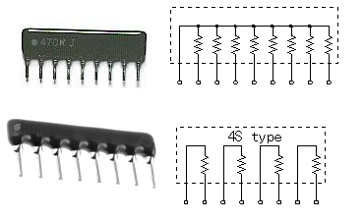
RESISTOR NETWORKS
Some resistor networks have a "4S" printed on the component. The 4S indicates the package contains 4 independent resistors that are not wired together inside. The housing has eight leads as shown in the second image.
Independent resistors have an even number of pins and measuring between each pair will produce identical values. Resistance between any pair will indicate leakage and may be a fault.
WIRE WOUND RESISTOR
A wire wound resistor is also called a POWER RESISTOR. This type of resistor can have a resistance as low as 0.1 ohms (one-tenth of an ohm) or as high as about 10k.
The image shows a 0.68 ohm resistor as the letter "R" represents the DECIMAL POINT and R68 is the same a .68 and this is 0.68 ohms. The wattage is 9 watts.
This resistor will allow xxx amps to flow. To work out the current, use the formula:
Power = Current x Current x resistance
9 = Current x Current x .68
Divide both sides by 0.68
13.2 = Current x Current
Find the square root of 13.2
Current = 3.6 amps
When 3.6 amps flow through the resistor, the voltage appearing across it will be:
V = current x resistance
= 3.6 x 0.68
= 2.5v and the wattage (heat) loss will be 9 watts.
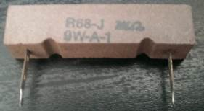
The purpose of a resistor like this is to stop or reduce "ripple." Ripple is the noise or hum in an amplifier when the sound is turned up.
There are many reasons why you need to reduce the level of hum and this resistor will remove ripple as large as 2.5v when 3.6 amps is flowing, provided you have filter electrolytics on both side of the resistor to assist in removing the ripple.
If the letter "R" is in a different position, the value of resistance would be:
68R = 68Ω
6R8 = 6.8Ω
R68 = 0.68Ω
If you replace the R68 resistor a 6R8 resistor by mistake, the voltage across it will rise to 25v and if 3.6 amps flows, the wattage will be: 90 watts!!!
The resistor will glow red and burn out.
TESTING A POSISTOR
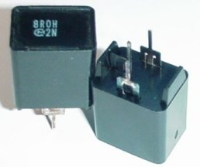
A Posistor is a resistor that connects in series with the degaussing coil around the picture tube or Monitor. When cold, it has a very low resistance and a large current flows when the monitor or TV is switched on. This current heats up the Posistor and the resistance increases. This causes the current to decrease and any magnetism in the shadow mask is removed. The posistor can one or two elements and it is kept warm so the resistance remains high. Many Posistors have a second element inside the case that connects directly to the supply to keep the Positive Temperature Coefficient resistor high so that the current through the degaussing coil falls to almost zero. This constant heat eventually destroys the package.
The heavy current that flows when a set is turned ON also causes the posistor to crack and break and this results in poor purity on the screen - as the shadow mask gradually becomes magnetic..
Posistors have different resistance values from different manufacturers and must be replaced with an identical type.
They can be checked for very low resistance when cold but any loose pieces inside the case will indicate a damaged component.
A "BURNT" RESISTOR - normally and technically called a "burnt-out" resistor.
The resistance of a "burnt" resistor can sometimes be determined by scraping away the outer coating - if the resistor has a spiral of resistance-material. You may be able to find a spot where the spiral has been damaged.
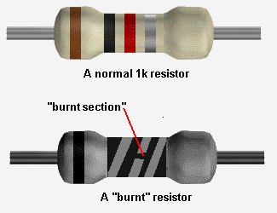
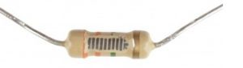
Note the spirals of conductive carbon.
The number of spirals has nothing to with the resistance.
It is the amount of carbon particles in the "track" that
determines the resistance. It is also the thickness and width
of the track that determines the resistance.
And then it is the overall size of the resistor that determines the wattage.
And then the size of the leads, the closeness to the PCB and
the size of the lands that eventually determines how hot the resistor
will get.
Clean the "spot" (burnt section of the spiral) very carefully and make sure you can get a good contact with the spiral and the tip of your probe. Measure from one lead of the resistor to the end of the damaged spiral. Then measure from the other lead to the other end of the spiral.
Add the two values and you have an approximate value for the resistor. You can add a small amount for the damaged section.
This process works very well for damaged wire-wound resistors. They can be pulled apart and each section of the resistance-wire (nichrome wire) measured and added to get the full resistance.
There is another way to determine the value of a damaged resistor.
Get a set of resistors of the same wattage as the damaged component and start with a high value. It's handy to know if the resistor is in the range: 10ohm to 100ohms or 1k to 10k etc, but this is not essential.
Start with a very high value and turn the circuit ON. You can perform voltage tests and if you know the expected output voltage, decrease the resistance until this voltage is obtained.
If you do not know the expected voltage, keep reducing the value of resistance until the circuit works as designed.
This is the best advice in a situation where you do not know the value of a resistor.
There is a third way to determine the value and this requires measuring the voltage drop across the resistor and the current-flow. By multiplying the two you will get a wattage and this must be less than the wattage of the resistor being replaced.
TESTING POTENTIOMETERS (variable resistors)
To check the value of a variable resistor, it should be removed from circuit or at least 2 legs should be removed. A Rheostat is a variable resistor using only one end and the middle connected to a circuit.
The resistance between the two outside pins is the value marked on the component and the centre leg will change from nearly zero to the full resistance as the shaft is rotated.
"Pots" generally suffer from "crackle" when turned and this can be fixed by spraying up the shaft and into the pot via the shaft with a tube fixed to a can of "spray-lubricant" (contact cleaner).
"Pre-set pots" and "trim pots" are miniature versions of a potentiometer and they are all tested the same. The photo shows a pot, two mini pots and 3 mini trim pots.
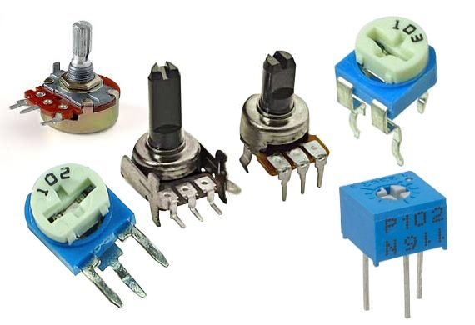
10-Turn POTs
A 10-turn pot is one of the worst items to be designed. I remove them immediately from any design.
You don't know the position of the wiper. You don't know which way you are turning the wiper and you can't remember which way you turned the post "the last time." The screwdriver always falls out of the slot.
If you need fine adjustment, place fixed resistors on each side of the pot and use a normal mini trim pot with much less resistance.
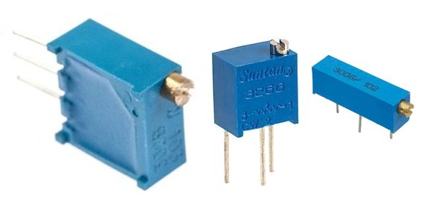
FOCUS POTS
Focus pots quite often get a spot of dirt where the wiper touches the track. Cleaning with spray fixes the bad focus but if the pot is leaking to chassis from inside the pot (due to the high voltage on the terminals) simply remove it from the chassis and leave it floating (this will restore the high voltage to the picture tube) or you can use one from an old chassis.
MAKING YOUR OWN RESISTOR, CAPACITOR, INDUCTOR or DIODE
Quite often you will not have the exact value of resistance or capacitance for a repair.
We have already covered placing resistors and capacitors in parallel and series:
Resistors in Parallel and/or Series
Capacitors in Parallel and/or Series
Here are some extras:
RESISTORS
Two 1k 0.5watt resistors in parallel produces a 470R 1watt resistor.
Two 1k 0.5watt resistors in series produces a 2k 1watt resistor.
CAPACITORS
Two 100n 100v capacitors in series produces a 50n capacitor @200v
INDUCTORS: Two inductors in series - ADD THE VALUES
DIODES: Two 1Amp 400v diodes in series produces a 1Amp 800v diode
Two 1Amp 400v diodes in parallel produces a 2Amp 400v diode
ZENER DIODES: Zener diodes can be connected in series to get a higher voltage.
Two 12v zener diodes in series produces a 24v zener.
CONTINUITY
Some multimeters have a "buzzer" that detects when the probes are touching each other or the resistance between the probes is very LOW. This is called a CONTINUITY TESTER.
You can use the resistance scale "x1" or "x10" to detect low values of resistance.
Set the pointer to "0" (right end of the scale) by touching the probes together and adjusting the "zero ohms" control.
When taking a reading, you will have to decide if a low value of resistance is a short-circuit or an "operating value."
For instance, the cold resistance of a 12v car globe is very low (about 2 ohms) and it increases (about 6 times) to 12 ohms when hot.
The "resistance of a circuit" may be very low as the electrolytics in the circuit are uncharged. This may not indicate a true "short-circuit."
The measurement across a diode is not a resistance-value but a "voltage-drop" and that is why the needle swings nearly full-scale.
Leads and wires and cords have a small resistance and depending on the length of the lead, this small resistance may be affecting a circuit.
Remember this:
When a circuit takes 1 amp, and the resistance of the leads is 1 ohm, the voltage drop across the leads will be 1v.
That's why a 12v battery supplying a circuit with these leads will have 11v at the circuit.
Note:
Turn off the equipment before making any continuity tests. The presence of even a small voltage (from an electrolytic) can give a false reading.
You can determine the resistance of a lead very accurately by taking the example above and applying it to your circuit.
If the battery is 12.6v and the voltage across the circuit is 10v, when the current is 2.6 amps, the resistance of the "leads" is 12.6 - 10 = 2.6 R=V/I = 2.6/2.6 = 1ohm. By making the lead shorter or using thicker wire, the resistance will be less and the voltage on the project will increase.
When taking readings in a circuit that has a number of diodes built-into IC's (Integrated Circuits) and transistors, some Continuity Testers will beep and give a false reading.
The following circuit has the advantage of providing a beep when a short-circuit is detected but does not detect the small voltage drop across a diode. This is ideal when testing logic circuits as it is quick and you can listen for the beep while concentrating on the probe. Using a multimeter is much slower.
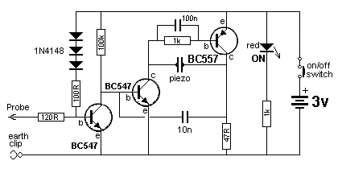
CONTINUITY TESTER
You can build the circuit on Matrix Board and add it to your Test Equipment.
You will need lots of "Test Equipment" and they can be built from circuits in this eBook.
TESTING FUSES, LEADS AND WIRES
All these components come under the heading TESTING for CONTINUITY. Turn off all power to the equipment before testing for shorts and continuity. Use the low resistance "Ohms Scale" or CONTINUITY range on your multimeter. All fuses, leads and wires should have a low, very low or zero resistance. This proves they are working.
A BLOWN FUSE
The appearance of a fuse after it has "blown" can tell you a lot about the fault in the circuit.
If the inside of the glass tube (of the fuse) is totally blackened, the fuse has been damaged very quickly. This indicates a very high current has passed through the fuse.
Depending on the rating of the fuse, (current rating) you will be able to look for components that can pass a high current when damaged - such as high power transistors, FETs, coils, electrolytics. Before re-connecting the supply, you should test the "SUPPLY RAILS" for resistance. This is done by measuring them on a low OHMs range in one direction then reverse the leads to see if the resistance is low in the other direction.
A reading can be very low at the start because electrolytics need time to charge-up and if the reading gradually increases, the power rail does not have a short. An overload can occur when the supply voltage rises to nearly full voltage, so you sometimes have to fit a fuse and see how long it takes to "blow."
If the fuse is just slightly damaged, you will need to read the next part of this eBook, to see how and why this happens:
FAST AND SLOW BLOW FUSES
There are many different sizes, shapes and ratings of a fuse. They are all current ratings as a fuse does not have a voltage rating. Some fuses are designed for cars as they fit into the special fuse holders. A fuse can be designed for 50mA, 100mA, 250mA, 315mA, 500mA, 1Amp, 1.5amp, 2amp, 3amp, 3.15amp 5amp, 10amp, 15amp, 20amp, 25amp, 30amp, 35amp, 50amp and higher.
Some fuses are fast-blow and some are slow-blow.
A "normal" fuse consists of a length of thin wire. Or it may be a loop of wire that is thin near the middle of the fuse. This is the section that will "burn-out."
A "normal" fuse is a fast-blow fuse. For instance, a 1amp fuse will remain intact when up to 1.25 amp flows. When a circuit is turned on, it may take 2-3 amps for a very short period of time and a normal 1 amp fuse will get very hot and the wire will stretch but not "burn-out." You can see the wire move when the supply turns on.
If the current increases to 2amps, the fuse will still remain intact. It needs about 3 amp to heat up the wire to red-hot and burn out.
If the current increases to 5 amp, the wire VOLATILISES (burns-out) and deposits carbon-black on the inside of the glass tube.
A slow-blow fuse uses a slightly thicker piece of wire and the fuse is made of two pieces of wire joined in the middle with a dob of low-temperature solder. Sometimes one of the pieces of wire is a spring and when the current rises to 2.5 amp, the heat generated in the wire melts the solder and the two pieces of wire "spring apart."
A slow-blow fuse will allow a higher current-surge to pass through the fuse and the wire will not heat up and sag.
Thus the fuse is not gradually being damaged and it will remain in a perfect state for a long period of time.
A fuse does not protect electronic equipment from failing. It acts AFTER the equipment has failed.
It will then protect a power supply from delivering a high current to a circuit that has failed.
If a slow-blow fuse has melted the solder, it could be due to a slight overload, slight weakening of the fuse over a period of time or the current-rating may be too low.
You can try another fuse to see what happens.
You can replace a fast-acting fuse (normal fuse) with a slow blow if the fast-acting fuse has been replaced a few times due to deterioration when the equipment is turned on.
But you cannot replace a slow-blow fuse with a fast acting fuse as it will be damaged slightly each time the equipment is turned on and eventually fail.
100mA FUSES
Fuses below about 100mA are very hard to make and very unreliable.
Many circuits take a high current when turned to charge the electrolytics and a 100mA (or 50mA or 63mA fuse) will bow and stretch and change shape, every time the equipment is turned ON.
Eventually it will break, due to it heating-up and stretching.
To produce a reliable fuse below 100mA, some manufacturers have placed a resistor inside the fuse and connected it to a spring. One end of the resistor is soldered to a wire with low-temperature metal and when the resistor gets hot, the metal softens and the spring pulls the resistor away from the wire.
Quite often you can heat up the metal and connect the wire and the fuse is perfect.
This type of fuse is called a DELAY fuse and the current rating is shown on the end-cap.
The value of the resistor determines the current rating.
There is a small voltage across this type of fuse and it means the circuit sees a slightly lower voltage than the supply voltage.
The third photo shows the pot of solder or low-temp metal and a wire connected to a spring. The heat generated in the wire is passed to the solder and it softens. The spring pulls the two components apart. You can smash the glass and set up the fuse in the two fuse-holders and repair the fuse while you wait for a new fuse to arrive.
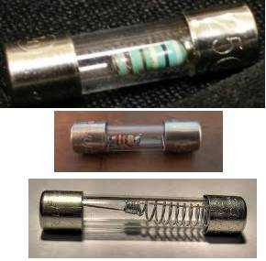
TESTING COILS, INDUCTORS and YOKES
Coils, inductors, chokes and yokes are just coils (turns) of wire. The wire may be wrapped around a core made of iron or ferrite.
It is labeled "L" on a circuit board.
You can test this component for continuity between the ends of the winding and also make sure there is no continuity between the winding and the core.
The winding can be less than one ohm, or greater than 100 ohms. A coil of wire is also called an INDUCTOR and it might look like a very simple component, but it can operate in a very complex way.
The way it works is a discussion for another eBook. It is important to understand the turns are insulated but a slight fracture in the insulation can cause two turns to touch each other and this is called a "SHORTED TURN" or you can say the inductor has "SHORTED TURNS."
When this happens, the inductor allows the circuit to draw MORE CURRENT. This causes the fuse to "blow."
The quickest way to check an inductor is to replace it, but if you want to measure the inductance, you can use an INDUCTANCE METER. You can then compare the inductance with a known good component.
An inductor with a shorted turn will have a very low or zero inductance, however you may not be able to detect the fault when it is not working in a circuit as the fault may be created by a high voltage generated between two of the turns.
Faulty yokes (both horizontal and vertical windings) can cause the picture to reduce in size and/or bend or produce a single horizontal line.
A TV or monitor screen is the best piece of Test Equipment as it has identified the fault. It is pointless trying to test the windings further as you will not be able to test them under full operating conditions. The fault may not show up when a low voltage (test voltage) is applied.
MEASURING AND TESTING INDUCTORS
Inductors are measured with an INDUCTANCE METER but the value of some inductors is very small and some Inductance Meters do not give an accurate reading.
The solution is to measure a larger inductor and note the reading. Now put the two inductors in SERIES and the values ADD UP - just like resistors in SERIES. This way you can measure very small inductors. VERY CLEVER!
Question from a reader: Can I add an inductor to stop a fuse blowing?
Basically, an inductor NEVER prevents a fuse blowing because an inductor prevents spikes on one lead (we will call the INPUT lead), appearing on its other lead.
This is the detection and prevention of current that exists for a very short period of time.
A fuse detects an excess of current that occurs over a very long period of time and they are entirely two different "detectors."
One cannot assist the other in any way.
An inductor is basically a coil of wire. It may be thick or thin wire. The value of the inductor is a combination of the number of turns and the material on which the wire is wound.
The value of an inductor does not change over say a period of 20 years but it can go faulty by the enamel cracking and two turns touching. This can also be due to the difference in voltage between the two turns creating a spark between the turns and creating a "short."
When you test it, the high voltage is not present and it will test ok.
You may not think a few turns of wire will have any effect on improving a circuit, but spikes are very high frequency and the inductor will have a very big effect on reducing them.
An inductor (say 100uH) can be produced in many different sizes and the thickness of the wire will be important as it determines the current that can flow through the inductor.
The term "inductor" also includes those with two or more windings and these components are called TRANSFORMERS. These devices can get "shorts" and "leaks" between the windings and sparks can be seen between the windings. These sparks do not occur when you are testing them on test-equipment so the only way to guarantee success is to replace it with an identical replacement.
TESTING SWITCHES and RELAYS
Switches and relays have contacts that open and close mechanically and you can test them for CONTINUITY. However these components can become intermittent due to dirt or pitting of the surface of the contacts due to arcing as the switch is opened.
It is best to test these items when the operating voltage and current is present as they quite often fail due to the arcing. A switch can work 49 times then fail on each 50th operation. The same with a relay. It can fail one time in 50 due to CONTACT WEAR.
If the contacts do not touch each other with a large amount of force and with a large amount of the metal touching, the current flowing through the contacts will create HEAT and this will damage the metal and sometimes reduce the pressure holding the contact together.
This causes more arcing and eventually the switch heats up and starts to burn. Switches are the biggest causes of fire in electrical equipment and households.
A relay also has a set of contacts that can cause problems.
There are many different types of relays and basically they can be put into two groups.
1. An electromagnetic relay is a switch operated by magnetic force. This force is generated by current through a coil. The relay opens and closes a set of contacts.
The contacts allow a current to flow and this current can damage the contacts. Connect 5v or 12v to the coil (or 24v) and listen for the "click" of the points closing. Measure the resistance across the points to see if they are closing.
You really need to put a load on the points to see if they are clean and can carry a current.
The coil will work in either direction.
If not, the relay is possibly a CMOS relay or Solid State relay.
2. An electronic relay (Solid State Relay) does not have a winding. It works on the principle of an opto-coupler and uses a LED and Light Activated SCR or Opto-TRIAC to produce a low resistance on the output. The two pins that energise the relay (the two input pins) must be connected to 5v (or 12v) around the correct way as the voltage is driving a LED (with series resistor). The LED illuminates and activates a light-sensitive device.
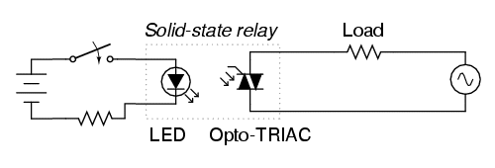
TESTING REED SWITCHES
A reed switch is generally contained in a long glass tube:
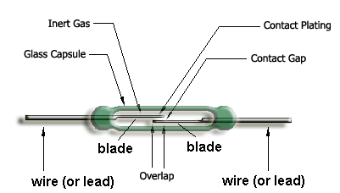
A wire or lead comes out each end for soldering to the reed switch to the project. The two "blades" inside the switch are made from a material that can be magnetised but does not retain its magnetism. This effect is called "temporally magnetised" (not permanently magnetised) and really only "passes" magnetism from one end to the other when in the presence of a magnet. One of the blades is made of a soft material and it will bend very easily. The other one is much stiffer.
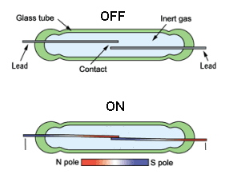
When a magnet is placed under the two blades (or on top), the magnetism from the magnet is passed to the two blades (INDUCTION or MUTUAL INDUCTION - commonly called INDUCED) and it produces a very weak magnet (in the blade) that is identical to the powerful magnet as far as the position of the north and south poles are concerned). Initially it produces a N-S and N-S set of poles and this makes the two blades click together because the top blade will be South at the contact and the bottom blade will be North.
When the two blades click together the magnetism runs through the two blades and keeps them together. The two blades attract and the switch is closed. When the magnet is removed, the magnetism in the two blades ceases and the two blades move apart.
Since there is a very small amount of movement in the top blade, this switch has a limited number of operations. Eventually it will fail. It is a mechanical device and is not suited for detecting a spinning shaft as 100,000 revolutions will very quickly weaken the switch.
If the switch does not make contact or remains closed, the moveable blade can be cracked or broken. This can be very hard to see. So replace the switch.
LATCHING REED SWITCH
A "normal" reed switch can be converted into a LATCHING REED SWITCH by carefully placing a magnet below the switch and moving it away so the two blades open. Now move it slightly closer but do not allow the blades to close.
This is called putting a "SET" on the switch and the two blades will have a small magnetic effect "induced" in them but not enough to close the contacts:
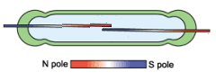
Now bring a strong magnet up to the reed switch on the other side of the glass tube with the north pole above the north of the lower magnet. This effect will increase the INDUCED MAGNETISM in the blades and close the contacts:
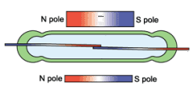
Remove the top magnet and the lower magnet will induce enough magnetism into the blades to keep them closed:
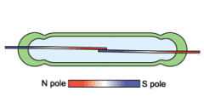
Now bring the upper magnet near the reed switch with the south pole above the north pole of the lower magnet. (In other words: AROUND THE OTHER WAY) This will have the effect of reducing the induced magnetism in the blades and a point will be reached when the two contacts will separate:
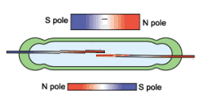
Remove the top magnet and the switch will remain separated because the lower magnet will not have sufficient influence on the blades to close the contact:
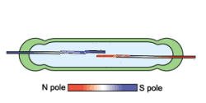
CAPACITORS
Capacitors are one of the most difficult things to test. That's because they don't give a reading on a multimeter and their value can range from 1p to 100,000u.
A faulty capacitor may be "open" when measured with a multimeter, and a good capacitor will also be "open."
You need a piece of test equipment called a CAPACITANCE METER to measure the value of a capacitor.
HOW A CAPACITOR WORKS
There are two ways to describe how a capacitor works. Both are correct and you have to combine them to get a full picture.
A capacitor has INFINITE resistance between one lead and the other.
This means no current flows through a capacitor. But it works in another way.
Suppose you have a strong magnet on one side of a door and a piece of metal on the other. By sliding the magnet up and down the door, the metal rises and falls.
The metal can be connected to a pump and you can pump water by sliding the magnet up and down.
A capacitor works in exactly the same way.
If you raise a voltage on one lead of a capacitor, the other lead will rise to the same voltage. This needs more explaining - we are keeping the discussion simple.
It works just like the magnetic field of the magnet through a door.
The next concept is this:
Capacitors are equivalent to a tiny rechargeable battery.
They store energy when the supply-voltage is present and release it when the supply drops.
These two concepts can be used in many ways and that's why capacitors perform tasks such as filtering, time-delays, passing a signal from one stage to another and create many different effects in a circuit.
CAPACITOR VALUES
The basic unit of capacitance is the FARAD. (C) This is the value used in all equations, but it is a very large value. A one FARAD capacitor would be the size of a car if made with plates and paper. Most electronic circuits use capacitors with smaller values such as 1p to 1,000u. 1p is about equal to two parallel wires 2cm long. 1p is one picofarad.
The easiest way to understand capacitor values is to start with a value of 1u. This is one microfarad and is one-millionth of a Farad. A 1 microfarad capacitor is about 1cm long and the diagram shows a 1u electrolytic.
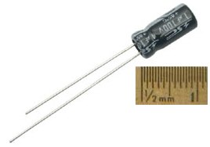
Smaller capacitors are ceramic and they look like the following. This is a 100n (0.1u)ceramic:
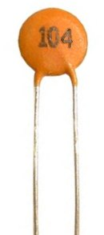
To read the value on a capacitor you need to know a few facts.
The basic value of capacitance is the FARAD.
1 microfarad is one millionth of 1 farad.
1 microfarad is divided into smaller parts called nanofarad.
1,000 nanofarad = 1 microfarad
Nanofarad is divided into small parts called picofarad
1,000 picofarad = 1 nanofarad.
Recapping:
1p = 1 picofarad. 1,000p = 1n ( 1 nanofarad)
1,000n = 1u (1 microfarad)
1,000u = 1millifarad
1,000,000u = 1 FARAD.
Examples:
All ceramic capacitors are marked in "p" (puff")
A ceramic with 22 is 22p = 22 picofarad
A ceramic with 47 is 47p = 47 picofarad
A ceramic with 470 is 470p = 470 picofarad
A ceramic with 471 is 470p = 470 picofarad
A ceramic with 102 is 1,000p = 1n
A ceramic with 223 is 22,000p = 22n
A ceramic with 104 is 100,000p = 100n = 0.1u
TYPES OF CAPACITOR
For testing purposes, there are two types of capacitor.
Capacitors from 1p to 100n are non-polar and can be inserted into a circuit around either way.
Capacitors from 1u to 100,000u are electrolytics and are polarised. They must be fitted so the positive lead goes to the supply voltage and the negative lead goes to ground (or earth).
There are many different sizes, shapes and types of capacitor. They are all the same. They consist of two plates with an insulating material between. The two plates can be stacked in layers or rolled together.
The important factor is the insulating material. It must be very thin to keep things small. This gives the capacitor its VOLTAGE RATING.
If a capacitor sees a voltage higher than its rating, the voltage will "jump through" the insulating material or around it.
If this happens, a carbon deposit is left behind and the capacitor becomes "leaky" or very low resistance, as carbon is conductive.
CERAMIC CAPACITORS
Nearly all small capacitors are ceramic capacitors as this material is cheap and the capacitor can be made in very thin layers to produced a high capacitance for the size of the component. This is especially true for surface-mount capacitors.
All capacitors are marked with a value and the basic unit is: "p" for "puff" However NO surface mount capacitors are marked and they are very difficult to test.
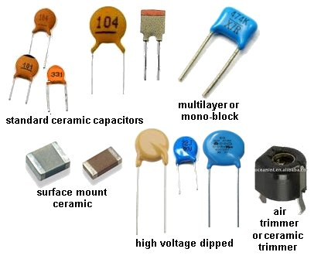
VALUE: | VALUE WRITTEN ON  THE COMPONENT:
0.1p  0.22p  0.47p  1.0p  2.2p  4.7p  5.6p  8.2p  10p  22p  47p  56p  100p  220p  470p  560p  820p  1,000p (1n)  2200p (2n2)  4700p (4n7)  8200p (8n2)  10n  22n  47n  100n  220n  470n  1u | 0p1  0p22  0p47  1p0  2p2  4p7  5p6  8p2  10 or 10p  22 or 22p  47 or 47p  56 or 56p  100 on 101  220 or 221  470 or 471  560 or 561  820 or 821  102  222  472  822  103  223  473  104  224  474  105
POLYESTER, POLYCARBONATE, POLYSTYRENE, MYLAR, METALLISED POLYESTER, ("POLY"), MICA and other types of CAPACITOR
There are many types of capacitor and they are chosen for their reliability, stability, temperate-range and cost.
For testing and repair work, they are all the same. Simply replace with exactly the same type and value.
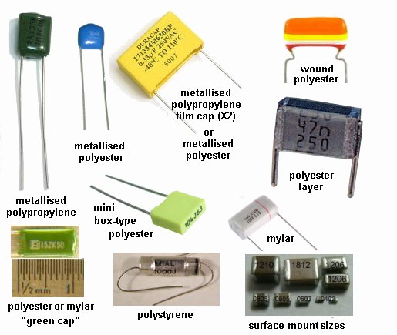

Capacitor Colour Code Table
Colour | Digit  A | Digit  B | Multiplier  D | Tolerance  (T) > 10pf | Tolerance  (T) < 10pf | Temperature Coefficient  (TC)
Black | 0 | 0 | x1 | ± 20% | ± 2.0pF
Brown | 1 | 1 | x10 | ± 1% | ± 0.1pF | -33x10⁻⁶
Red | 2 | 2 | x100 | ± 2% | ± 0.25pF | -75x10⁻⁶
Orange | 3 | 3 | x1,000 | ± 3% |  | -150x10⁻⁶
Yellow | 4 | 4 | x10,000 | ± 4% |  | -220x10⁻⁶
Green | 5 | 5 | x100,000 | ± 5% | ± 0.5pF | -330x10⁻⁶
Blue | 6 | 6 | x1,000,000 |  |  | -470x10⁻⁶
Violet | 7 | 7 |  |  |  | -750x10⁻⁶
Grey | 8 | 8 | x0.01 | +80%,-20%
White | 9 | 9 | x0.1 | ± 10% | ± 1.0pF
Gold |  |  | x0.1 | ± 5%
Silver |  |  | x0.01 | ± 10%
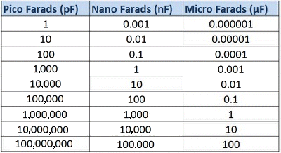
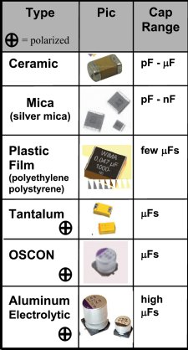
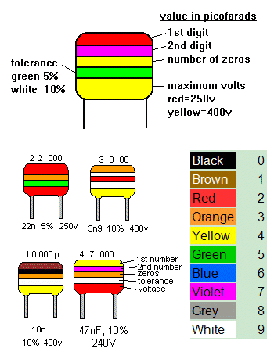
ELECTROLYTIC and TANTALUM CAPACITORS
Electrolytics and Tantalums are the same for testing purposes but their performance is slightly different in some circuits. A tantalum is smaller for the same rating as an electrolytic and has a better ability at delivering a current. They are available up to about 1,000u, at about 50v but their cost is much higher than an electrolytic.
Electrolytics are available in 1u, 2u2 3u3 4u7 10u, 22u, 47u, 100u, 220u, 330u, 470u, 1,000u, 2,200u, 3,300u, 4,700u, 10,000u and higher.
The "voltage" or "working voltage" can be: 3.3v, 10v, 16v, 25v, 63v, 100v, 200v and higher.
There is also another important factor that is rarely covered in text books. It is RIPPLE FACTOR.
This is the amount of current that can enter and leave an electrolytic. This current heats up the electrolytic and that is why some electrolytics are much larger than others, even though the capacitance and voltage-ratings are the same.
If you replace an electrolytic with a "miniature" version, it will heat up and have a very short life. This is especially important in power supplies where current (energy) is constantly entering and exiting the electrolytic as its main purpose is to provide a smooth output from a set of diodes that delivers "pulsing DC." (see "Power Diodes")
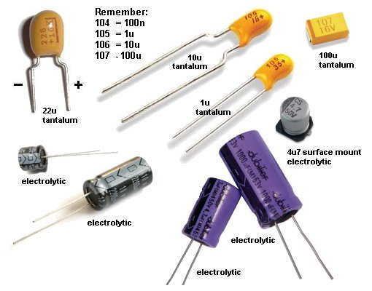
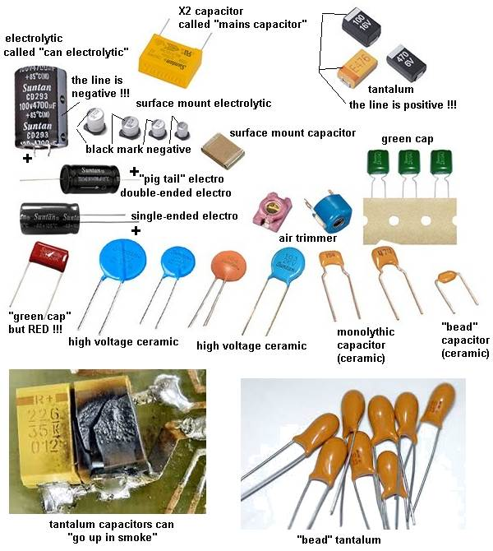
PARALLEL and SERIES CAPACITORS
Capacitors can be connected in PARALLEL and/or SERIES for a number of reasons.
1. If you do not have the exact value, two or more connected in parallel or series can produce the value you need.
2. Capacitors connected in series will produce one with a higher voltage rating.
3. Capacitors connected in parallel will produce a larger-value capacitance.
Here are examples of two equal capacitors connected in series or parallel and the results they produce:
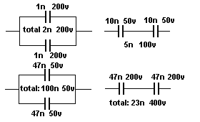
NON-POLAR CAPACITORS (ELECTROLYTICS)
Electrolytics are also available in non-polar values. It sometimes has the letters "NP" on the component. Sometimes the leads are not identified.
This is an electrolytic that does not have a positive and negative lead but two leads and either lead can be connected to the positive or negative of the circuit.
These electrolytics are usually connected to the output of an amplifier (such as in a filter near the speaker) where the signal is rising and falling.
A non-polar electrolytic can be created from two ordinary electrolytics by connecting the negative leads together and the two positive leads become the new leads.
For example: two 100u 63v electrolytics will produce a 47u 63v non-polar electrolytic.
In the circuit below, the non-polar capacitor is replaced with two electrolytics.
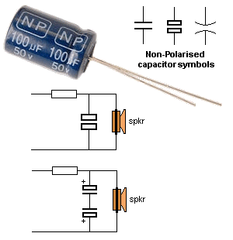
MAKING A NON-POLAR ELECTROLYTIC
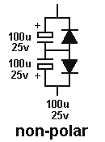
A normal electrolytic must be connected the correct way in a circuit because it has a thin insulating layer covering the plates that has a high resistance.
If you connect the electrolytic around the wrong way, this layer "breaks-down" and the resistance of the electrolytic becomes very small and a high current flows. This heats up the electrolytic and the current increases. Very soon the capacitor produces gasses and explodes.
One big mistake in many text books shows how to make a non-polar electrolytic by connecting two "back-to-back."
They claim 2 x 100u connected back-to-back is equal to 47u.
This appears to be case when testing on a meter but the meter simply charges them for a short period of time to get a reading.
If you allow them to charge fully you will find the reverse electrolytic has a very small voltage across it.
Secondly, when you are charging them, you are putting a high current through the reverse electrolytic and damaging the layer.
To prevent this, you need to add two diodes as shown in the diagram.
In addition, 2 x 100u "back-to-back" is very near 100u.
Here is a question from a reader:
I have an amplifier with 2 x2,200u electrolytics on the output of a bridge. Can I replace them with a single 10,000u?
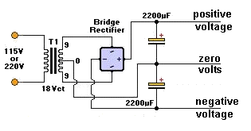
You need to look at the circuit of your amplifier. The two 2,200u electrolytics are possibly connected as shown in the circuit above and you will notice they are joined to produce a positive rail and a negative rail with zero (called earth) in the centre.
This forms two different circuits with the top electrolytic filtering the positive rail and the bottom electro filtering the negative rail. They must be connected to the zero volts rail.
A single 10,000u cannot be connected to the 0v rail and cannot be substituted for the two electro's.
You can easily determine of the two electro's are connected as shown above.
Test the positive terminal of each electro by placing the negative of the meter on the chassis.
If the positive of one electro have zero volts, it will be the lower electro in the diagram above. The negative terminal of the electro will have a minus voltage on it.
VOLTAGE RATING OF CAPACITOR
Capacitors have a voltage rating, stated as WV for working voltage, or WVDC. This specifies the maximum voltage that can be applied across the capacitor without puncturing the dielectric. Voltage ratings for "poly," mica and ceramic capacitors are typically 50v to 500 VDC. Ceramic capacitors with ratings of 1kv to 5kv are also available. Electrolytic capacitors are commonly available in 6v, 10v 16v, 25v, 50v, 100v, 150v, and 450v ratings.
THE SIZE OF A CAPACITOR - RIPPLE FACTOR
The size of a capacitor depends on a number of factors, namely the value of the capacitor (in microfarads etc) and the voltage rating. But there is also another factor that is most important. It is the RIPPLE FACTOR. Ripple Factor is the amount of voltage-fluctuation the capacitor (electrolytic) can withstand without getting too hot.
When current flows in and out of an electrolytic, it gets hot and this will eventually dry-out the capacitor as some of the liquid inside the capacitor escapes through the seal. It's a very slow process but over a period of years, the capacitor looses its capacitance.
If you have two identical 1,000u 35v electrolytics and one is smaller, it will get hotter when operating in a circuit and that's why it is necessary to choose the largest electrolytic.
CAUTION
If a capacitor has a voltage rating of 63v, do not put it in a 100v circuit as the insulation (called the dielectric) will be punctured and the capacitor will "short-circuit." It's ok to replace a 0.22uF 50WV capacitor with 0.22uF 250WVDC.
SAFETY
A capacitor can store a charge for a period of time after the equipment is turned off. High voltage electrolytic caps can pose a safety hazard. These capacitors are in power supplies and some have a resistor across them, called a bleed resistor, to discharge the cap after power is switched off.
If a bleed resistor is not present the cap can retain a charge after the equipment is unplugged.
How to discharge a capacitor
Do not use a screwdriver to short between the terminals as this will damage the capacitor internally and the screwdriver.
Use a 1k 1 watt or 3watt or 5watt resistor on jumper leads (or held with pliers) and keep them connected for up to 15 seconds to fully discharge the electro.
Test it with a voltmeter to make sure all the energy has been removed.
Before testing any capacitors, especially electrolytics, you should look to see if any are damaged, overheated or leaking. Swelling at the top of an electrolytic indicates heating (and pressure inside the case) and will result in drying out of the electrolyte. Any hot or warm electrolytic indicates leakage and ceramic capacitors with portions missing indicates something has gone wrong (such as it being "blown apart").
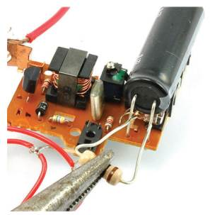
Here is a 120u 330v electrolytic from a flash circuit in an old-fashioned film camera.
If the flash does not "fire," the electrolytic will be charged to about 350 volts !!
Use a 1k resistor (held with pliers) to slowly discharge it. It may take 15 seconds to fully discharge.
TESTING A CAPACITOR
There are two things you can test with a multimeter:
1. A short-circuit within the capacitor
2. Capacitor values above 1u.
You can test capacitors in-circuit for short-circuits. Use the x1 ohms range.
To test a capacitor for leakage, you need to remove it or at least one lead must be removed. Use the x10k range on an analogue or digital multimeter.
For values above 1u you can determine if the capacitor is charging by using an analogue meter. The needle will initially move across the scale to indicate the cap is charging, then go to "no deflection." Any permanent deflection of the needle will indicate leakage.
You can reverse the probes to see if the needle moves in the opposite direction. This indicates it has been charged. Values below 1u will not respond to charging and the needle will not deflect.
This does not work with a digital meter as the resistance range does not output any current and the electrolytic does not charge.
Rather than spending money on a capacitance meter, it is cheaper to replace any suspect capacitor or electrolytic.
Capacitors can produce very unusual faults and no piece of test equipment is going to detect the problem.
In most cases, it is a simple matter to solder another capacitor across the suspect component and view or listen to the result.
This saves all the worry of removing the component and testing it with equipment that cannot possibly give you an accurate reading when the full voltage and current is not present.
It is complete madness to even think of testing critical components such as capacitors, with TEST EQUIPMENT. You are fooling yourself. If the Test Equipment says the component is ok, you will look somewhere else and waste a lot of time.
FINDING THE VALUE OF A CAPACITOR
If you want to find the value of a surface-mount capacitor or one where the markings have been removed, you will need a CAPACITANCE METER. Here is a simple circuit that can be added to your meter to read capacitor values from 10p to 10u.
The full article can be found HERE.
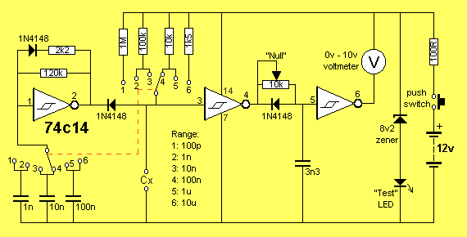
ADD-ON CAPACITANCE METER
CAPACITOR SUBSTITUTION BOX
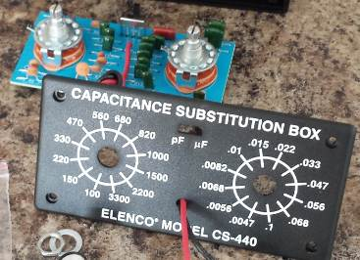
You can get a kit or a ready-made piece of test gear called CAPACITOR SUBSTITUTION BOX and also RESISTOR SUBSTITUTION BOX.
I bought one of each 30 years ago and I have only used them ONCE.
They appear to be very handy but when you are testing a circuit, you want the component next to the other parts.
It is just as easy to pick the component you need from your junk box and connect it to the circuit via jumper leads.
REPLACING A CAPACITOR
Always replace a capacitor with the exact same type.
A capacitor may be slightly important in a circuit or it might be extremely critical.
A manufacturer may have taken years to select the right type of capacitor due to previous failures.
A capacitor just doesn't have a "value of capacitance."
It may also has an effect called "tightening of the rails."
In other words, a capacitor has the ability to react quickly and either absorb or deliver energy to prevent spikes or fluctuations on the rail.
This is due to the way it is constructed. Some capacitors are simply plates of metal film while others are wound in a coil. Some capacitors are large while others are small.
They all react differently when the voltage fluctuates.
Not only this, but some capacitors are very stable and all these features go into the decision for the type of capacitor to use.
You can completely destroy the operation of a circuit by selecting the wrong type of capacitor.
No capacitor is perfect and when it gets charged or discharged, it appears to have a small value of resistance in series with the value of capacitance. This is known as "ESR" and stands for EQUIVALENT SERIES RESISTANCE. This effectively makes the capacitor slightly slower to charge and discharge.
We cannot go into the theory on selecting a capacitor as it would be larger than this eBook so the only solution is to replace a capacitor with an identical type.
However if you get more than one repair with identical faults, you should ask other technicians if the original capacitor comes from a faulty batch.
The author has fixed TV's and fax machines where the capacitors have been inferior and alternate types have solved the problem.
Some capacitor are suitable for high frequencies, others for low frequencies.
DECOUPLING CAPACITORS
A Decoupling Capacitor can severe one, two or three functions. You need to think of a decoupling capacitor as a miniature battery with the ability to deliver a brief pulse of energy when ever the line-voltage drops and also absorb a brief pulse of energy when ever the line voltage rises (or spikes).
Decoupling capacitor can range from 100n to 1,000u.
100n capacitors are designed to absorb spikes and also have the effect of tightening-up the rails for high frequencies. They have no effect on low frequencies such as audio frequencies.
These capacitors are generally ceramic and have very low internal impedance and thus they can operate at high frequencies.
Capacitors above about 10u are used for decoupling and these are nearly always electrolytics.
Decoupling means "tightening-up the power rails." The electrolytic acts just like a miniature rechargeable battery, supplying a small number of components in a circuit with a smooth and stable voltage.
The electrolytic is usually fed from a dropper resistor and this resistor charges the electrolytic and adds to the ability of the electrolytic to create a "separate power supply."
These two components help remove spikes as an electrolytic cannot remove spikes if connected directly to the supply rails - it's internal impedance is high and the spikes are not absorbed.
Decoupling capacitors are very difficult to test.
They rarely fail but if a project is suffering from unknown glitches and spikes, it is best to simply add more 100n decoupling caps on the underside of the board and replace all electrolytics.
Some small electrolytics will dry out due to faulty manufacture and simply replacing every one on a board will solve the problem.
Some of the functions of a decoupling capacitor are:
Removing ripple - hum or buzz in the background of an amplifier
Removing glitches or spikes.
Separating one stage from another to reduce or remove MOTORBOATING - a low frequency sound due to the output putting a pulse on the power rails that is picked up by the pre-amplifier section and amplified.
TESTING DIODES
Diodes can have 4 different faults.
1. Open circuit in both directions.
2. Low resistance in both directions.
3. Leaky.
4. Breakdown under load.
TESTING A DIODE ON AN ANALOGUE METER
Testing a diode with an Analogue Multimeter can be done on any of the resistance ranges. [The high resistance range is best - it sometimes has a high voltage battery for this range but this does not affect our testing]
There are two things you must remember.
1. When the diode is measured in one direction, the needle will not move at all. The technical term for this is the diode is reverse biased. It will not allow any current to flow. Thus the needle will not move.
When the diode is connected around the other way, the needle will swing to the right (move up scale) to about 80% of the scale. This position represents the voltage drop across the junction of the diode and is NOT a resistance value. If you change the resistance range, the needle will move to a slightly different position due to the resistances inside the meter. The technical term for this is the diode is forward biased. This indicates the diode is not faulty.
The needle will swing to a slightly different position for a "normal diode" compared to a Schottky diode. This is due to the different junction voltage drops.
However we are only testing the diode at very low voltage and it may break-down when fitted to a circuit due to a higher voltage being present or due to a high current flowing.
2. The leads of an Analogue Multimeter have the positive of the battery connected to the black probe and the readings of a "good diode" are shown in the following two diagrams:
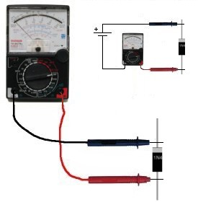
The diode is REVERSE BIASED in the
diagram above and diodes not conduct.
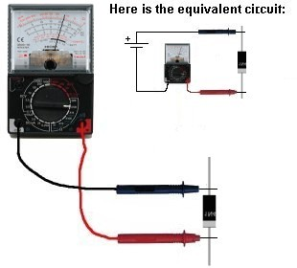
The diode is FORWARD BIASED in the
diagram above and it conducts
TESTING A DIODE ON A DIGITAL METER
Testing a diode with a Digital Meter must be done on the "DIODE" setting as a digital meter does not deliver a current through the probes on some of the resistance settings and will not produce an accurate reading.
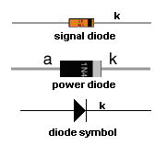
The best thing to do with a "suspect" diode is to replace it. This is because a diode has a number of characteristics that cannot be tested with simple equipment. Some diodes have a fast recovery for use in high frequency circuits. They conduct very quickly and turn off very quickly so the waveform is processed accurately and efficiently.
If the diode is replaced with an ordinary diode, it will heat up as does not have the high-speed characteristic.
Other diodes have a low drop across them and if an ordinary is used, it will heat up.
Most diodes fail by going: SHORT-CIRCUIT. This can be detected by a low resistance (x1 or x10 Ohms range) in both directions.
A diode can also go OPEN CIRCUIT. To locate this fault, place an identical diode across the diode being tested.
A leaky diode can be detected by a low reading in one direction and a slight reading the other direction.
However this type of fault can only be detected when the circuit is working. The output of the circuit will be low and sometimes the diode heats up (more than normal).
A diode can go open under full load conditions and perform intermittently.
Diodes come in pairs in surface-mount packages and 4 diodes can be found in a bridge.
They are also available in pairs that look like a 3-leaded transistor.
The line on the end of the body of a diode indicates the cathode and you cannot say "this is the positive lead." The correct way to describe the leads is to say the "cathode lead." The other lead is the anode. The cathode is defined as the electrode (or lead) through which an electric current flows out of a device.
The following diagrams show different types of diodes:
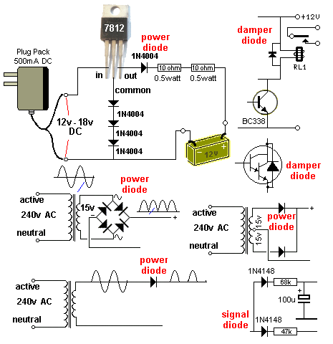
POWER DIODES
To understand how a power diode works, we need to describe a few things. This has NEVER been described before, so read carefully.
The 240v AC (called the "mains") consists of two wires, one is called the ACTIVE and the other is NEUTRAL. Suppose you touch both wires. You will get a shock. The neutral is connected to an earth wire (or rod driven into the ground or connected to a water pipe) at the point where the electricity enters the premises and you do not get a shock from the NEUTRAL.
But the voltage on the active is rising to +345v then goes to -345v at the rate of 50 times per second (for a complete cycle).
345v is the peak voltage of 240v. You never get a 240v shock. (It is a 345v shock.)
In other words, if you touch the two wires at a particular instant, you would get a POSITIVE 345v shock and at another instant you would get a negative 345v shock. This is shown in the diagram below.
We now transfer this concept to the output of a transformer. The diagram shows an AC waveform on the output of the secondary.
This voltage is rising 15v higher than the bottom lead then it is 15v LOWER than the bottom lead. The bottom lead is called "zero volts." You have to say one lead or wire is not "rising and falling" as you need a "reference" or starting-point" or "zero point" for voltage measurements.
The diode only conducts when the voltage is "above zero" (actually when it is 0.7v above zero) and does not conduct (at all) when the voltage goes below zero.
This is shown on the output of the Power Diode. Only the positive peaks or the positive parts of the waveform appear on the output and this is called "pulsing DC." This is called "half-wave" and is not used in a power supply. We have used it to describe how the diode works. The electrolytics charge during the peaks and deliver energy when the diode is not delivering current. This is how the output becomes a steady DC voltage.
Power supplies use FULL WAVE rectification and the other half of the AC waveform is delivered to the output (and fills in the "gaps") and appears as shown in "A."
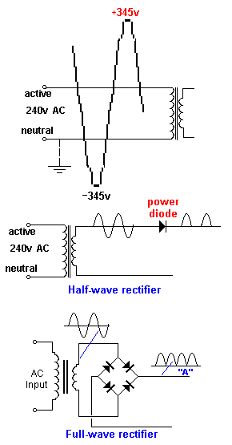
ONE FAULTY DIODE
One diode in a bridge can go open (any of the 4 diodes will produce the same effect) and produce an output voltage that can be slightly lower than the original voltage. The actual "voltage-drop" will depend on the current taken by the circuit and the ability of the transformer to produce the required voltage and current during half-wave operation. The voltage during each half cycle (when none of the diodes is delivering any energy to the circuit) is maintained by the electrolytic and its size (relative to the current taken by the circuit) will determine the size of the ripple that will result when the diode fails. The ripple will be 100 to 1,000 times greater after the failure of a diode, depending on the value of the filter capacitor.
To locate the faulty diode, simply get a diode and place it across each of the diodes in the bridge (in turn) when the circuit is working.
For a bridge rectifier, the ripple-frequency will be twice the mains frequency and its ripple will be very small if the electrolytic is the correct value. When a diode fails, the ripple-frequency will be equal to mains-frequency and the amplitude will increase considerably. You may even hear background hum from audio equipment.
If you cannot find a faulty diode, the filter capacitor will be at fault. Turn off the equipment and connect an electrolytic across the filter capacitor via jumper leads. Turn the power ON and see if the hum has reduced.
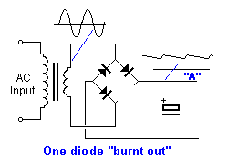
DAMPER DIODES
A damper diode is a diode that detects a high voltage and SQUELCHES IT (reduces it - removes it). The signal that it squelches is a voltage that is in the opposite direction to the "supply voltage" and is produced by the collapsing of a magnetic field. Whenever a magnetic filed collapses, it produces a voltage in the winding that is opposite to the supply voltage and can be much higher. This is the principle of a flyback circuit or EHT circuit. The high voltage comes from the transformer.
The diode is placed so that the signal passes through it and less than 0.5v appears across it.
A damper diode can be placed across the coil of a relay, incorporated into a transistor or FET or placed across a winding of a flyback transformer to protect the driving transistor or FET.
It can also be called a "Reverse-Voltage Protection Diode," "Spike Suppression Diode," or "Voltage Clamp Diode."
The main characteristic of a Damper Diode is HIGH SPEED so it can detect the spike and absorb the energy.
It does not have to be a high-voltage diode as the high voltage in the circuit is being absorbed by the diode.
SILICON, GERMANIUM AND SCHOTTKY DIODES
When testing a diode with an analogue meter, you will get a low reading in one direction and a high (or NO READING) in the other direction. When reading in the LOW direction, the needle will swing nearly full scale and the reading is not a resistance-value but a reflection of the characteristic voltage drop across the junction of the diode. As we mentioned before, a resistance reading is really a voltage reading and the meter is measuring the voltage of the battery minus the voltage-drop across the diode.
Since Silicon, Germanium and Schottky Diodes have slightly different characteristic voltage drops across the junction, you will get a slightly different reading on the scale. This does not represent one diode being better than the other or capable of handling a higher current or any other feature.
The quickest, easiest and cheapest way to find, fix and solve a problem caused by a faulty diode is to replace it.
There is no piece of test equipment capable of testing a diode fully, and the circuit you are working on is actually the best piece of test equipment as it is identifying the fault UNDER LOAD.
Only very simple tests can be done with a multimeter and it is best to check a diode with an ANALOGUE MULTIMETER as it outputs a higher current though the diode and produces a more-reliable result.
A Digital meter can produce false readings as it does not apply enough current to activate the junction.
Fortunately almost every digital multimeter has a diode test mode. Using this, a silicon diode should read a voltage drop between 0.5v to 0.8v in the forward direction and open in the reverse direction. For a germanium diode, the reading will be lower, around 0.2v - 0.4v in the forward direction. A bad diode will read zero volts in both directions.
REPLACING A DIODE
It is alway best to replace a diode with the same type but quite often this is not possible. Many diodes have unusual markings or colours or "in-house" letters.
This is only a general guide because many diodes have special features, especially when used in high-frequency circuits.
However if you are desperate to get a piece of equipment working, here are the steps:
Determine if the diode is a signal diode, power diode, or zener diode.
For a signal diode, try 1N4148.
For a power diode (1 amp) try 1N4004. (for up to 400v)
For a power diode (3 amp) try 1N5404. (for up to 400v)
For a high-speed diode, try UF4004 (for up to 400v)
If you put an ordinary diode in a high-speed application, it will get very hot very quickly.
To replace an unknown zener diode, start with a low voltage such as 6v2 and see if the circuit works.
The size of a diode and the thickness of the leads will give an idea of the current-capability of the diode.
Keep the leads short as the PC board acts as a heat-sink.
You can also add fins to the leads to keep the diode cool.
LIGHT EMITTING DIODES (LEDs)
Light Emitting Diodes (LEDs) are diodes that produce light when current flows from anode to cathode. The LED does not emit light when it is revered-biased. It is used as a low current indicator in many types of consumer and industrial equipment, such as monitors, TV’s, printers, hi-fi systems, machinery and control panels.
The light produced by a LED can be visible, such as red, green, yellow or white. It can also be invisible and these LEDs are called Infrared LEDs. They are used in remote controls and to see if they are working, you need to point a digital camera at the LED and view the picture on the camera screen.
An LED needs about 2v - 3.6v across its leads to make it emit light, but this voltage must be exact for the type and colour of the LED. The simplest way to deliver the exact voltage is to have a supply that is higher than needed and include a voltage-dropping resistor. The value of the resistor must be selected so the current is between 2mA and 25mA.
The cathode of the LED is identified by a flat on the side of the LED. The life expectancy of a LED is about 100,000 hours. LEDs rarely fail but they are very sensitive to heat and they must be soldered and de-soldered quickly. They are one of the most heat-sensitive components.
Light emitting diodes cannot be tested with most multimeters because the characteristic voltage across them is higher than the voltage of the battery in the meter.
However a simple tester can be made by joining 3 cells together with a 220R resistor and 2 alligator clips:
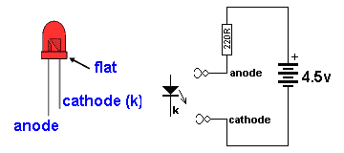
LED TESTER
Connect the clips to a LED and it will illuminate in only one direction.
The colour of the LED will determine the voltage across it. You can measure this voltage if you want to match two or more LEDs for identical operation.
Red LEDs are generally 1.7v to 1.9v. - depending on the quality such as "high-bright"
Green LEDs are 1.9v to 2.3v.
Orange LEDs are about 2.3v and
White LEDs and IR LEDs are about 3.3v to 3.6v.
The illumination produced by a LED is determined by the quality of the crystal. It is the crystal that produces the colour and you need to replace a LED with the same quality to achieve the same illumination.
Never connect a LED across a battery (such as 6v or 9v), as it will be instantly damaged. You must have a resistor in series with the LED to limit the current.
ZENER DIODES
All diodes are Zener diodes. For instance a 1N4148 is a 120v zener diode as this is its reverse breakdown voltage.
And a zener diode can be used as an ordinary diode in a circuit with a voltage that is below the zener value.
For instance, 20v zener diodes can be used in a 12v power supply as the voltage never reaches 20v, and the zener characteristic is never reached.
Most diodes have a reverse breakdown voltage above 100v, while most zeners are below 70v. A 24v zener can be created by using two 12v zeners in series and a normal diode has a characteristic voltage of 0.7v. This can be used to increase the voltage of a zener diode by 0.7v. See the diagram above. It uses 3 ordinary diodes to increase the output voltage of a 3-terminal regulator by 2.1v.
To tests a zener diode you need a power supply about 10v higher than the zener of the diode. Connect the zener across the supply with a 1k to 4k7 resistor and measure the voltage across the diode. If it measures less than 1v, reverse the zener.
If the reading is high or low in both directions, the zener is damaged.
Here is a zener diode tester. The circuit will test up to 56v zeners.
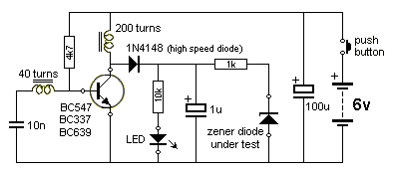
ZENER DIODE TESTER
TRANSFORMERLESS POWER SUPPLY
Here's a circuit that uses zener diodes in a power supply to show how they work. This clever design uses 4 diodes in a bridge to produce a fixed voltage power supply capable of supplying 35mA.
If we put 2 zener diodes in a bridge with two ordinary power diodes, the bridge will break-down at the voltage of the zener. This is what we have done. If we use 18v zeners, the output will be 17v4.
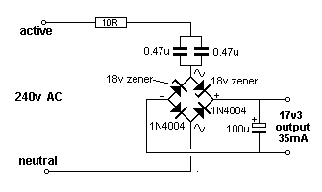
SUPPLY USING ZENER DIODES
When the incoming voltage is positive at the top, the left zener provides 18v limit (and the other zener produces a drop of 0.6v). This allows the right zener to pass current just like a normal diode. The output is 17v4. The same with the other half-cycle.
You cannot use this type of bridge in a normal power supply as the zener diode will "short" when the input voltage reaches the zener value. The concept only works in the circuit above.
VOLTAGE REGULATORS
A Voltage Regulator takes a high input voltage and delivers a fixed output voltage.
Providing the input voltage is 4v above the output voltage, the regulator will deliver a fixed output voltage with almost no ripple.
Voltage regulators are also called "3-TERMINAL REGULATORS" or "REGULATOR IC's" - although this name is not generally used.
In most cases, a voltage regulator gets quite hot and for this reason it has a high failure-rate.
If a regulator is not getting hot (or warm) it has either failed or the circuit is not operating.
A regulator can only decrease the voltage. It cannot increase the current. This means the current being supplied to a circuit must also be available from the circuit supplying the regulator.
All regulators have different pin-outs, so you need to find the input pin and output pin and make sure the voltage-difference is at least 4v. Some regulators will work with a difference as low as 1v, so you need to read the specifications for the type you are servicing.
Some regulators are called “negative voltage regulators” and the input voltage will be negative and the output will be negative.
You need to test a voltage regulator with the power "ON".
Make sure you do not allow the probes to short any of the pins together as this will destroy the regulator or the circuit being supplied.
With the power turned off or the regulator removed from the circuit, you can test it with a multimeter set to resistance to see if it is ok. If any resistance readings are very low or zero ohms, the regulator is damaged.
TRANSFORMERS
All transformers and coils are tested the same way. This includes chokes, coils, inductors, yokes, power transformers, EHT transformers (flyback transformers), switch mode transformers, isolation transformers, IF transformers, baluns, and any device that has turns of wire around a former. All these devices can go faulty.
The coating on the wire is called insulation or "enamel" and this can crack or become overheated or damaged due to vibration or movement. When two turns touch each other, a very interesting thing happens. The winding becomes two separate windings.
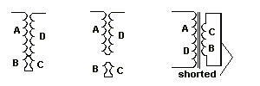
We will take the case of a single winding such as a coil. This is shown in the first diagram above and the winding is wound across a former (a former is a bobbin or plastic molding or something to hold the winding) and back again, making two layers. The bottom and top layers touch at the point shown in the diagram and the current that originally passed though A, B, C, D now passes though A & D.
Winding B C becomes a separate winding as shown in the second diagram.
In other words the coil becomes a TRANSFORMER with a SHORT CIRCUIT on the secondary winding as shown in the third diagram.
When the output wires of a transformer are shorted together, it delivers a very high current because you have created a SHORT-CIRCUIT. This short-circuit causes the transformer to get very hot.
That’s exactly what happens when any coil or transformer gets a “shorted turn.”
The shorted turns can be a single turn or many turns.
It is not possible to measure a fault like this with a multimeter as you don’t know the exact resistance of a working coil or winding and the resistance of a faulty winding may be only 0.001 ohms less.
However when a transformer or coil is measured with an inductance meter, an oscillating voltage (or spike) is delivered into the core as magnetic flux, then the magnetic flux collapses and passes the energy into the winding to produce a waveform. The inductance meter reads this and produces a value of inductance in Henry (or milliHenry or microHenry.)
This is done with the transformer removed from the circuit and this can be a very difficult thing to do, as most transformers have a number of connections.
If the coil or transformer has a shorted turn, the energy from the magnetic flux will pass into the turns that are shorted and produce a current. Almost no voltage will be detected from winding.
The reading from the inductance meter will be low or very low and you have to work out if it is correct.
However there is one major problem with measuring a faulty transformer or coil.
It may only become faulty when power is applied.
The voltage between the turns may be sparking or jumping a gap and creating a problem. A tester is not going to find this fault.
Secondly, an inductance meter may produce a reading but you do not know if the reading is correct. An improved tester is a RING TESTER.
The circuit for a ring tester can be found here:
http://www.flippers.com/pdfs/k7205.pdf
It sends a pulse to the coil and counts the number of returning pulses or "rings." A faulty coil (or winding) may return one pulse but nearly all the energy will be passed to the shorted turns and you will be able to see this on the scale. You will only get one or two return pulses, whereas a good winding will return more pulses.
One way to detect a faulty power transformer is to connect it to the supply and feel the temperature-rise (when nothing is connected to the secondary).
It should NOT get hot.
Detecting shorted turns is not easy to diagnose as you really need another identical component to compare the results.
Most transformers get very hot when a shorted turn has developed. It may deliver a voltage but the heat generated and a smell from the transformer will indicate a fault.
ISOLATION TRANSFORMER
An isolation transformer is a piece of Test Equipment that provides "Mains Voltage" but the voltage is "floating." You will still get a shock if you touch the two output leads, but it has a special use when testing unknown equipment.
Many electrical appliances are fully insulated and only have two leads connected to the mains.
When you take these appliances apart, you do not know which end of say a heating element is connected to the "live" (active) side of the mains and which end connects to the neutral.
I am not suggesting you carry out the following tests, but they are described to show how an isolation transformer works.
If you touch a soldering iron on the "live" (active) end of the heating element it will create a short-circuit.
However when the appliance is connected to the mains via an isolation transformer, you can touch an earthed soldering iron on either end of the heater as both leads from the isolation transformer are "floating."
Note: As soon as you earth one lead of the output an isolation transformer, the other lead becomes "active."
You can make your own Isolation Transformer by connecting two identical transformers "back-to-back."
The following diagram shows how this is done:
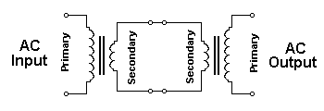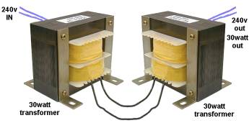
You can use any transformers providing the primary and secondary voltages are the same. The current capability of the secondary winding does not matter. However if you want a supply that has almost the same voltage as your "Mains," you need two transformers with the same voltages.
This handy isolation transformer will provide you with "Mains Voltage" but with a limited current.
In other words it will have a limited capability to supply "wattage." If you are using two 15VA transformers, you will only be able to test an appliance rated at 15 watts.
This has some advantages and some disadvantages.
If you are working on a project, and a short-circuit occurs, the damage will be limited to 15 watts.
If you are using two transformers with different VA ratings, the lower rating will be the capability of the combination.
If the secondaries are not equal, you will get a higher or lower "Mains Voltage."
If you get two transformers from TVs or Monitors, with a rating on the compliance plate of 45 watts, or 90 watts, you can assume the transformers are capable of delivering this wattage and making an isolation transformer will enable you to test similar items with the safety of being isolated from the mains.
Colin Mitchell designs a lot of "LED lighting lamps" that are connected directly to the mains. He always works with an isolating transformer, just to be safe. Working on exposed "mains" devices is extremely nerve-wracking and you have to be very careful.
The isolation transformer will prevent a BIG EXPLOSION.
DETERMINING THE SPECS OF A TRANSFORMER
Suppose you have a "mains transformer" with unknown output voltages and unknown current capability.
You must be sure it is a mains transformer designed for operation on 50Hz or 60Hz. Switch-Mode transformers operate at frequencies 40kHz and higher and are not covered in this discussion.
To be on the safe-side, connect the unknown transformer to the output of your isolating transformer.
Since the transformer will take almost no current when not loaded, the output voltages it produces will be fairly accurate. Measure the input AC voltage and output AC voltage.
If the transformer has loaded your isolating transformer it will be faulty.
Mains transformers are approx 15VA for 500gm, 30VA for 1kgm 50VA for 2kgm and and 100VA for 2.5kgm.
VA stands for Volts-Amps and is similar to saying watts. Watts is used for DC circuits, while VA refers to AC circuits.
Once you have the weight of the transformer and the output voltage, you can work out the current capability of the secondary.
For transformers up to 30vA, the output voltage on no-load is 30% higher than the final "loaded voltage."
This is due to the poor regulation of these small devices.
If the transformer is 15VA and the output voltage is 15v AC, the current will be 1 amp AC.
You can check the "quality" of the transformer, (the regulation) by fully loading the output and measuring the final voltage. If the transformer has a number of secondaries, the VA rating must be divided between all the windings.
240v to 110v ISOLATION TRANSFORMER
Here's how to create a 110v isolating transformer:
Find a 240v:12v transformer.
Now find a transformer that has two secondary windings, such as 240v:12v+12v.
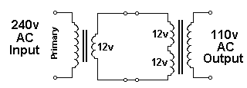
Connect the two transformers as shown in the circuit above. If the output is zero, connect ONE of the 12v windings of the second transformer around the other way.
110v to 240v ISOLATION TRANSFORMER
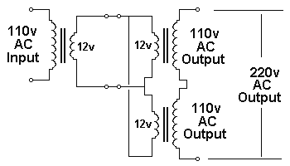
A 110v to 240v isolation transformer can be created by connecting 3 identical transformers as shown in the diagram above. If the output is zero, connect one of the outputs around the other way.
TRANSFORMER RATINGS
Question from a reader:
I have a 28v - 0 - 28v transformer @3amps. Does this mean each side is 1.5 amps?
The transformer is called CENTRE TAPPED and is shown in figures B and C.
It is designed to be connected to two diodes so each winding takes it in turn to deliver the current as shown in diagram C and the output will be 28v AC at 3 amps.
The 28v and 3 amp are both AC values.
If you connect across both outside wires, the output will be 56v at 1.5 amp.
This is because the transformer has a VA rating of 28 x 3 = 84VA. This is very similar to the term "watts."
When the 28v AC is rectified and smoothed, it becomes 28 x 1.4 = 39v (minus 0.6v across the diode) and since the transformer has a rating of 84 VA, the current must be reduced to 84/39 = 2.1 amps to maintain the VA rating.
Some transformers are specified as say: 12v - 0 - 12v, but the wiring diagram is shown as "A." This transformer should be specified as 12v + 12v as the secondaries are separate.
12v - 0 - 12v means the two secondary windings are NOT separate.
It does not make any difference to the output voltage and current, if the windings are separate or joined. The only difference is 12v +12v can be turned into two separate 12v outputs.
If you do not know the output current for a particular transformer, go to the website of electronic parts suppliers and compare the weight of your transformer with others. This will give you a VA rating and you can work out the current, once you know the output voltage.
Note: the output current finishes up ONLY 60% of the rating on the transformer tag because the rating is an AC RATING.
With 2 separate secondaries, you can parallel the outputs to get double the current, but don't forget 12v + 12v @ 3amp means 12v in parallel with 12v will provide 2amp DC and the DC voltage will be about 17v.
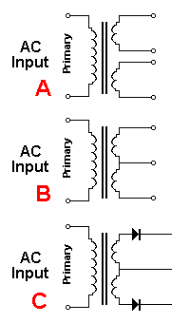
CURRENT TRANSFORMER
A Current Transformer is really an ordinary transformer.
All transformers produce a CURRENT output and a VOLTAGE output.
If you put an ammeter across the secondary, the current will increase through the meter when the primary voltage is increased.
This is because the output voltage will increase and this voltage will allow a higher current to flow.
WHY DETECT CURRENT? Why not voltage?
Because the voltage of say the "240v AC" is always 240v but the current can increase from say 1 amp to nearly 15 amps, depending what appliance is connected. So it is pointless measuring voltage.
A Current Transformer is a step-up transformer. When we say step-up and step-down, we are referring to the voltage - comparing the primary voltage to the secondary voltage. (Most transformers on the "mains" are step-down transformers and are used as power supplies to laptops, phone chargers etc.) Even a welding transformer is a step-down device and produces about 20v to 70v, while the current can be as high as 100 amps. This current is higher than the mains will deliver and is needed to melt the metal at the point of contact of the probe and the item being welded.
A Current Transformer is a step-up transformer. The primary consists of a single turn (or maybe 2 - 5 turns) and the secondary has 100 turns (or more).
This means the voltage seen by the primary will be increased 100 times and appear as anything from a few hundred millivolts to a few volts, depending on the quality of the coupling. (the magnetic coupling between the wire through the centre of the core, the quality of the core to transfer this magnetic flux to the secondary turns.) This voltage is then passed to a low value resistor, where the voltage is reduced to a level that suits the detection circuit and the resulting millivolts is interpreted as current in the wire being tested.
Recapping:
The reading on the secondary has no relation to the current in the primary. We need to add a LOAD RESISTOR and create a table before we can use the transformer.
There is no such thing as a CURRENT TRANSFORMER. It is really an INSTRUMENT TRANSFORMER and the scale has been marked in units of CURRENT after measurements have been made. (INSTRUMENT TRANSFORMER means it is a device that helps us to produce a connection between current flowing through a wire and a reading on a meter or display).
If we connect a load to the secondary, (say an ammeter), it will produce a reading that increases when the current through the single primary turn is increased. That's because the ammeter is a LOAD. But the reading is meaningless until be calibrate the scale.
Now, lets look at the primary.
A wire (or cable) through the centre of the core is counted as one turn. If the turn is wrapped around the core, the coupling will be improved, but if we always use a straight wire, it does not matter where it is positioned inside the centre of the core.
It does not matter if the magnetic interaction of the flux from the wire is good or bad, we just have to keep to the same way of using the transformer.
The calibration can be done with any poor coupling and the result will be accurate for all future readings.
If a low-value resistor is placed across the secondary, the voltage across this resistor will increase and also the current through it will increase. But we are not going to measure the current through the resistor. We are going to measure the voltage across the resistor and by taking lots of reading we will finish up with a scale or table and this is called CALIBRATION. The results will be equated to the current flowing through the primary wire (primary turn).
A clamp meter uses a current transformer and the jaws must be closed completely and cleanly for the flux to flow around the core and produce a reading in the secondary.
Dirt in the jaws will reduce the reading considerably.
You cannot measure the current in a "power cord" because it contains both the active and neutral wires.
Even though the current is a maximum in both conductors at the same time, the current is flowing in two different directions and the magnetic flux produced by one conductor is clockwise and the other is anticlockwise and they are cancelled by each other.
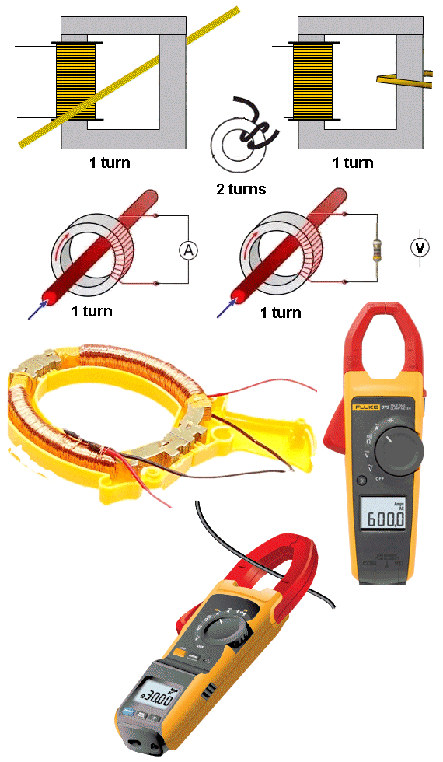
Identifying ONE TURN.
The quality (the coupling) of a single STRAIGHT wire
through the centre of a core is very poor
but if all readings are taken with this amount
of coupling, the readings will be accurate, as the
calibrations have been done with this arrangement.
OPTO ISOLATORS and OPTO COUPLERS
Opto Isolators and Opto Couplers are the same thing. A common opto-coupler is 4N35. It is used to allow two circuits to exchange signals yet remain electrically isolated. The signal is applied to the LED, which shines on a silicon NPN photo-transistor in the IC.
The light is proportional to the signal, so the signal is transferred to the photo transistor to turn it on a proportional amount. Opto-couplers can have Light Activated SCR's, photodiodes, TRIAC's and other semiconductor devices as an output. The 4N35 opto-coupler schematic is shown below:
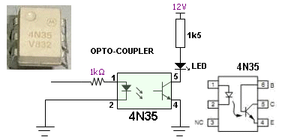
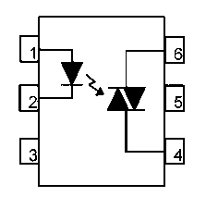
An opto-Coupler using a TRIAC
Note: the pinout is different to 4N35
TESTING AN OPTO COUPLER
Most multimeters cannot test the LED on the input of an opto-coupler because the ohms range does not have a voltage high enough to activate the LED with at least 2mA.
You need to set-up the test-circuit shown above with a 1k resistor on the input and 1k5 on the output. When the 1k is connected to 12v, the output LED will illuminate.
The opto-coupler should be removed from circuit to perform this test.
TRANSISTORS
Transistors are solid-state devices and although they operate completely differently to a diode, they appear as two back-to-back diodes when tested.
There are basically 2 types of transistor NPN and PNP.
A transistor is sometimes referred to as BJT (Bi-polar Junction Transistor) to distinguish it from other types of transistor such as Field Effect transistor, Programmable Unijunction Transistor and others.
In the following diagram, two diodes are connected together and although the construction of a transistor is more complex, we see the transistor as two diodes when testing it.
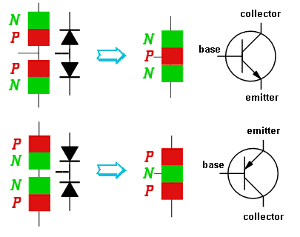
A TRANSISTOR APPEARS AS TWO DIODES WHEN TESTING IT
All transistors have three leads. Base (b), Collector (c), and Emitter (e).
For an NPN transistor, the arrow on the emitter points away from the base.
It is fortunate that the arrow on both symbols points in the direction of the flow of current (Conventional Current) and this makes it easy to describe testing methods using our simplified set of instructions. The symbols have been drawn exactly as they appear on a circuit diagram.
All transistors are the same but we talk about digital and analogue transistors. There is no difference between the two.
The difference is the circuit. And the only other slight difference between transistors is the fact that some have inbuilt diodes and resistors to simplify the rest of the circuit.
All transistors work the same way. The only difference is the amount of amplification they provide, the current and voltage they can withstand and the speed at which they work. For simple testing purposes, they are all the same.
NPN transistors are the most common and for an NPN transistor, the following applies.
(the opposite applies for PNP)
To test a transistor, there is one thing you have to know:
When the base voltage is higher than the emitter, current flows though the collector-emitter leads.
As the voltage is increased on the base, nothing happens until the voltage reaches 0.55v. At this point a very small current flows through the collector-emitter leads. As the voltage is increased, the current-flow increases. At about 0.75v, the current-flow is a MAXIMUM. (can be as high as 0.9v). That's how it works. A transistor also needs current to flow into the base to perform this amplifying function and this is the one feature that separates an ordinary transistor from a FET.
If the voltage on the base is 0v, then instantly goes to 0.75v, the transistor initially passes NO current, then FULL current. The transistor is said to be working in its two states: OFF then ON (sometimes called: "cut-off" and "saturation"). These are called digital states and the transistor is said to be a DIGITAL TRANSISTOR or a SWITCHING TRANSISTOR , working in DIGITAL MODE.
If the base is delivered 0.5v, then slowly rises to 0.75v and slowly to 0.65v, then 0.7v, then 0.56v etc, the transistor is said to be working in ANALOGUE MODE and the transistor is an ANALOGUE TRANSISTOR.
Since a transistor is capable of amplifying a signal, it is said to be an active device. Components such as resistors, capacitors, inductors and diodes are not able to amplify and are therefore known as passive components.
In the following tests, use your finger to provide the TURN ON voltage for the base (this is 0.55v to 0.7v) and as you press harder, more current flows into the base and thus more current flows through the collector-emitter terminals. As more current flows, the needle of the multimeter moves UP-SCALE.
TESTING A TRANSISTOR ON A DIGITAL METER
Testing a transistor with a Digital Meter must be done on the "DIODE" setting as a digital meter does not deliver a current through the probes on some of the resistance settings and will not produce an accurate reading.
The "DIODE" setting must be used for diodes and transistors. It should also be called a "TRANSISTOR" setting.
TESTING AN unknown TRANSISTOR
The first thing you may want to do is test an unknown transistor for COLLECTOR, BASE AND EMITTER. You also want to perform a test to find out if it is NPN or PNP.
That's what this test will provide.
You need a cheap multimeter called an ANALOGUE METER - a multimeter with a scale and pointer (needle).
It will measure resistance values (normally used to test resistors) - (you can also test other components) and Voltage and Current. We use the resistance settings. It may have ranges such as "x10" "x100" "x1k" "x10"
Look at the resistance scale on the meter. It will be the top scale.
The scale starts at zero on the right and the high values are on the left. This is opposite to all the other scales.
When the two probes are touched together, the needle swings FULL SCALE and reads "ZERO." Adjust the pot on the side of the meter to make the pointer read exactly zero.
How to read: "x10" "x100" "x1k" "x10"
Up-scale from the zero mark is "1"
When the needle swings to this position on the "x10" setting, the value is 10 ohms.
When the needle swings to "1" on the "x100" setting, the value is 100 ohms.
When the needle swings to "1" on the "x1k" setting, the value is 1,000 ohms = 1k.
When the needle swings to "1" on the "x10k" setting, the value is 10,000 ohms = 10k.
Use this to work out all the other values on the scale.
Resistance values get very close-together (and very inaccurate) at the high end of the scale. [This is just a point to note and does not affect testing a transistor.]
Step 1 - FINDING THE BASE and determining NPN or PNP
Get an unknown transistor and test it with a multimeter set to "x10"
Try the 6 combinations and when you have the black probe on a pin and the red probe touches the other pins and the meter swings nearly full scale, you have an NPN transistor. The black probe is BASE
If the red probe touches a pin and the black probe produces a swing on the other two pins, you have a PNP transistor. The red probe is BASE
If the needle swings FULL SCALE or if it swings for more than 2 readings, the transistor is FAULTY.
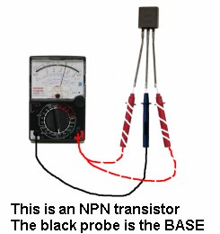 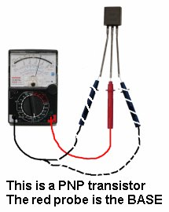
Step 2 - FINDING THE COLLECTOR and EMITTER
Set the meter to "x10k."
For an NPN transistor, place the leads on the transistor and when you press hard on the two leads shown in the diagram below, the needle will swing almost full scale.
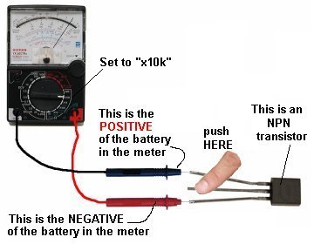
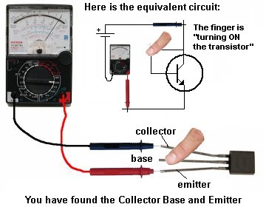
For a PNP transistor, set the meter to "x10k" place the leads on the transistor and when you press hard on the two leads shown in the diagram below, the needle will
swing almost full scale.
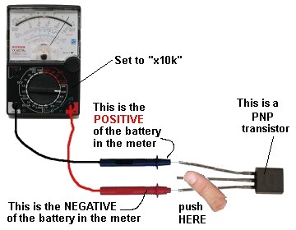
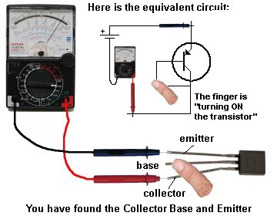
SIMPLEST TRANSISTOR TESTER
The simplest transistor tester uses a 9v battery, 1k resistor and a LED (any colour). Keep trying a transistor in all different combinations until you get one of the circuits below. When you push on the two leads, the LED will get brighter.
The transistor will be NPN or PNP and the leads will be identified:
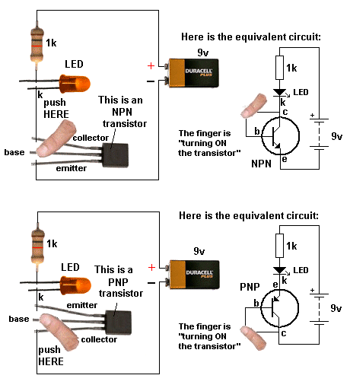
The leads of some transistors will need to be bent so the pins are in the same positions as shown in the diagrams. This helps you see how the transistor is being turned on. This works with NPN, PNP transistors and Darlington transistors.
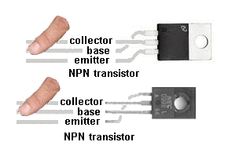
HEATSINKING
Heat generated by current flowing between the collector and emitter leads of a transistor causes its temperature to rise. This heat must be conducted away from the transistor otherwise the rise may be high enough to damage the P-N junctions inside the device. Power transistors produce a lot of heat, and are therefore usually mounted on a piece of aluminium with fins, called a HEATSINK.
This draws heat away, allowing it to handle more current. Low-power signal transistors do not normally require heat sinking. Some transistors have a metal body or fin to connect to a larger heatsink. If the transistor is connected to a heatsink with a mica sheet (mica washer), it can be damaged or cracked and create a short-circuit. (See Testing Mica Washers). Or a small piece of metal may be puncturing the mica. Sometimes white compound called Heatsink Compound is used to conduct heat through the mica. This is very important as mica is a very poor conductor of heat and the compound is needed to provide maximum thermal conduction.
TRANSISTOR FAILURE
Transistor can fail in a number of ways. They have forward and reverse voltage ratings and once these are exceeded, the transistor will ZENER or conduct and may fail. In some cases a high voltage will "puncture" the transistor and it will fail instantly. In fact it will fail much faster via a voltage-spike than a current overload.
It may fail with a "short" between any leads, with a collector-emitter short being the most common. However failures will also create shorts between all three leads.
A shorted transistor will allow a large current to flow, and cause other components to heat up.
Transistors can also develop an open circuit between base and collector, base and emitter or collector and emitter.
The first step in identifying a faulty transistor is to check for signs of overheating. It may appear to be burnt, melted or exploded. When the equipment is switched off, you can touch the transistor to see if it feels unusually hot. The amount of heat you feel should be proportional to the size of the transistor's heat sink. If the transistor has no heat sink, yet is very hot, you can suspect a problem.
DO NOT TOUCH A TRANSISTOR IF IT IS PART OF A CIRCUIT THAT CARRIES 240VAC. Always switch off the equipment before touching any components.
TRANSISTOR REPLACEMENT
If you can't get an exact replacement, refer to a transistor substitution guide to identify a near equivalent.
The important parameters are:
- Voltage
- Current
- Wattage
- Maximum frequency of operation
The replacement part should have parameters equal to or higher than the original.
Points to remember:
- Polarity of the transistor i.e. PNP or NPN.
- At least the same voltage, current and wattage rating.
- Low frequency or high frequency type.
- Check the pinout of the replacement part
- Use a desoldering pump to remove the transistor to prevent damage to the
printed circuit board.
- Fit the heat sink.
- Check the mica washer and use heat-sink compound
- Tighten the nut/bolt - not too tight or too loose.
- Horizontal output transistors with an integrated diode should be replaced with the
same type.
DIGITAL TRANSISTORS
There is no such thing as a DIGITAL TRANSISTOR or an AUDIO TRANSISTOR.
All transistors are just "TRANSISTORS" and the surrounding components as well as the type of signal, make the transistor operate in DIGITAL MODE or ANALOGUE MODE.
But we have some transistors that have inbuilt resistors to make them suitable for connecting to a digital circuit without the need for a base resistor.
Here is the datasheet for an NPN transistor BCR135w and PNP datasheet for BCR185w.
These transistors are called "Digital Transistors" because the "base lead" can be connected directly to the output of a digital stage. This "lead" or "pin" is not really the base of the transistor but a 4k7 (or 10k) resistor connected to the base allows the transistor to be connected to the rest of a digital circuit.
You cannot actually get to the base. The resistor(s) are built into the chip and the transistor is converted into a "Digital Transistor" because it will accept 5v on the "b" lead.
The 47k is not really needed but it makes sure the transistor is fully turned OFF if the signal on the "b" lead is removed (in other words - if the input signal is converted to a high-impedance signal - see tri-state output from microcontrollers for a full explanation).
This transistor is designed to be placed in a circuit where the input changes from low to high and high to low and does not stop mid-way. This is called a DIGITAL SIGNAL and that is one reason why the transistor is called a digital transistor. (However you could stop half-way but the transistor may heat up and get too hot).
Any transistor placed in a digital circuit can be called a "digital transistor" but it is better to say it is operating in DIGITAL MODE.
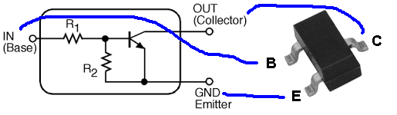
The digital transistor has two resistors included inside the case
R1 is about 10k and R2 is approx 47k
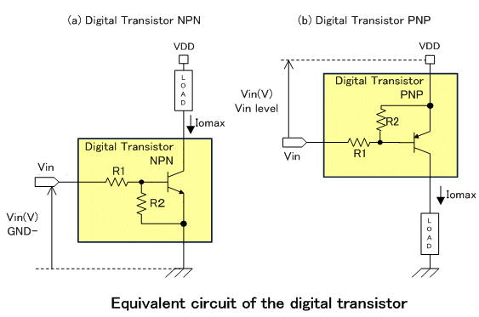
These transistors can be made to work in analogue circuits
because they are ordinary transistors with a 10k base resistor,
but you will have to know what you are doing.
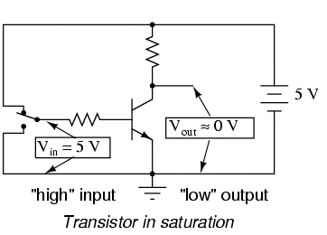
The circuit above shows the digital transistor is designed to allow a voltage of 5v to be supplied to the "base" pin and the transistor will Fully Conduct.
This type of transistor saves putting a base resistor on the PC board.
It can be tested just like a normal transistor but the resistance between base and emitter will be about 5k to 50k in both directions. If the collector-emitter is low in both directions the transistor is damaged.
Here's how to look at how the transistor works:
The 10k resistor on the base will allow 0.5mA to flow into the base. But the 47k will reduce this to 0.4mA. If the transistor has a gain of 100, the collector-emitter current can be 40mA.
To determine the current capability of the transistor, connect 100R load and turn the transistor ON. This will allow about 100mA for the collector-emitter current. Measure the collector-emitter voltage. If it is more than 0.5v, the transistor is OVER-LOADED.
DARLINGTON TRANSISTORS
A DARLINGTON TRANSISTOR is two transistors in a single package with three leads. They are internally connected in cascade so the gain of the pair is very high. This allows a very small input signal to produce a large signal at the output. They have three leads (Base, Collector and Emitter and can be PNP or NPN) and are equivalent to the leads of a standard individual transistor, but with a very high gain. The second advantage of a Darlington Transistor is its high input impedance. It puts very little load on the previous circuit.
Some Darlington transistors have a built-in diode and/or built-in resistor and this will produce a low reading in both directions between the base and emitter leads.
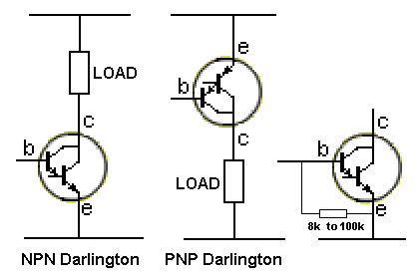
Darlington transistors are tested the same as an ordinary transistor and a multimeter will produce about the same deflection, even though you will be measuring across two junctions, (and a base-emitter resistor is present).
HORIZONTAL OUTPUT TRANSISTORS, SWITCH-MODE TRANSISTORS, FLYBACK TRANSISTORS, POWER TRANSISTORS, VERTICAL TRANSISTORS . . . .
These are all names given to a transistor when it is used in a particular circuit. ALL these transistors are the same for testing purposes.
We are not testing for gain, maximum voltage, speed of operation or any special feature. We are just testing to see if the transistor is completely faulty and SHORTED.
A transistor can have lots of other faults and the circuit using the transistor is the best piece of TEST EQUIPMENT as it is detecting the fault.
TESTING MOSFETs and FETs
MOSFETs and JFETs are all part of the FET family.
MOSFET stands for Metal Oxide Semiconductor Field Effect Transistor.
FETs operate exactly the same as a "normal" transistor except they have different names for the input and output leads and the voltage between the gate and the source has to between 2v to 5v for the device to turn on fully. A FET requires almost NO CURRENT into the Gate for it to turn on and when it does, the voltage between drain and source is very low (only a few mV). This allows them to pass very high currents without getting hot. There is a point where they start to turn on and the input voltage must rise higher than this so the FET turns on FULLY and does not get hot.
Field Effect Transistors are difficult to test with a multimeter, but "fortunately" when a power MOSFET blows, it is completely damaged. All the leads will show a short circuit. 99% of bad MOSFETs will have GS, GD and DS shorted.
The following symbols show some of the different types of MOSFETs:
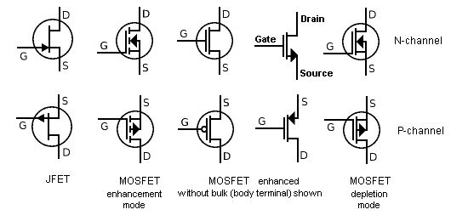
Most MOSFET transistors cannot be tested with a multimeter. This due to the fact that the Gate needs 2v - 5v to turn on the device and this voltage is not present on the probes of either meter set to any of the ohms ranges.
You need to build the following Test Circuit:
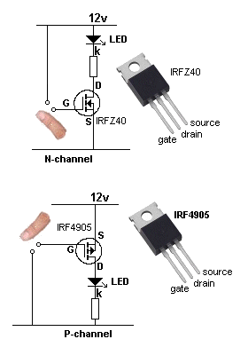
Touching the Gate will increase the voltage on the Gate and the MOSFET will turn ON and illuminate the LED. Removing your finger will turn the LED off.
Large devices such as the TO-220 types shown above do not like static electricity on the gate and you have to be careful not to "spike" the gate with any static. Generally this type of device is not "super sensitive" and you can use your finger or a large value resistor.
When replacing one of these devices, there are 2 things to match-up.
Voltage and Current.
In most cases, the "turn-ON" resistance (the resistance between Source and Drain) will be the same (something like 22 milli ohms) and the speed of operation will be ok.
Check the voltage needed to turn the gate ON and make sure you can supply the required voltage.
SILICON CONTROLLED RECTIFIERs (SCR)
The Silicon Controlled Rectifier (SCR) is a semiconductor device that is a member of a family of control devices known as Thyristors. It is a 3-leaded device and when a small current enters the Gate, the thyristor turns on. AND STAYS ON. It only conducts current between Anode and Cathode in one direction and it is mainly only used in DC circuits. When it is used with AC, it will only conduct for a maximum of half the cycle.
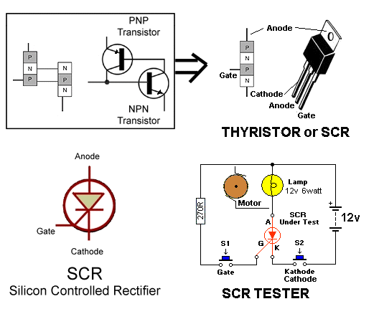
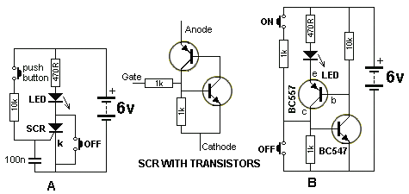
To understand how an SCR "latches" when the gate is provided with a small current, we can replace it with two transistors as shown in diagram B above. When the ON button is pressed, the BC547 transistor turns on. This turns ON the BC557 and it takes over from the action of the switch.
To turn the circuit off, the OFF button removes the voltage from the base of the BC547.
Testing an SCR
An SCR can be tested with some multimeters but a minimum current Anode-to-Cathode is needed to keep the device turned on. Some multimeters do not provide this amount of current and the SCR Tester circuit above is the best way to test these devices.
Shorted SCRs can usually be detected with an ohmmeter check (SCRs usually fail shorted rather than open).
Measure the anode-to-cathode resistance in both the forward and reverse direction; a good SCR should measure near infinity in both directions.
Small and medium-size SCRs can also be gated ON with an ohmmeter (on a digital meter use the Diode Check Function). Forward bias the SCR with the ohmmeter by connecting the black ( - ) lead to the anode and the red ( + ) lead to the cathode (because the + of the battery is connected to the negative lead, in most analogue multimeters). Momentarily touch the gate lead to the anode while the probes are still touching both leads; this will provide a small positive turn-on voltage to the gate and the cathode-to-anode resistance reading will drop to a low value. Even after removing the gate voltage, the SCR will stay conducting. Disconnecting the meter leads from the anode or cathode will cause the SCR to revert to its non-conducting state.
When making the above test, the meter impedance acts as the SCR load. On larger SCRs, it may not latch ON because the test current is not above the SCR holding current.
Using the SCR Tester
Connect an SCR and press Switch2. The lamp should not illuminate. If it illuminates, the SCR is around the wrong way or it is faulty.
Keep Switch 2 PRESSED. Press Sw1 very briefly. The lamp or motor will turn ON and remain ON. Release Sw 2 and press it again. The Lamp or motor will be OFF.
TRIACs
A triac is a bidirectional, three-terminal dual, back-to-back thyristor (SCR) switch. This device will conduct current in both directions when a small current is constantly applied to the Gate.
If the gate is given a small, brief, current during any instant of a cycle, it will remain triggered during the completion of the cycle until the current though the Main Terminals drops to zero.
This means it will conduct both the positive and negative half-cycles of an AC waveform. If it is tuned on (with a brief pulse) half-way up the positive waveform, it will remain on until the wave rises and finally reaches zero. If it is then turned on (with a brief pulse) part-way on the negative wave, the result will be pulses of energy and the end result will be about 50% of the full-energy delivered at a rate of 100 times per second for a 50HZ supply.
TRIACs are particularly suited for AC power control applications such as motor speed control, light dimmers, temperature control and many others.
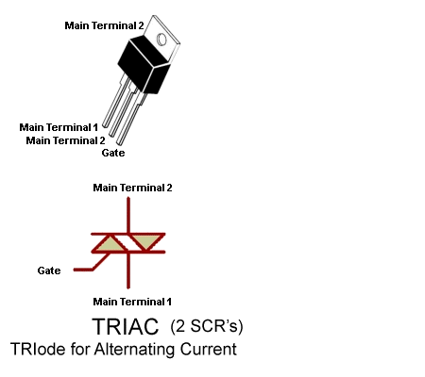
Using the TRIAC Tester
Connect a TRIAC and press Switch2. The lamp should not illuminate. If it illuminates, the TRIAC is faulty.
Keep Switch 2 PRESSED. Press Sw1 very briefly. The lamp or motor will turn ON and remain ON. If the lamp does not turn on, reverse the TRIAC as the current into the gate must produce a slight voltage between Gate and Main Terminal 1.
Release Sw 2 and press it again. The Lamp or motor will be OFF.
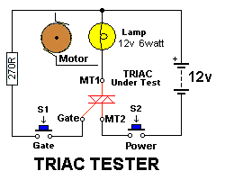
MICA WASHERS AND INSULATORS
Plastic insulating sheets (washers) between a transistor and heatsink are most often made from mica but some are plastic and these get damaged over a period of time, turn dark and become cracked.
The plastic eventually becomes carbonized and conducts current and can affect the operation of the appliance. You can see the difference between a mica sheet (washer) and plastic by looking where it extends from under the transistor. Replace all plastic insulators as they eventually fail.
SPARK GAPS
Some TV's and monitors with a CRT (picture tube), have spark gaps either on the socket at the end of the tube or on the chassis.
These can consist of two wires inside a plastic holder or a glass tube or special resistive device.
The purpose of a spark gap is to take any flash-over (from inside the tube), to earth. This prevents damage to the rest of the circuit.
However if the tube constantly flashes over, a carbon track builds up between the wires and effectively reduces the screen voltage. This can cause brightness and/or focus problems. Removing the spark-gap will restore the voltage.
These are not available as a spare component and it's best to get one from a discarded chassis.
CO-AX CABLES
Co-Ax cables can produce very high losses and it seems impossible that a few metres of cable will reduce the signal. The author has had a 3 metre cable reduce the signal to "snow" so be aware that this can occur. Faults can also come from a splitter and/or balun as well as dirty plugs and sockets. This can result in very loud bangs in the sound on digital reception.
TESTING EARTH LEAKAGE DETECTORS or
Residual Current Devices or
Ground Fault Circuit Interrupters or GFCI
An Earth Leakage Detector or Sensor is a circuit designed to continuously monitor the imbalance in the current in a pair of load carrying conductors.
These two conductors are normally the Active and Neutral. Should the imbalance current reach 30mA the sensor will "trip" and remove the voltage (and current) from the line being monitored.
Some detectors will trip at 15mA.
You cannot alter the sensitivity of the device however there are a number of faults in these devices that can be fixed.
In some devices the contact pressure for the 10Amp or 15 Amp contacts is very weak and they arc and produce an open circuit. The result is this: When you press the rest button, power is not restored to the output.
Clean the contacts with a small file and bend the metal strips to the contacts so they make a very strong contact.
The other fault is the trip mechanism.
The magnetism from the coil does not allow the pin to move and "trip" the contacts. It may be due to a small metal filing or the pin not moving freely enough.
All good Earth Leakage Detectors have a TEST BUTTON. This connects a resistor between the active line and earth so that 15mA or 30mA flows.
The detector should trip immediately. Make sure the trigger mechanism trips when the test button is pressed.
None of the electronics in the detector can be replaced however you can test the mechanical operation and the pressure on the contacts when the unit is removed from the power. Do not work on the device when it is connected to the mains.
TESTING CELLS AND BATTERIES
There is an enormous number of batteries and cells on the market and a number of "battery testers." Instead of buying a battery tester that may give you a false reading, here is a method of testing cells that is guaranteed to work.
There are two types of cell: a rechargeable cell and a non rechargeable cell.
The easiest way to test a rechargeable cell is to put a group of them in an appliance and use them until the appliance "runs down" or fails to work. If you consider the cells did not last very long, remove them and check the voltage of each cell. The cell or cells with the lowest voltage will be faulty. You can replace them with new cells or good cells you have in reserve.
There is no other simple way to test a rechargeable cell.
You cannot test the "current of a cell" by using an ammeter. A rechargeable cell can deliver 10 amps or more, even when nearly discharged and you cannot determine a good cell for a faulty cell.
Dry cells are classified as "non-rechargeable" cells.
DRY CELLS and MANGANESE CELLS are the same thing. These produce 1.5v per cell (manganese means the Manganese Dioxide depolariser inside the cell. All "dry cells" use manganese dioxide).
ALKALINE CELLS produce between 2 - 10 times more energy than a "dry cell" and produce 1.5v per cell.
Alkaline cells can fail for no reason at any stage in their life and are not recommended for emergency situations.
The output voltage of some Alkaline cells can fall to 0.7v or 0.9v for not apparent reason.
There are lots of other cells including "button cells," hearing-aid cells, air cells, and they produce from 1.2v to 3v per cell.
Note:
Lithium cells are also called "button cells" and they produce 3v per cell.
Lithium cells are non-rechargeable (they are generally called "button cells") but some Lithium cells can be recharged. These are Lithium-ion cells and generally have a voltage of 3.6v. Some Lithium-ion cells look exactly like 3v Lithium cells, so you have to read the data on the cell before charging.
You cannot test the voltage of a cell and come to any conclusion as to the age of the cell or how much energy remains. The voltage of a cell is characteristic to the chemicals used and the actual voltage does not tell you its condition.
Some "dry cells" deliver 1.5v up to the end of their life whereas others drop to about 1.1v very quickly.
Once you know the name of the cell that drops to 1.1v, avoid them as the operation of the equipment "drops off" very quickly.
However if you have a number of different cells and need to know which ones to keep, here's the solution:
1. Check the voltage and use those with a voltage above 1.1v
2. Next, select 500mA or 10A range on a meter and place the probes on a cell. For a AAA or AA cell, the current should be over 500mA and the needle will swing full scale very quickly.
Keep the testing short as you are short-circuiting the cell but it is the only way to determine the internal impedance of the cell and this has a lot to do with its stage-of-charge.
This will give you a cell with a good terminal voltage and a good current capability.
This also applies to button cells, but the maximum current they will deliver will be less.
If you want to get the last of the energy out of a group of cells they can be used in the following circuits:
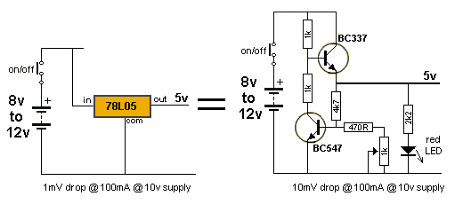
TESTING PIEZO DIAPHRAGMS and PIEZO BUZZERS
There are two types of piezo devices that produce a sound.
They are called PIEZO DIAPHRAGMS and PIEZO BUZZERS.
A piezo diaphragm consists of two metal plates with a ceramic material between. The ceramic expands and contracts when an alternating voltage is placed on the two plates and this causes the main plate to "dish" and "bow."
This creates a high-pitched sound. There are no other components inside the case and it requires an AC voltage of the appropriate frequency to produce a sound.
A piezo buzzer has a transistor and coil enclosed and when supplied with a DC voltage, the buzzer produces a sound.
Both devices can look exactly the same and the only way to tell them apart is by connecting a 9v battery. One device may have "+' and "-" on the case to indicate it is a piezo buzzer, but supplying 9v will make the buzzer produce a sound while the piezo diaphragm will only produce a "click."
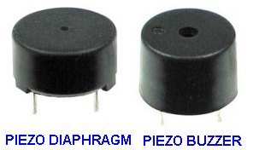
A piezo diaphragm will produce a click
when connected to 9v DC.
A piezo buzzer will produce a tone when
connected to a DC voltage.
How a PIEZO BUZZER WORKS
A Piezo Buzzer contains a transistor, coil, and piezo diaphragm and produces sound when a voltage is applied. The buzzer in the circuit above is a PIEZO BUZZER.
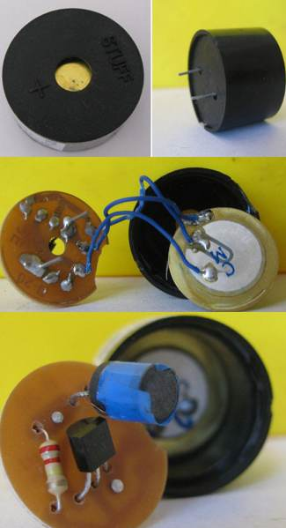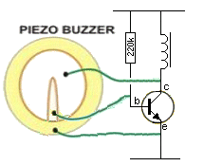
The circuit starts by the base receiving a small current from the 220k resistor. This produces a small magnetic flux in the inductor and after a very short period of time the current does not increase. This causes the magnetic flux to collapse and produce a voltage in the opposite direction that is higher than the applied voltage.
3 wires are soldered to pieces of metal on the top and bottom sides of a ceramic substrate that expands sideways when it sees a voltage. The voltage on the top surface is passed to the small electrode and this positive voltage is passed to the base to turn the transistor ON again. This time it is turned ON more and eventually the transistor is fully turned ON and the current through the inductor is not an INCREASING CURRENT by a STATIONARY CURRENT and once again the magnetic flux collapses and produces a very high voltage in the opposite direction. This voltage is passed to the piezo diaphragm and causes the electrode to "Dish" and produce the characteristic sound. At the same time a small amount is "picked-off" and sent to the transistor to create the next cycle.
TESTING A SPEAKER
A speaker (also called a loud speaker) has coil of wire wrapped around a magnet but it does not touch the magnet as it is wound on a thin cardboard former so that the coil will be pulled closer to the magnet when a current flows in the coil.
When the current flows in the other direction, the coil moves away from the magnet.
The coil is called voice coil and it is connected to a sheet of thin card called a CONE and as the cone vibrates, the speaker reproduces music or noise.
Use a multimeter on a low ohms scale to read the value of resistance of the coil.
It can be as low as 2 ohms or as high as 100 ohms.
Most speakers have an 8R voice coil and the actual resistance may be slightly lower than this.
Some speakers have a resistance of 16R, 32R or 50R and even 75 ohms.
You would think putting a 16R speaker in place of 8R would reduce the sound output, but this is not always the case.
You can even use 50R or 75R and get the same performance.
This may sound amazing, but here is the reason.
The cone is deflected a certain amount due to the current flowing and the number of turns.
These two values are multiplied together to produce a value called AMP-TURNS.
If we have an 8R speaker with 80 turns and 100mA, the result is 0.1 x 80 = 8.
If we use a 16R speaker, the average current flow will be 50mA and the number of turns will be about 160. The multiplication of 0.05 x 160 = 8.
The author then tried a 50R speaker and the sound output was equal to 8R and the same with 75R speaker.
This might not apply in all situations, but the 75R speaker was slightly larger and the ticking sound form the Metal Detector kit was louder than using an 8R mini speaker.
To see if the cone of a speaker is undamaged, push it slightly and it will move towards the magnet. If it does not move, it is bent or damaged. If the cone is scratchy when pushed, it is rubbing against the magnet.
A cone should be able to be pushed and pulled from its rest-state. If not, it will produce a distorted sound.
TESTING A CIRCUIT
Whenever you test a circuit, the TEST EQUIPMENT puts "a load" or "a change" on it.
It does not matter if the test equipment is a multimeter, Logic Probe, CRO, Tone Injector or simply a LED and resistor.
There are two things you need to know.
1. The IMPEDANCE of the circuit at the location you are testing, and
2. The amount of load you are adding to the circuit via the test equipment.
There is also one other hidden factor. The test equipment may be injecting "hum" due to its leads or the effect of your body at absorbing hum from the surroundings or the test equipment may be connected to the mains.
These will affect the reading on the test equipment and also any output of the circuit.
Sometimes the test equipment will prevent the circuit from working and sometimes it will just change the operating conditions slightly. You have to be aware of this.
The last section of this eBook covers High and Low Impedance and understanding impedance is something you need to know.
The point to note here is the fact that the equipment (and the reading) can be upset by hum and resistance/capacitance effects of test equipment. This is particularly critical in high impedance and high frequency circuits.
TESTING INTEGRATED CIRCUITS (IC's)
Integrated Circuits can be tested with a LOGIC PROBE. A Logic Probe will tell you if a line is HIGH, LOW or PULSING.
Most logic circuits operate on 5v and a Logic Probe is connected to the 5v supply so the readings are accurate for the voltages being tested.
A Logic Probe can also be connected to a 12v CMOS circuit.
You can make your own Logic Probe and learn how to use it from the following link:
http://www.talkingelectronics.com/projects/LogicProbeMkIIB/LogicProbeMk-IIB.html
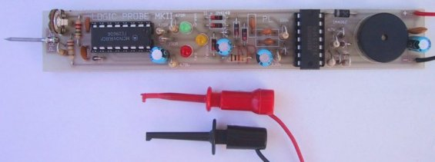
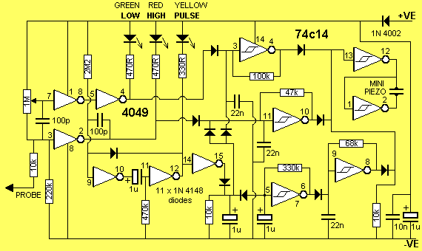
LOGIC PROBE with PULSE
This is a very simple transistor circuit to provide HIGH-LOW-PULSE indication for digital circuits. It can be built for less than $5.00 on a piece of matrix board or on a small strip of copper clad board if you are using surface mount components. The probe will detect a HIGH at 3v and thus the project can be used for 3v, 5v and CMOS circuits.
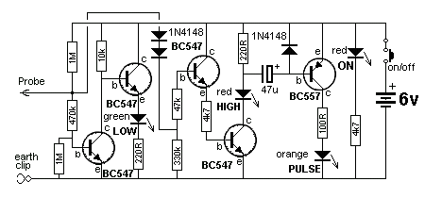
LOGIC PROBE using CD4001 and CD4011
Here is a simple Logic Probe using a single chip. The circuits have been designed for the CD4001 CMOS quad NOR gate and CD4011 CMOS NAND gate. The output has an active buzzer that produces a beep when the pulse LED illuminates (the buzzer is not a piezo-diaphragm but an active buzzer containing components).
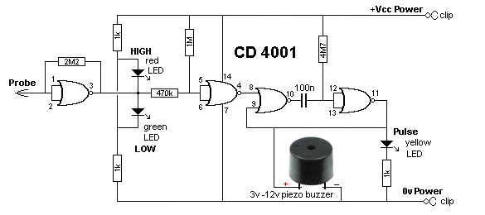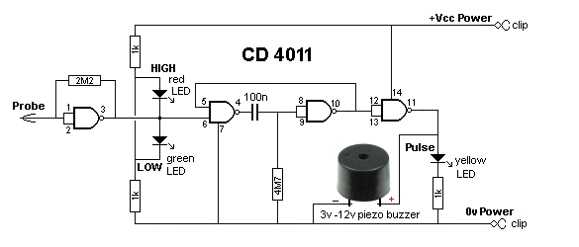
SUPER PROBE MkII has 20 different features including a Logic Probe, capacitance tester, Inductance tester, and more.
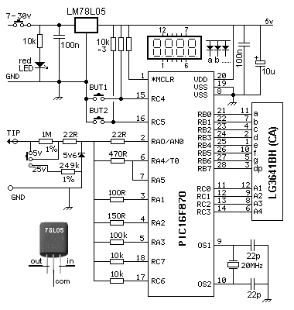
SUPER PROBE MkII Circuit
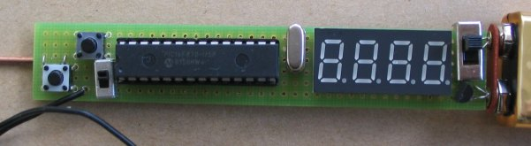
SUPER PROBE MkII
To test an IC, you need a circuit diagram with waveforms. These diagrams will show the signals and are very handy if a CRO (cathode ray Oscilloscope ) is used to diagnose the problem. The CRO will reproduce the waveform and prove the circuit is functioning correctly.
A Logic Probe will just show activity and if an output is not producing a "pulse" or "activity," you should check the power to the IC and test the input line.
It is beyond the scope of this eBook to explain how to diagnose waveforms, however it is important to know if signals are entering and exiting an IC and a Logic Probe is designed for this.
SIGNAL INJECTOR
This circuit is rich in harmonics and is ideal for testing amplifier circuits. To find a fault in an amplifier, connect the earth clip to the 0v rail and move through each stage, starting at the speaker. An increase in volume should be heard at each preceding stage. This Injector will also go through the IF stages of radios and FM sound sections in TV's.
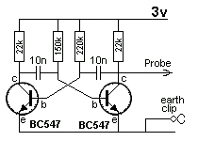
TESTING AUDIO AMPLIFIERS and AUDIO IC's
The Super Probe MII described above has a "noise" function and a tone function that allows you to inject a signal into an audio stage, amplifier (made from discrete components) or an audio chip, and detect the output on a speaker.
Audio stages are very difficult to work-with if you don't have a TONE GENERATOR or SIGNAL INJECTOR.
The signals are very small and not detected by a multimeter.
You can start anywhere in an amplifier and when a tone is heard, you can keep probing until the signal is not present or louder. From this you can work out which way the signal is travelling.
A Signal Injector is very handy for finding shorts and broken wires in switches, plugs, sockets and especially leads to headphones.
You can determine the gain of a stage (amplification) by probing before and after a chip or transistor and listen for the relative increase in volume from the speaker.
You can also use your finger to produce "hum" or "buzz" if a Signal Injector is not available.
Nearly all audio problems are plugs, sockets and cracks in the PC board, but finding them takes a lot of time and skill.
TESTING IC's - also called "CHIPS"
An Integrated Circuit is also called a "chip." It might have 8 pins or as many as 40.
Some chips are ANALOGUE. This means the input signal is rising and falling slowly and the output produces a larger version of the input.
Other chips are classified as DIGITAL and the input starts at 0v and rises to rail voltage very quickly. The output does exactly the same - it rises and falls very quickly.
You might think the chip performs no function, because the input and output voltage has the same value, but you will find the chip may have more than one output and the others only go high after a number of clock-pulses on the input, or the chip may be outputting when a combination of inputs is recognised or the output may go HIGH after a number of clock pulses.
ANALOGUE CHIPS (also see above)
Analogue chips are AUDIO chips or AMPLIFIER chips.
To test these chips you will need three pieces of test equipment:
1. A multimeter - this can be digital or analogue.
2. A Signal Injector
3. A Mini Bench Amplifier.
The Mini Bench Amplifier is available as a kit.
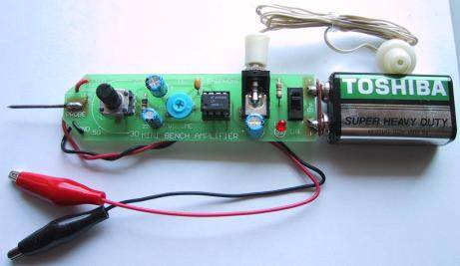
MINI BENCH AMPLIFIER
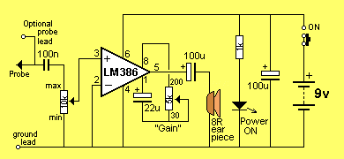
MINI BENCH AMPLIFIER CIRCUIT
Start by locating the power pin with a multimeter.
If the chip is receiving a voltage, you can use the Mini Bench Amplifier to detect an output.
Connect the Ground Lead of the Mini Bench Amplifier to 0v and touch the Probe tip on each of the pins.
You will hear faint audio on the Input pin and very loud audio on the Output pin.
If no input is detected, you can use a Signal Injector to produce a tone.
Connect the clip of the Signal Injector to 0v and the probe to the input pin of the amplifier chip. At the same time, connect the Mini Bench Amplifier to the output pin and you will hear a very loud tone.
These pieces of test equipment can also be used to diagnose an amplifier circuit constructed with individual components.
Amplifier circuits using discrete components are very hard to trouble-shoot and these pieces of test equipment make it very easy.
DIGITAL CHIPS
It is always best to have data on the chip you are testing, but if this is not available, you will need three pieces of equipment:
1. A multimeter - this can be digital or analogue.
2. A Logic Probe,
3. A logic Pulser.
Firstly test the chip to see if power is being delivered. This might be anything from 3v3 to 15v.
Place the negative lead of the multimeter on the earth rail of the project - this might be the chassis, or the track around the edge of the board or some point that is obviously 0v.
Try all the pins of the chip and if you get a reading, the chip will have "supply."
Identify pin 1 of the chip by looking for the "cut-out" at the end of the chip and you may find a small dimple below the cut-out (or notch). This is pin 1 and the "power pin" can be directly above or any of the other pins.
Next you need to now if a signal is entering the chip.
For this you will need a LOGIC PROBE.
A Logic Probe is connected to the same voltage as the chip, so it will detect a HIGH and illuminate a red LED.
Connect the Logic Probe and touch the tip of the probe on each pin.
You will not know if a signal is an input or output, however if you get two or more active pins, you can assume one is input and the other is output. If none of the pins are active, you can assume the signal is not reaching this IC.
If only one pin is active, you can assume the chip is called a CLOCK (or Clock Generator). This type of chip produces pulses. If more than two pins are active, you can assume the chip is performing its function and unless you can monitor all the pins at the same time, you don't know what is happening.
This is about all you can do without any data on the chip.
If you have data on the chip, you can identify the input(s) and output(s).
A Logic Probe on each of these pins will identify activity.
A Logic Probe has 3 LEDs. Red LED indicates a HIGH, Green indicates a LOW and Orange indicates a PULSE (activity).
Some Logic Probes include a piezo and you can hear what is happening, so you don't take your eyes off the probe-tip.
It is important not to let the probe tip slip between the pins and create a short-circuit.
LOGIC PULSER
If you have a board or a single chip and want to create activity (clock pulses), you can use a Logic Pulser. This piece of test equipment will produce a stream of pulses that can be injected into the clock-line (clock input) of a chip.
You can then use a Logic Probe at the same time on the outputs to observe the operation of the chip.
You can also use the Mini Bench Amplifier to detect "noise" or activity on the inputs and outputs of digital chips.
This only applies if the frequency is in the audio range such as scanning a keyboard or switches or a display.
This is how to approach servicing/testing in a general way. There are thousands of digital chips and if you want to test a specific chip for its exact performance, you will need to set-up a "test-bed."
REMOTE CONTROLS
There are two types of remote control - Infrared and RF. Infrared is used for short-range, line-of-sight for TV's DVD's etc.
A few faults can be fixed, but anything complex needs a new remote control.
Check the batteries and battery-contacts. See if the IR LED is illuminating by focusing it into a digital camera and looking on the screen for illumination.
The only other things are a sticky button, a worn-out button or a crack in the PC board. Water damage is generally too much work to repair.
RF remote controls for cars, garage doors etc need a second working unit to check the power output.
Here is a simple circuit that can be connected to an analog multimeter to detect the signal strength at a very close range:
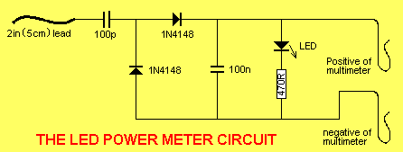
To hear the tone from a transmitter, the Mini Bug Detector circuit can be used:
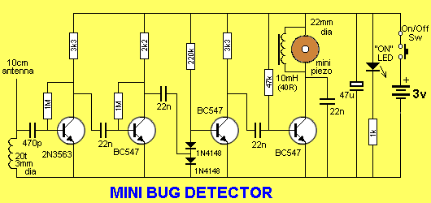
Any further investigation requires a circuit diagram so you can work out what is actually being sent from the transmitter.
Most of the time it is a faulty switch, battery or contacts. Make sure the setting is correct on the "dip switches" and use a working unit to compare all your testing.
TESTING VOLTAGES ON (in) A CIRCUIT
There are basically two different types of circuit.
1. ANALOGUE CIRCUIT
An analogue circuit can also be called an AUDIO CIRCUIT and the voltages at different points in a circuit can be measured with a multimeter but the changes (the waveforms) will be quite small or changing at a rapid rate and cannot be detected by a multimeter.
You need a CRO to "see" the signals or a Signal Injector to inject a waveform into the circuit and hear the result on the circuit's speaker.
2. DIGITAL CIRCUIT
A digital circuit can also be called a "Computer Circuit" or "Logic Circuit" and some of the voltages can be measured with a multimeter (such as supply voltages) but the "signal lines" will be be changing from HIGH to LOW to HIGH very quickly and these signals are detected with a Logic Probe.
Here are some circuits with details of how to test the voltages.
Most circuits do not show voltages at various different points and we will explain what to expect on each "stage."
A "STAGE"
A stage is a set of components with an input and output. A "stage" can also be called a "Building Block."
Sometimes it has a capacitor on the input and one on the output.
This means the stage is completely isolated as far as DC is concerned.
The stage has a supply (a DC supply) and it is producing its own voltages on various points on the "stage." It can only process (amplify) "AC." (signals).
Sometimes the stage can be given a name, such as small-signal amplifier, push-pull amplifier or output.
If the stage has a link or resistor connected to a previous stage, the previous stage will have a "DC effect" on the stage. In other words it will be biasing or controlling the voltages on the stage. The stage may be called a "timer" or "delay" or "DC amplifier."
It is important to break every circuit into sections. This makes testing easy. If you have a capacitor at the input and output, you know all the problems lie within the two capacitors.
In a digital circuit (no capacitors) you need to work on each IC (integrated Circuit) and test the input for activity and all the outputs.
Once you have determined if the circuit is Analogue or Digital, or a combination of both, you have to look at the rail voltage and work out the size or amplitude of the voltage or waveform.
This is done before making a test, so your predictions are confirmed.
You will need a multimeter (either Digital or Analogue) a Logic Probe and a Signal Injector (Tone Generator). An analogue meter has the advantage that it will detect slight fluctuations of voltage at a test-point and its readings are faster than a digital meter. A digital meter will produce an accurate voltage-reading - so you should have both available.
HIGH IMPEDANCE AND LOW IMPEDANCE
Every point in a circuit has a characteristic called "IMPEDANCE." This has never been discussed before in any text book. That's why it will be new to you.
In other words, every point will be "sensitive to outside noise."
An audio amplifier is a good example. If you put your finger on the active input, it will produce hum or buzz in the speaker. This is because it is a HIGH IMPEDANCE line or high impedance section of the circuit.
The same applies to every part in a circuit and when you place Test Equipment on a line for testing purposes, the equipment will "upset" the line. It may be very slight but it can also alter the voltage on the point CONSIDERABLY.
We have already mentioned (above) how a cheap multimeter can produce a false reading when measuring across a 1M resistor. That's why you need high impedance test Equipment so you do not "load" the point you are testing and create an inaccurate reading.
The word Impedance really means resistance, but when you have surrounding components such as diodes, capacitors, transistors, coils, Integrated Circuits, supply-voltages and resistors, the combined effect is very difficult to work out as a "resistance" and that's why we call it "Impedance."
The term "High and Low Impedance" is a relative term and does not have any absolute values but we can mention a few points to help you decide.
In general, the base of a transistor, FET input of an IC are classified as HIGH IMPEDANCE.
The output of these devices are LOW IMPEDANCE.
Power rails are LOW IMPEDANCE.
An oscillator circuit and timing circuit are HIGH IMPEDANCE.
A LOAD is low impedance.
And it gets tricky: An input can be designed to accept a low-impedance device (called a transducer or pick-up) and when the device is connected, the circuit becomes LOW impedance, but the input circuitry is actually high impedance.
The impedance of a diode or LED is HIGH before the device sees a voltage higher than the junction voltage and then it becomes LOW Impedance.
Impedance is one of the most complex topics however it all comes down to testing a circuit without loading it.
That's why test equipment should have an input impedance higher than 1M.
The first circuit we will investigate is the Mini Bug Detector, shown above and below. Points on the circuit have been labelled A, B, C etc:
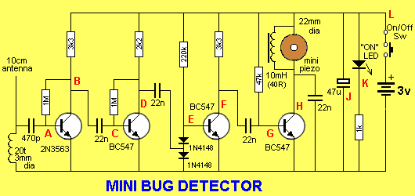
Point A - The first transistor is "self-biased" and will have 0.6v on the base. The antenna is connected to a 20 turn coil and you might think the coil will "short" the signals to earth.
But the coil and 470p capacitor form a circuit that oscillates at a high frequency when the antenna wire picks up stray signals. The coil and capacitor actually amplify the signals (see Talking Electronics website: Spy Circuits to see how a TANK CIRCUIT works) and these signals enter the base of the first transistor.
This is classified as a HIGH Impedance section because the signals are small and delicate and any loading via test equipment will kill them. The first transistor amplifies the signals about 70 times and they appear at Point B.
The signal passes though a 22n to Point C and the transistor amplifies the signal about 70 times to point D. Point C is classified as high impedance as any voltage measurement at this point will upset the biasing of the stage as a few millivolts change in base-voltage will alter the voltage on the collector considerably. Point D is classified as low impedance as any voltage-testing will not alter the voltage appreciably.
The output of the second stage passes through a capacitor to the join of two diodes. These two diodes are not turned on because the voltage at Point E can never rise above 0.7v as this is the voltage produced by the base-emitter of the third transistor.
The purpose of the two diodes is to remove background noise. Background noise is low amplitude waveforms and even though the transistor is turned on via the 220k, low amplitude signals will not be received. The third transistor works like this: It cannot be turned ON any more because any waveform from the 22n will be "clipped" by the bottom diode and it will never rise above 0.6v.
So, the only signal to affect the transistor is a negative signal - to turn it OFF.
Firstly we have to understand the voltage on the 22n. When the second transistor is sitting at mid-rail voltage, the 22n gets charged via the 2k2 and lower diode. When the transistor gets tuned ON, the collector voltage falls and the left side of the 22n drops. The right side of the 22n also drops and when it drops 0.6v, the top diode starts to conduct and when the voltage on the 22n drops more than 0.6v the third transistor starts to turn OFF. This effect is amplified by the transistor at least 100 times and appears at Point F. All the voltages around the two diodes are classified as HIGH Impedance as any piece of test equipment will upset the voltage and change the output.
There are some losses in amplitude of the signal as it passes through the 22n coupling capacitors but the end result is a very high strength signal at point G. The 4th transistor drives a 10mH choke and the mini piezo is effectively a 20n capacitor that detects the "ringing" of the inductor to produce a very loud output.
The 22n capacitor on the collector eliminates some of the background noise. The choke and piezo form an oscillatory circuit that can produce voltages above 15v, even though the supply is 3v.
The 47n capacitor at Point J is to keep the supply rails "tight" (to create a LOW Impedance) to allow weak cells to operate the circuit.
The "Power-ON" LED tells you to turn the device off when not being used and Point L is the power supply - a low impedance line due to the 47u electrolytic.
Testing the Mini Bug Detector
To test the Mini Bug Detector, you will need a Signal Injector.
Place the Injector on Point G and you will hear a tone. Then go to E, C and A. The tone will increase in volume. If it does not increase, you have pin-pointed the faulty stage.
The next circuit is a combination of digital and analogue signals. It is a Logic Probe:
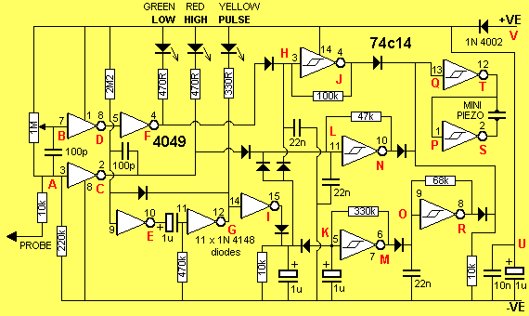
The voltage on a circuit (to be tested) is detected by the probe at Point A of the circuit above and the "tip" is classified as "reasonably high impedance" as it has a 220k resistor between the tip and 0v rail. The 1M reduces the impedance by about 20% but the inputs of the two inverters have no effect on the "tip" impedance as they are extremely high input-impedance devices.
The 1M trim pot is designed to put put a voltage on point B that is slightly higher than mid-rail so the green LED is turned off.
Point A will see a voltage below mid-rail and point C will be HIGH. Point C and F are low-impedance outputs.
When the tip of the probe is connected to a LOW voltage, Point B sees a LOW and Point F goes LOW to illuminate the green LED. At the same time it removes the "jamming voltage" produced by the diode between pin 4 of the 4049 and pin 3 of the 74C14 and the oscillator between points H and J produces a low-tone via the 100k resistor and 22n to indicate a LOW.
When the probe tip sees a HIGH, a lot more things happen.
Point C goes LOW and turns on the red LED. At the same time the 100p is in an uncharged state and the right lead goes LOW. This takes the left lead LOW as the left lead connects to a HIGH Impedance line and pin 9 goes LOW. This makes point E HIGH
and since the 1u is in an uncharged state, pin 11 goes HIGH. This makes point G LOW and the diode between pins 9 and 12 keeps pin 9 LOW and takes over from the pulse from the 100p. The yellow LED is illuminated. The 1u starts to charge via the 470k and when it is approx half-charged, pin 11 sees a HIGH and point G goes low. This creates the length of pulse for the yellow LED.
At the same time, Point L goes LOW because the "jamming diode" from pin 2 of the 4049 goes low and allows the inverter between point L and N to produce a tone for the piezo.
In addition, Point I goes HIGH and quickly charges a 1u electrolytic. This removes the effect of the jamming diode on pin 5 of the 74C14 and a low frequency oscillator made up of 68k and 1u between pins 5&6 turns on and off an oscillator between points O and R to get a beep. The mini piezo is driven n bridge mode via the two gates between points QT and PS.
Point U is a 1u electrolytic to reduce the impedance of the power rail and Point V is a protection diode to prevent damage if the probe is connected to the supply around the wrong way.
Testing the Logic Probe
You can test the Logic Probe with the simple Logic Probe with Pulse project described above. It will let you know if each point in the circuit is HIGH or LOW. You will also find out the difficulty in testing the points that are HIGH Impedance, as the Probe will upset the voltage levels and the reading may be inaccurate.
More circuits will be added here in the future.
THE VOLTAGE DIVIDER - this topic could fill a book.
You need to read lots of other sections in this eBook, including the section on measuring across a resistor with a multimeter, and high impedance circuits, to fully understand the complexities of a VOLTAGE DIVIDER CIRCUIT.
It is one of the most important BUILDING BLOCKS to understand. Even though it may consists of two components, you have to understand what is happening between these two components. You have to realise there is a voltage at their join that will be rising and falling due to one of the components changing RESISTANCE.
Sometimes you can work out the voltage at the join by using Ohm's LAW but quite often it will be impossible as it is changing (rising and falling) during the operation of the circuit.
At the beginning of this discussion we will only dealing with DC circuits and the voltage across a particular component will be due to its RESISTANCE. We are not going into any formulas, as it is very easy to measure the voltages with a multimeter set to VOLTS and you will have an accurate result.
The simplest two components in series are resistors. They always have the same resistance during the operation of a circuit and the voltage across each will not change.
In a further discussion we will cover "resistors" that change value according to the temperature. These are called THERMISTORS. And we have "resistors" that change value according to the light they receive. These are called LIGHT DEPENDENT RESISTORS (LDR's) or PHOTO RESISTORS.
A transistor that is partly or fully turned ON can be considered to be similar to a resistor.
In these 3 cases we need to measure the voltage at the join with a voltmeter as it will be a lot of work to measure the resistance and work out a value.
You can also keep a voltmeter on the joint and watch the voltage change.
Finally we have some components that produce a fixed voltage across them (or nearly fixed) and the remaining voltage is dropped across a resistor. These components MUST have a resistor connected in series to limit the current and allow the component to pass the specified in the datasheet.
These devices include LEDs, diodes and zener diodes. A LED will have a fairly fixed voltage across it from 1.7v to 3.6v depending on the colour. A diode will have a voltage of 0.7v across it when it is connected to a voltage via a resistor. And a zener diode will have a fixed voltage across it when it is connected with the cathode to the positive rail via a resistor. The voltage across it will be as marked on the zener.
The concept of a VOLTAGE DIVIDER is very simple, but it takes a lot of understanding because both VOLTAGE and CURRENT are involved in the UNDERSTANDING-PROCESS.
Each component has a resistance and this can be measured with a multimeter. When two components are connected in series, a current will flow and a voltage will develop across each item.
More voltage will develop across the item with the higher resistance and the addition of each voltage will always equal the supply voltage.
That's the simple answer.
There is a little more involved . . . It is the word CURRENT. Here is an explanation:
Suppose we have a 1k and 2k resistor on a 12v supply. The voltage at the join will be 4v.
In other words, there will be 4v across the 1k and 8v across the 2k.
If we have a 10k and 20k resistors in series, the voltage will also be 4v at the join.
If we have a 100k and 200k resistors, the voltage will also be 4v at the join.
The voltage will be the same in all cases, but the current will be different. The current in the second case will be one-tenth and only one hundredth in the third case.
If you want to go further, place a one ohm and two ohm in series and get 4v. But the resistors will get very hot and burn out very quickly.
SOLDERING
Here are three 30-minute videos on soldering.
1. TOOLS
2. Soldering components
3. Soldering SURFACE MOUNT components
TESTING A MOTOR
Strictly speaking, a motor is not an electronic component, but since a website gave a useless description on testing motors, I have decided to supply the correct information.
The only REAL way to test a motor is to have two identical motors and check the torque by connecting them to a low voltage and trying to stop the shaft with your fingers. This will give you two results. Firstly it will let you know the torque of the motor.
This is the twisting effect of the shaft. There is no way to determine the torque by knowing the voltage or current.
The unknown factor is the strength of the field magnets (permanent magnets) and this determines the torque.
Secondly, feeling the shaft will let you know if the torque is even for a complete revolution.
By having two identical motors, you can see if one has a lower torque.
Almost nothing can go wrong with a motor except for the brushes. If the brushes wear out, additional resistance will be produced at the interface between the brush and commutator and this can be detected by allowing the shaft to rotate slowly and feeling the resistance as it revolves. A 3-pole motor will have three places where the strength is greatest and each should have the same feeling. A 5-pole motor will have five places of strength.
If the strength is weak or not uniform, the motor is faulty.
You cannot test a motor with a multimeter as the resistance of the armature winding is very low and if the motor is allowed to spin, the back voltage produced by the spinning, increases the reading on the meter and is false.
Micro motors have a coreless armature. This means the 3 windings for the armature are wound on a machine then bent slightly into shape and glued. A circular magnet with 3 poles is in the centre and the armature rotates around this.
This type of motor is reasonably efficient because the armature is the greatest distance from the point of rotation, and the motor reaches full RPM very quickly because the armature has very little inertia.
I have not heard of the armature-winding flying apart but if you hear any scraping noise, it may be the winding.
3-pole, 5-pole and micro motors can be found in printers, eject mechanisms of CD players, toys, RC helicopters, cars etc and rarely fail.
Motors do not work on "voltage." They actually work on CURRENT and as you increase the voltage, more current will flow and produce a stronger magnetic field (by the winding on each pole). This magnetic field will be attracted by the permanent magnet surrounding the armature and repelled by the surrounding permanent magnet, depending on where the face of the pole is, during each revolution.
If the permanent magnet is not very strong, the repulsion part of the interaction will be very weak and thus the torque will be small.
Because motors work on "current" you must have a high current available when you increase the voltage as the motor will require short bursts of high current during each revolution.
It is the combination of voltage and current (called watts) that gives the motor "strength" (torque) as well as the "strength" of the permanent magnets (called the field magnets) and the number of turns of wire on each pole (and the gauge of wire).
Basically, if a motor is hard to spin, and has 3 "hard spots" on each revolution, it will be powerful.
A 2-pole motor does not self-start and will spin in either direction. But a 3-pole motor will self-start and you can determine the direction of rotation.
A 5-pole motor has a lower RPM. It is slightly smoother in output but is not more powerful than a 3-pole version.
A motor with "permanent magnets" is called a DC motor as it will not work on AC. If the magnets are replaced with a coil, it will work on AC and it will be called a "shunt wound" motor of the field coil is connected across the same terminals as the brushes or a "series wound" motor if the field coil is in series with the armature.
TESTING COMPONENTS "IN-CIRCUIT"
You can test components while they are IN CIRCUIT, but the surrounding components will have an effect on the results.
You can get all sorts of "In-Circuit" testers. They are expensive and offer little more accuracy than a multimeter.
In-Circuit testing with a multimeter can give you the same results as a tester.
All you have to do is turn the project ON and use a multimeter (set to voltage) to determine the voltage at various points. It is best to have a circuit of the equipment so you can what to expect at each point.
Only major departures from the expected can be located in this way.
Obviously the first thing to look for is burnt-out components. Then feel components such as transistors for overheating.
The look for electrolytics that may be dry. Sometimes these have changed colour or are slightly swollen.
If they are near hot components, they will be dry.
For the cost of a few dollars I change ALL THE ELECTROLYTICS in some pieces of equipment, as a dry electrolytic is very difficult to detect.
Testing a transistor "in-circuit" is firstly done with the supply ON. That's because it is quicker.
Measure the voltage between ground and collector.
In most cases you should get a voltage of about half-rail. If it is zero, or close to rail voltage, you may have a problem.
Turn off the supply and use the multimeter on low-ohms to measure all six resistances between the leads.
A low resistance in both directions on two leads will indicate a fault.
Resistors almost NEVER go "HIGH." For instance, a 22k will never go to 50k. However a low-value resistor will "burn-out" and you will read the value of the surrounding components.
Don't forget, some low-value resistors are designed to burn-out (called fusible resistors) and anytime you find a damaged low-value resistor, you will need to look for the associated semiconductor.
You can replace the resistor quickly and turn the circuit ON to see it burn out again.
Alternatively you can trace though the circuit and find the shorted semiconductor.
It's always nice to "see the fault" then "fix the fault."
Sometimes a transistor will only break-down when a voltage is present, or it may be influenced by other components.
When the piece of equipment is turned OFF, you can test for resistance values. The main thing you are looking for is "dry joints" and continuity. Dry joints occur around the termination of transformers and any components that get hot. Rather than wasting time checking for dry joints, it is better to simply go over the connections with a hot iron and fresh solder.
You may need to check the continuity of a track (trace) and it may go from one side of the PC board to the other.
Use a multimeter set to low-ohms and make sure the needle reads "zero-ohms."
It is very dangerous to do any testing on a project using a multimeter set to "amps" or "milliamps."
You cannot test "current flowing through a component" by placing the probes across a component. You will simply over-load the rest of the circuit and create a problem.
To find out if current is flowing though a circuit or a low-value resistor, turn the project ON and measure the voltage either across the component or the voltage on one end then the other.
A voltage-drop indicates current is flowing.
That's about it for testing "in-circuit." Use the rest of this eBook to help you with diagnosis.
Don't think an IN-CIRCUIT COMPONENT TESTER is going to find a fault any faster than a multimeter. They all use a multimeter principle.
SHORT CIRCUIT
Nearly every component can fail and produce an effect called a SHORT CIRCUIT.
This basically means the component takes more current than normal and it may fail completely or simply take more current and the operation of the circuit may be reduced only a small amount.
The resistance of the component may reduce a very small amount but this may have a very large effect on the operation of the circuit.
For instance, two turns in the horizontal or vertical winding of a yoke on the picture tube or monitor may arc and weld together and reduce the size of the picture on the screen, but measuring the winding will not detect the difference in resistance.
The same with the windings on a motor and a short between two winding in a transformer.
If the "short" is between two near-by turns, the change in resistance will be very small. If the "short" is between to different layers, the resistance will be reduced and it may be detected.
When a "short" occurs, the winding turns into a transformer. To be exact, an AUTO-TRANSFORMER.
In the following diagram you can see a normal winding in fig A:
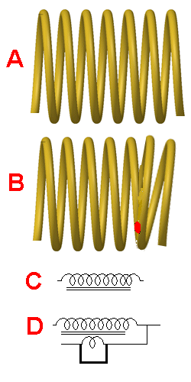
Fig B shows two turns touching each other and if the wire is enamelled, the coating has been damaged so the copper wire from the two turns is touching. This is called a SHORTED TURN.
In fig C you can see two turns touching.
In fig D the shorted-turn has been moved to the other side of the symbol to show the effect it has on the operation of the winding.
The shorted-turn is exactly like the secondary of a transformer with a "jumper" across the output.
This will produce a very high current in the secondary.
A very high current flows through the shorted turn and this changes the operation of the rest of the winding.
1. In most cases a SHORT CIRCUIT can be detected by feeling the additional heat generated by the component.
2. Next, turn off the supply and measure the resistance of the component. If it is lower than expected, the component will be faulty.
3. Next, measure the voltage across the component. If it is lower than normal, the component will be faulty.
4. Next, measure the current taken by the component. If it is higher than normal, the component will be faulty.
5. If the component is an inductor, such as a motor, coil or transformer, you can use an inductance meter. Compare a good winding with a faulty winding. Sometimes the fault will disappear because an arc develops across the fault when the component is operating.
INTERNAL AND EXTERNAL SHORTS
An internal short refers to two windings shorting together and the winding has a very high resistance between the winding and the frame on which it is wound. An external short refers to a winding shorting to the frame of the component - such as one of the armature windings shorting to the metal core, around which the wire is wound.
This may not be important unless another winding shorts to the metal frame and creates "inter winding" problems (inner winding problems is within the same winding).
The opposite to a short circuit is an OPEN CIRCUIT.
This is generally a broken lead or contact or a wire that has "burnt-out" or been "eaten-away" by acid attack or galvanic action by water and voltage (current).
1. No current will flow when an OPEN CIRCUIT exists.
2. The voltage on each end of the OPEN CIRCUIT will not be the same.
3. Measure the current across the OPEN CIRCUIT and determine if excess current is flowing.
4. Join the two ends of the OPEN CIRCUIT and see if the circuit operates normally.
> HEATSINKS
This is not an electronic component but it can certainly affect the operation of a circuit.
If you cannot hold your fingers on a heatsink, it is getting too hot. This is because the actual location where the heat is being generated is much hotter than the part you are touching.
Transistors and IC's can withstand a high temperature but if they go above this temp, they BLOW UP.
They also have a shorter life when operating at a high temperature.
The secret to a good heatsink is called an INFINITE HEATSINK.
This is the metal frame of a case.
There are lots of charts and data on choosing a heatsink but they don't take into account two factors:
Sometimes a circuit takes a very high current for a short time and this creates a high temperature gradient. This will cause the transistor to get very hot and fail.
The solution is to have two or more transistors in parallel to separate the "heat spots."
The second problem with designing a heatsink is the unknown location of the heatsink and the air-flow. Products placed on a shelf or in a cupboard will get very little air-flow.
Remember: some transistors are mounted on thermal insulators. This means the transistor will have a voltage on it but the heatsink will be zero voltage.
The temperature of the transistor will be MUCH HIGHER than the heatsink under the transistor and the transfer of the heat from the transistor to the heatsink will be very slow. This can be the cause of the transistor failing. Sometimes the transistor will fail because insulation is high temp plastic and it gets brittle. The plastic can carbonise and leak and sometimes a voltage can flash through the insulator. Some amazing things have happened under these transistors and you may need to pull it apart and replace all the insulation.
Finally, feel the heatsink after 15 minutes and feel right up to the transistor. If you cannot touch the transistor, increase the thickness of the heatsink or use two transistors to dissipate the heat.
To design a heatsink, you have to have some idea of the size of a heatsink for the application.
Charts and data can send you in the wrong direction.
Start with a heatsink twice the recommended size and feel the temp after 15 minutes. Put the project in a cupboard and see how the temperature rises.
If possible, connect the heatsink to the metal case to get added dissipation and if you include fan-cooling, remember the fan will eventually gather dust and reduce its efficiency.
It is very difficult to explain how heat passes through a mica washer or plastic washer, but if the transistor has a copper base, the heat transfer has a value of 400. For aluminium it is 200. If it is steel, the transfer has a value of 50. For a mica sheet it is 1 and for plastic it is 0.1
Even though the sheet is very thin, the transfer is a lot less than metal-to-metal transfer.
Most references state the temperature difference is about one degree C for each watt of heat generated by the transistor.
Don't believe anything you read.
Feel the temperature yourself and if you cannot hold your finger on the transistor, fix the problem.
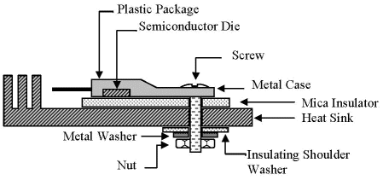
In the end, use a heatsink 50% larger than recommended.
THE END
This is not the full story to learning about servicing. It is just the beginning.
We have only covered the simplest tests and shown how 90% of faults can be found by checking voltages, waveforms and looking for obvious things such as burnt out components, cracks in PC boards.
The author has fixed over 35,000 TV's, radios, stereos, VCRs and all those things that were on the market 30 years ago.
Things have not changed. It's just that some repairs cost nearly as much as buying a new product and half the customers opt for dumping a faulty item and buying the latest "flat screen" version. That's why you have to get things through the workshop as fast and as cheaply as possible, to make a living.
If you want any more devices added to this list, email Colin Mitchell.
To help with understanding how a transistor circuit works, we have produced an eBook: The Transistor Amplifier. It covers a whole range of circuits using a transistor.

Not copyright by Colin Mitchell
You can use any of this material. Please pass this eBook to your friends and let them know that everything on the web is FREE. I have looked at all the "Pay Sites" and found the information they "sell" is available on the web at NO COST.
Nearly all text books are also downloadable for free on "Download.com" etc and when you see a used copy of a $74.00 textbook on Amazon for $12.00 you realise many users have already discarded their copy. A good textbook never gets thrown out or sold for $12.00!!!
See the enormous amount of information on Talking Electronics website
